  NYSDEC  Division of Environmental Remediation |  |  |  |  |  |  |  |  |  |  |  |  |  |  |  |  | NYSDEC Contract No. D011107  Superintendent:  NYSDEC PM: P. Long  Consultant PM: M. Wright  Consultant Site Inspectors: J. Brown
Site Location: 110 Cutter Mill Rd, Great Neck, NY
Weather Conditions
General Description | Cloudy |  |  |  |  |  |  | AM | Cloudy |  |  |  |  |  | PM
Temperature | 66 |  |  |  |  |  |  | AM | 78 |  |  |  |  |  | PM
Wind | SW |  |  |  |  |  |  | AM | SW |  |  |  |  |  | PM

Health & Safety
If any box below is checked “Yes”, provide explanation under “Health & Safety Comments”.
Were there any changes to the Health & Safety Plan? |  |  |  |  |  |  |  |  |  |  |  |  |  |  |  |  |  | *Yes |  | No |  |  |  | NA
Were there any exceedances of the perimeter air monitoring reported on this date? |  |  |  |  |  |  |  |  |  |  |  |  |  |  |  |  |  | *Yes |  | No |  |  |  | NA
Were there any nuisance issues reported/observed on this date? |  |  |  |  |  |  |  |  |  |  |  |  |  |  |  |  |  | *Yes |  | No |  |  |  | NA
Health & Safety Comments
General safety precautions and PPE used. Socially safe distances observed

Summary of Work Performed |  |  |  |  |  | Arrived at site: |  |  |  |  |  | 0715 |  |  |  | Departed Site: |  |  |  |  |  | 1215
Onsite for routine monthly O&M of GWETS and SVE systems including GWETS water sampling and water level gauging at monitoring wells. Collected quarterly SVE air samples. Collected spent carbon sample at SVE VGAC vessel. Conducted weed/vine removal.

Equipment/Material Tracking
If any box below is checked “Yes”, provide explanation under “Material Tracking Comments”.
Were there any vehicles which did not display proper D.O.T numbers and placards? |  |  |  |  |  |  |  |  |  |  |  |  |  |  |  |  |  | *Yes |  | No |  |  |  | NA
Were there any vehicles which were not tarped? |  |  |  |  |  |  |  |  |  |  |  |  |  |  |  |  |  | * Yes |  | No |  |  |  | NA
Were there any vehicles which were not decontaminated prior to exiting the work site? |  |  |  |  |  |  |  |  |  |  |  |  |  |  |  |  |  | * Yes |  | No |  |  |  | NA
Personnel and Equipment
Individual |  |  | Company |  |  |  |  |  |  |  |  |  | Trade |  |  |  |  |  |  |  | Total Hours
Jason Brown |  |  | EAR |  |  |  |  |  |  |  |  |  | Technician |  |  |  |  |  |  |  | 5.0
Equipment Description |  |  |  | Contractor/Vendor |  |  |  |  |  |  |  |  |  |  |  |  |  |  | Quantity |  | Used
Transit/van |  |  |  | EAR |  |  |  |  |  |  |  |  |  |  |  |  |  |  | 1 |  | Yes
PID |  |  |  | EAR |  |  |  |  |  |  |  |  |  |  |  |  |  |  | 1 |  | Yes
AVM |  |  |  | EAR |  |  |  |  |  |  |  |  |  |  |  |  |  |  | 1 |  | Yes
4-gas meter |  |  |  | EAR |  |  |  |  |  |  |  |  |  |  |  |  |  |  | 1 |  | Yes
Water level Meter |  |  |  | EAR |  |  |  |  |  |  |  |  |  |  |  |  |  |  | 1 |  | Yes
Material Description |  | Imported/Delivered to Site |  |  | Exported off Site |  |  |  |  | Waste Profile  (If Applicable) |  |  |  | Source or Disposal Facility (If Applicable) |  |  |  |  |  |  |  |  | Daily Loads |  | Daily Weight (tons)*
*On-Site scale for off-site shipment, delivery ticket for material received
Equipment/Material Tracking Comments:

Visitors to Site

Name |  |  |  |  |  |  | Representing |  |  |  |  |  |  |  |  |  |  | Entered Exclusion/CRZ Zone
 |  |  |  |  |  |  |  |  |  |  |  |  |  |  |  |  |  | Yes |  |  |  |  | No
 |  |  |  |  |  |  |  |  |  |  |  |  |  |  |  |  |  | Yes |  |  |  |  | No
 |  |  |  |  |  |  |  |  |  |  |  |  |  |  |  |  |  | Yes |  |  |  |  | No
 |  |  |  |  |  |  |  |  |  |  |  |  |  |  |  |  |  | Yes |  |  |  |  | No
 |  |  |  |  |  |  |  |  |  |  |  |  |  |  |  |  |  | Yes |  |  |  |  | No
 |  |  |  |  |  |  |  |  |  |  |  |  |  |  |  |  |  | Yes |  |  |  |  | No
 |  |  |  |  |  |  |  |  |  |  |  |  |  |  |  |  |  | Yes |  |  |  |  | No
 |  |  |  |  |  |  |  |  |  |  |  |  |  |  |  |  |  | Yes |  |  |  |  | No
 |  |  |  |  |  |  |  |  |  |  |  |  |  |  |  |  |  | Yes |  |  |  |  | No
Site Representatives
Name |  |  |  |  |  |  |  |  |  |  | Representing
Project Schedule Comments
Issues Pending
Interaction with Public, Property Owners, Media, etc.
Include (insert) figures with markups showing location of work and job progress

Site Photographs (Descriptions Below)
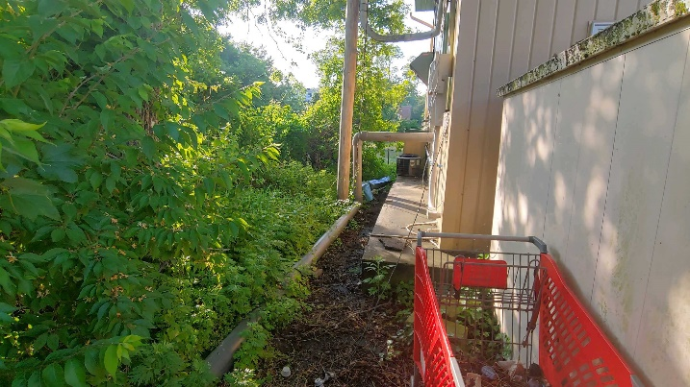 | 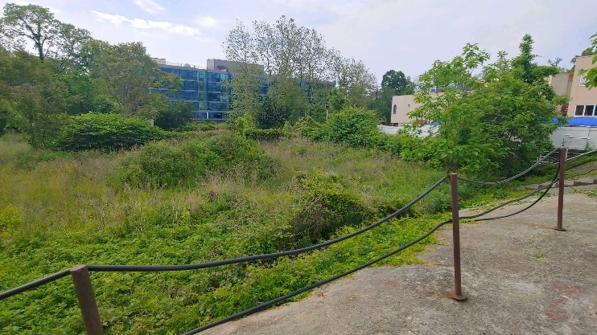
Behind compound | Vacant lot behind compound
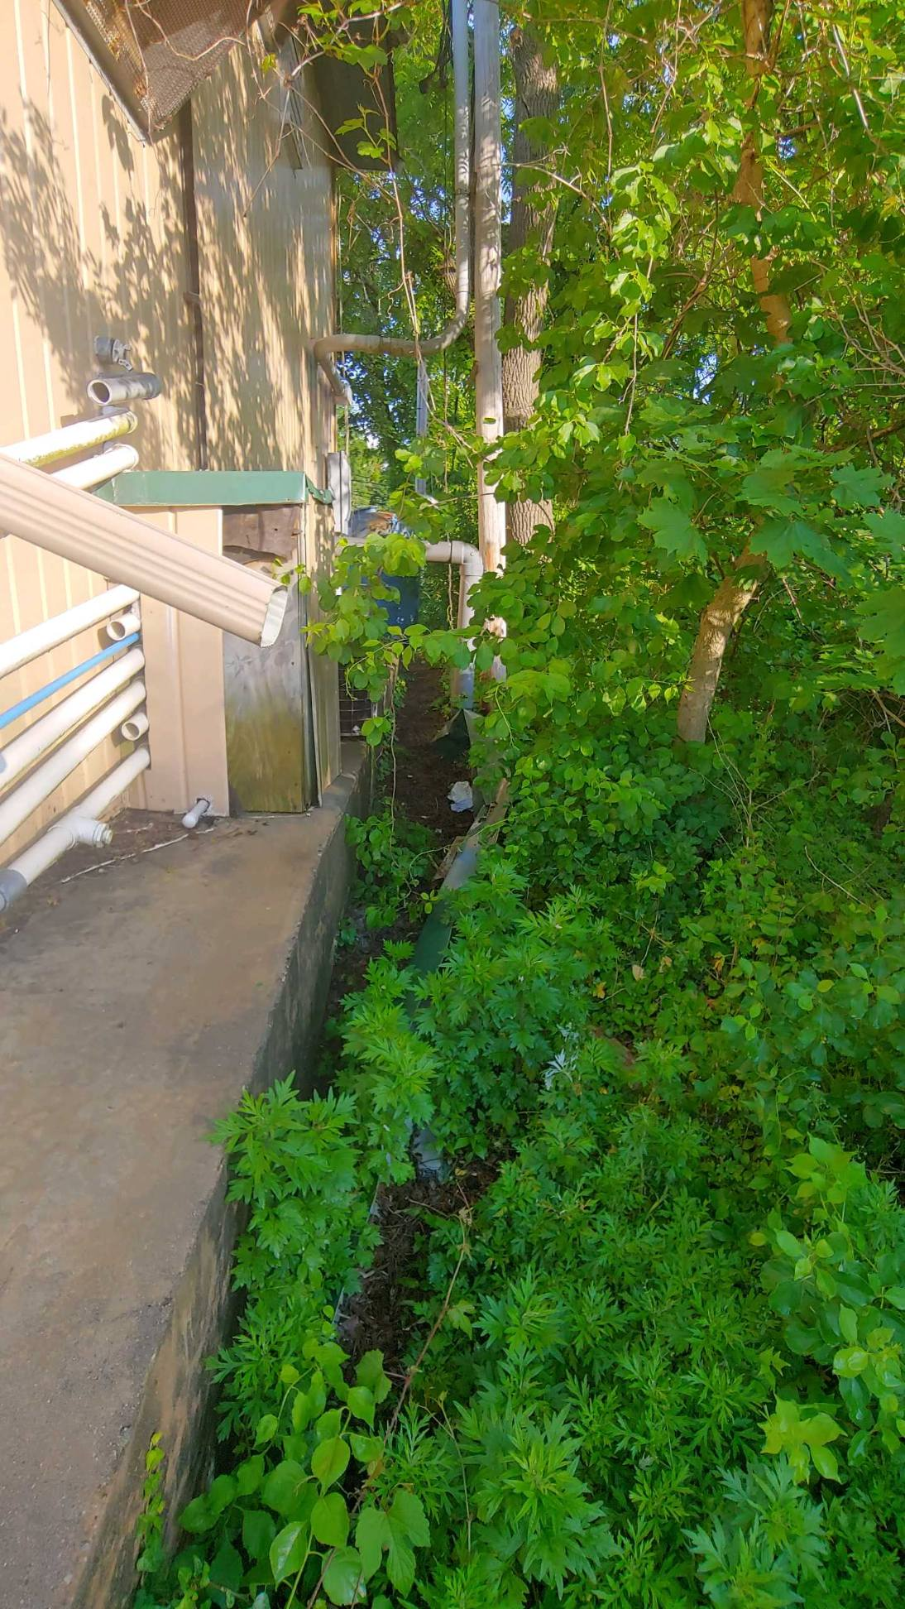 | 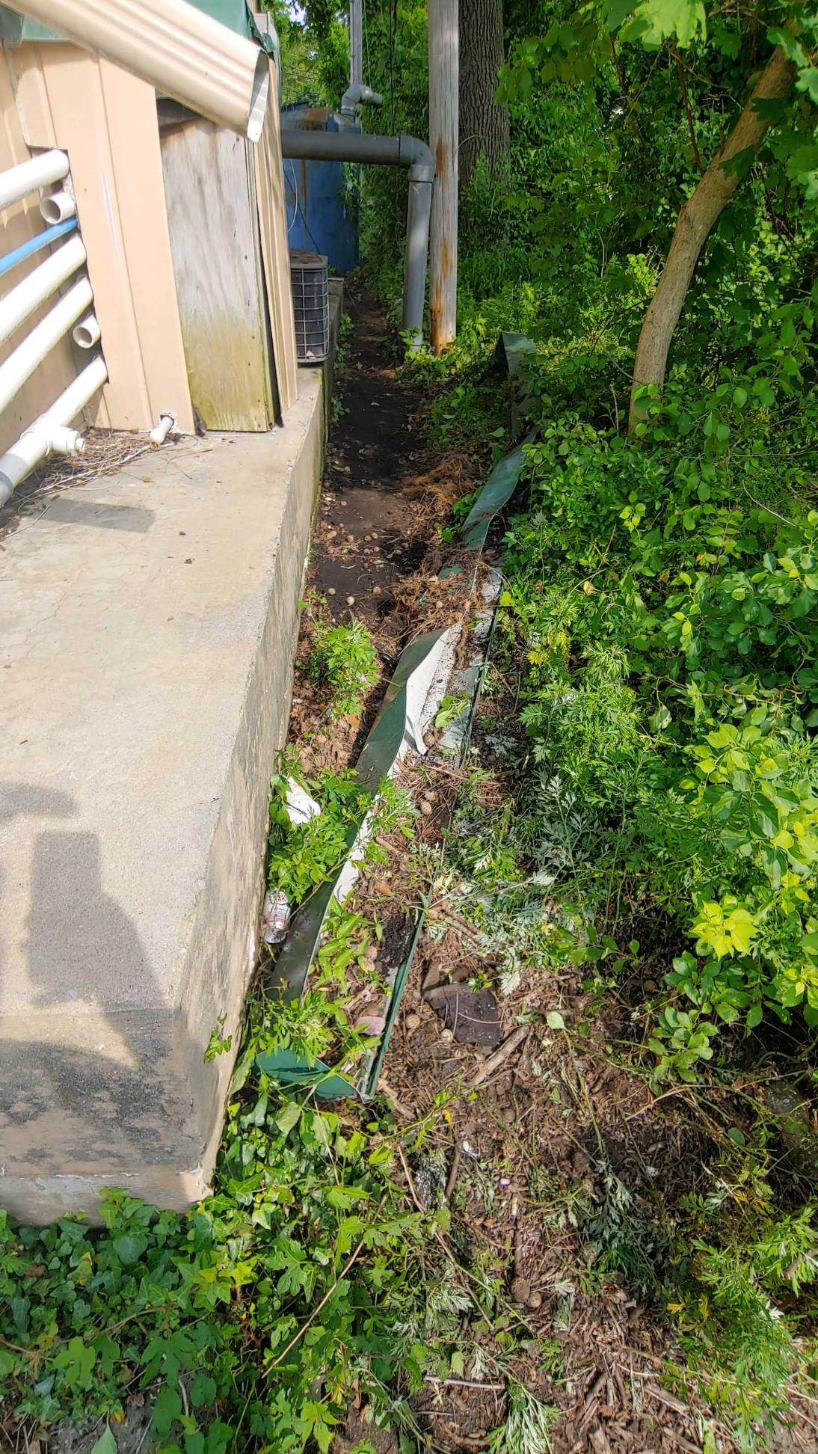
Weed encroachment | Following weed removal
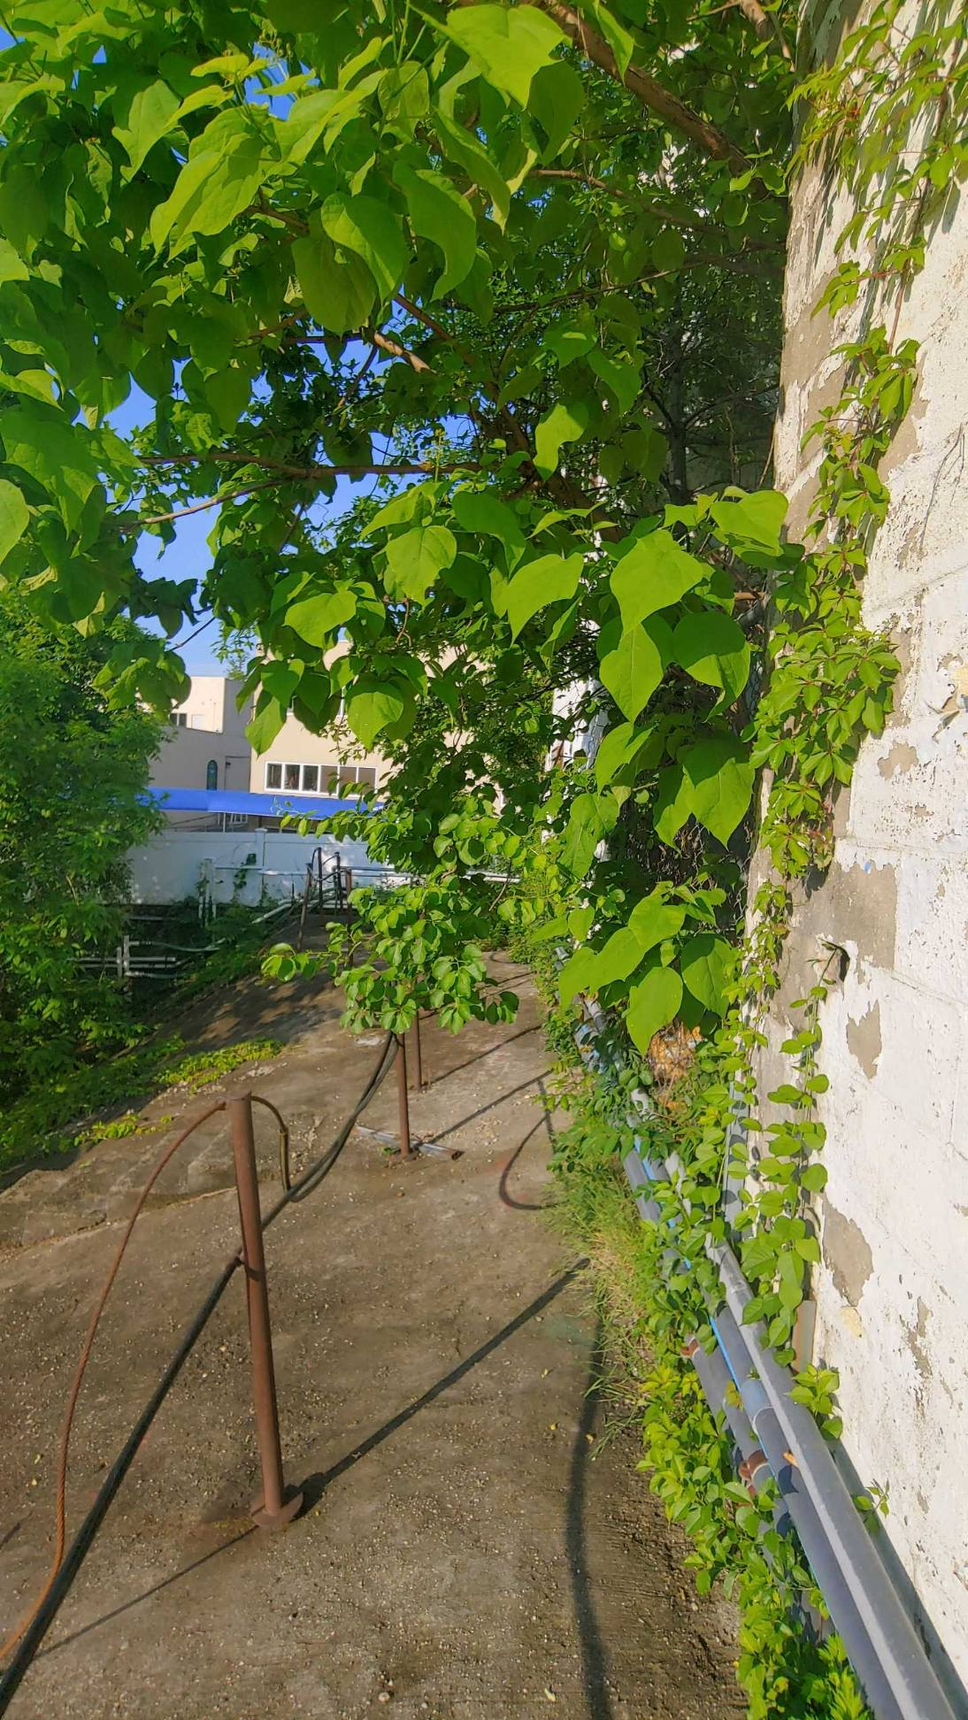 | 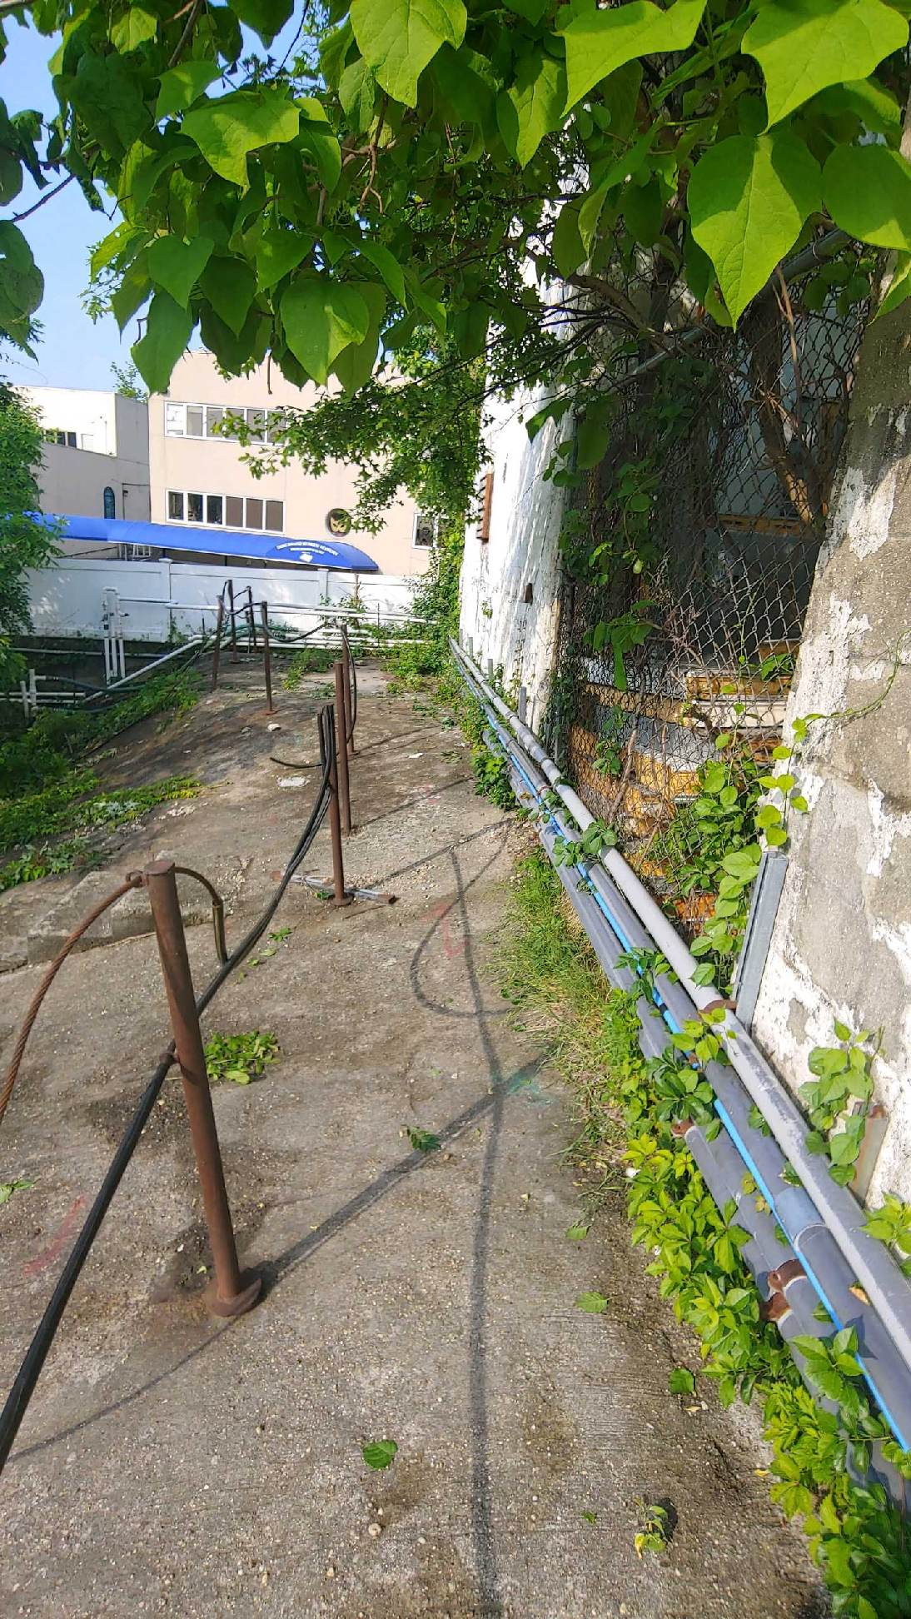
Weed encroachment | Following weed removal

Comments
Site Inspector(s): JB |  | Date: 6/3/20

DAILY HEALTH CHECKLIST

Is social distancing being practiced? | Yes ☒ | No ☐
Is the tail gate safety meeting held outdoors? | Yes ☒ | No ☐
Are remote/call in job meetings being held in lieu of meeting in person where possible? | Yes ☒ | No ☐
Were personal protective gloves, masks, and eye protection being used? | Yes ☒ | No ☐
Are sanitizing wipes, wash stations or spray available? | Yes ☒ | No ☐
Have any workers/visitors been excluded based on close contact with individuals diagnosed with COVID-19, have recently traveled to restricted areas or countries, or are symptomatic (fever, chills, cough/shortness of breath)? | Yes ☐ | No ☒
Comments:

REMEDIAL ACTIVITIES AT PROPERTIES

- Have anyone at this location been tested and confirmed to have COVID-19? | Yes ☐ | No ☒
- Is anyone at this location isolated or quarantined for COVID-19? | Yes ☐ | No ☒
- Has anyone at this locaton had contact with anyone known to have COVID-19 in the past 14 days? | Yes ☐ | No ☒
- Does anyone at this locaton have any symptoms of a respiratory infection (e.g., cough, sore throat, fever, or shortness of breath)? | Yes ☐ | No ☒
- Does the Department and its contractors have your permission to enter the property at this time? | Yes ☐ | No ☐
If Yes to any of 1-4 above:  - If it is not critical that service/entry be carried out immediately and can be postponed until the risk of COVID-19 is lower, or can be accomplished remotely/without entry, postpone or conduct service without entry.  - If it is critical that service/entry be carried out immediately, advise occupants that as a precaution and for our own protection, project personnel will be donning appropriate PPE* (including respiratory protection) - and do so prior to entry. | Yes ☐ | No ☐
Comments:

NUISANCE CHECKLIST

Were there any community complaints related to work on this date? | Yes ☐ | No ☒ | N/A☐
Were there any odors detected on this date? | Yes ☐ | No ☒ | N/A☐
Was noise outside specification and/or above background on this date? | Yes ☐ | No ☐ | N/A☒
Were vibration readings outside specification and/or above background on this date? | Yes ☐ | No ☐ | N/A☒
Any visible dust observed beyond the work perimeter on this date? | Yes ☐ | No ☐ | N/A☒
Any visible contrast (turbidity) beyond engineering controls observed on this date? | Yes ☐ | No ☐ | N/A☒
Was turbidity checked at the Montauk Highway outfall? | AM ☐ | PM ☐ | N/A☒
Were any property owners NOT provided advance notice for work performed on this property on this date? | Yes ☐ | No ☐ | N/A☒
Was the temporary fabric structure closed at the end of the day? | Yes ☐ | No ☐ | N/A☒
Has Contractor failed to protect all foundations and structures adjacent to and adjoining the site which are affected by the excavations or other operations connected with performance of the Work? | Yes ☐ | No ☐ | N/A☒
If yes, has Contractor been notified? | Yes ☐ | No ☐ | N/A☒
Comments:

