SAMPLING TRIP REPORT
Site Name: SMS Instruments, Inc. Site CERCLIS ID Number: NYD001533165 Sampling Dates: August 31, 2005 CLP Case Number: N/A Site Location: 120 Marcus Boulevard, Deer Park, New York, 11729 Sample Descriptions: Groundwater Treatment System Influent / Effluent and Post Air Stripper/Post Carbon Grab Air sampling Activities
Laboratories Receiving Samples (Table 1):
Case Number | Sample Type | Name and Address of Laboratory
N/A | USEPA Method 624 [with a forward library search for Tentatively Identified Compounds (TICs)] | Mitkem Corporation (MBE)  175 Metro Center Boulevard  Warwick, RI 02886-1755
N/A | USEPA Method  TO-15 | Con-Test Analytical Laboratory  39 Spruce Street  East Longmeadow, MA 01028

Sample Dispatch Data (Table 2):
On August 31, 2005, three (3) Groundwater samples, including one (1) Duplicate sample were shipped to Mitkem Corporation (MBE) for Methane analysis. Also on August 31, 2005, three (3) Grab Air samples, including one (1) Duplicate sample were shipped to Con-Test Analytical Laboratory for Total Organic Analysis.
FedEx Air bill No. | Number of | Number and Type of Samples | Time and Date of
 | Coolers |  | Shipping
8531 6642 0862 | 1 | 3 Aqueous Samples including 1 | 8/31/04 @ 12:00
 |  | Duplicate sample for Methane | TO: Mitkem
 |  | analysis. | Corporation (MBE)
8531 6642 0884 | 1 | 3 Grab Air Samples including 1 | 8/31/04 @ 12:00
 |  | Duplicate sample for Total Organic Analysis | TO: Con-Test Analytical Laboratory

Sampling Personnel (Table 3):
Name | Organization | Site Duties
Tom Williams | Earth Tech, Inc. | Response Manager
James Kearns | Earth Tech, Inc. | Task Manager/Health& Safety/Sampler
Frank Mahalski | Earth Tech, Inc. | Sampler

Sample Numbers and Collection Points (Table 4):

Laboratory | Analyses | Sample Type | Field Sample # | Sample Collection Point(SCP)
Mitkem Corporation (MBE) | USEPA Methane 624+10 | Aqueous Groundwater | INFLUENT | Influent
Mitkem Corporation (MBE) | USEPA Methane 624+10 | Aqueous Groundwater | EFFLUENT | Effluent
Mitkem Corporation (MBE) | USEPA Methane 624+10 | Aqueous Groundwater | EFFLUENT-A | Duplicate of Effluent
Con-Test Analytical Laboratory | USEPA TO-15 | Grab Air | POST AIR STRIPPER | Post Air Stripper
Con-Test Analytical Laboratory | USEPA TO-15 | Grab Air | POST CARBON | Post Carbon
Con-Test Analytical Laboratory | USEPA TO-15 | Grab Air | POST AIR STRIPPER-A | Duplicate of Post Air Stripper

Additional Comments:
All groundwater samples were collected after a minimum of five gallons was purged from the sample ports located within the treatment system. Volumes were collected from the Influent (INFLUENT) and Effluent (EFFLUENT) of the treatment system for the following analysis: Methane. In addition, one Duplicate sample (EFFLUENT-A) was collected from the Effluent of the groundwater treatment process and was a Duplicate sample of sample EFFLUENT.
All Grab Air samples were collected using Summa canisters for a period of two minutes per sample. Volumes were collected from the Post Air Stripper (POST AIR STRIPPER) and Post Carbon (POST CARBON) of the treatment system for the following analysis: Total Organics. In addition, one Duplicate sample (POST AIR STRIPPER-A) was collected from the Post Air Stripper of the air treatment process and was a Duplicate sample of sample POST AIR STRIPPER.

Copies of the Chain of Custody forms and a copy of the FedEx air bills are included in Appendix A and B, respectively. A copy of the Summa canister sampling data is included in Appendix C.

Earth Tech personnel also collected real time water quality parameters from the raw water for all the sampling locations (Influent and Effluent) and real time air quality parameters from the raw air for the Post Air Stripper location. The results are included in Appendix D.

Appendix A
Chain of Custody
(August 31, 2005 System Sampling Event)
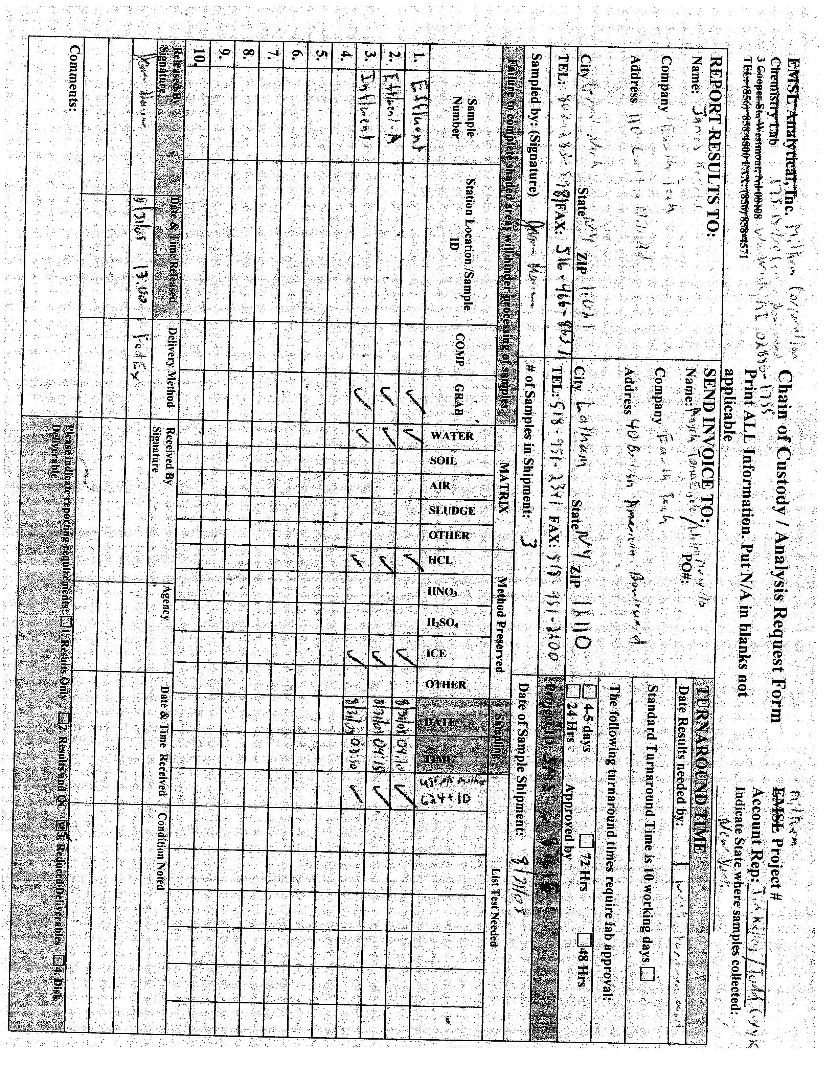
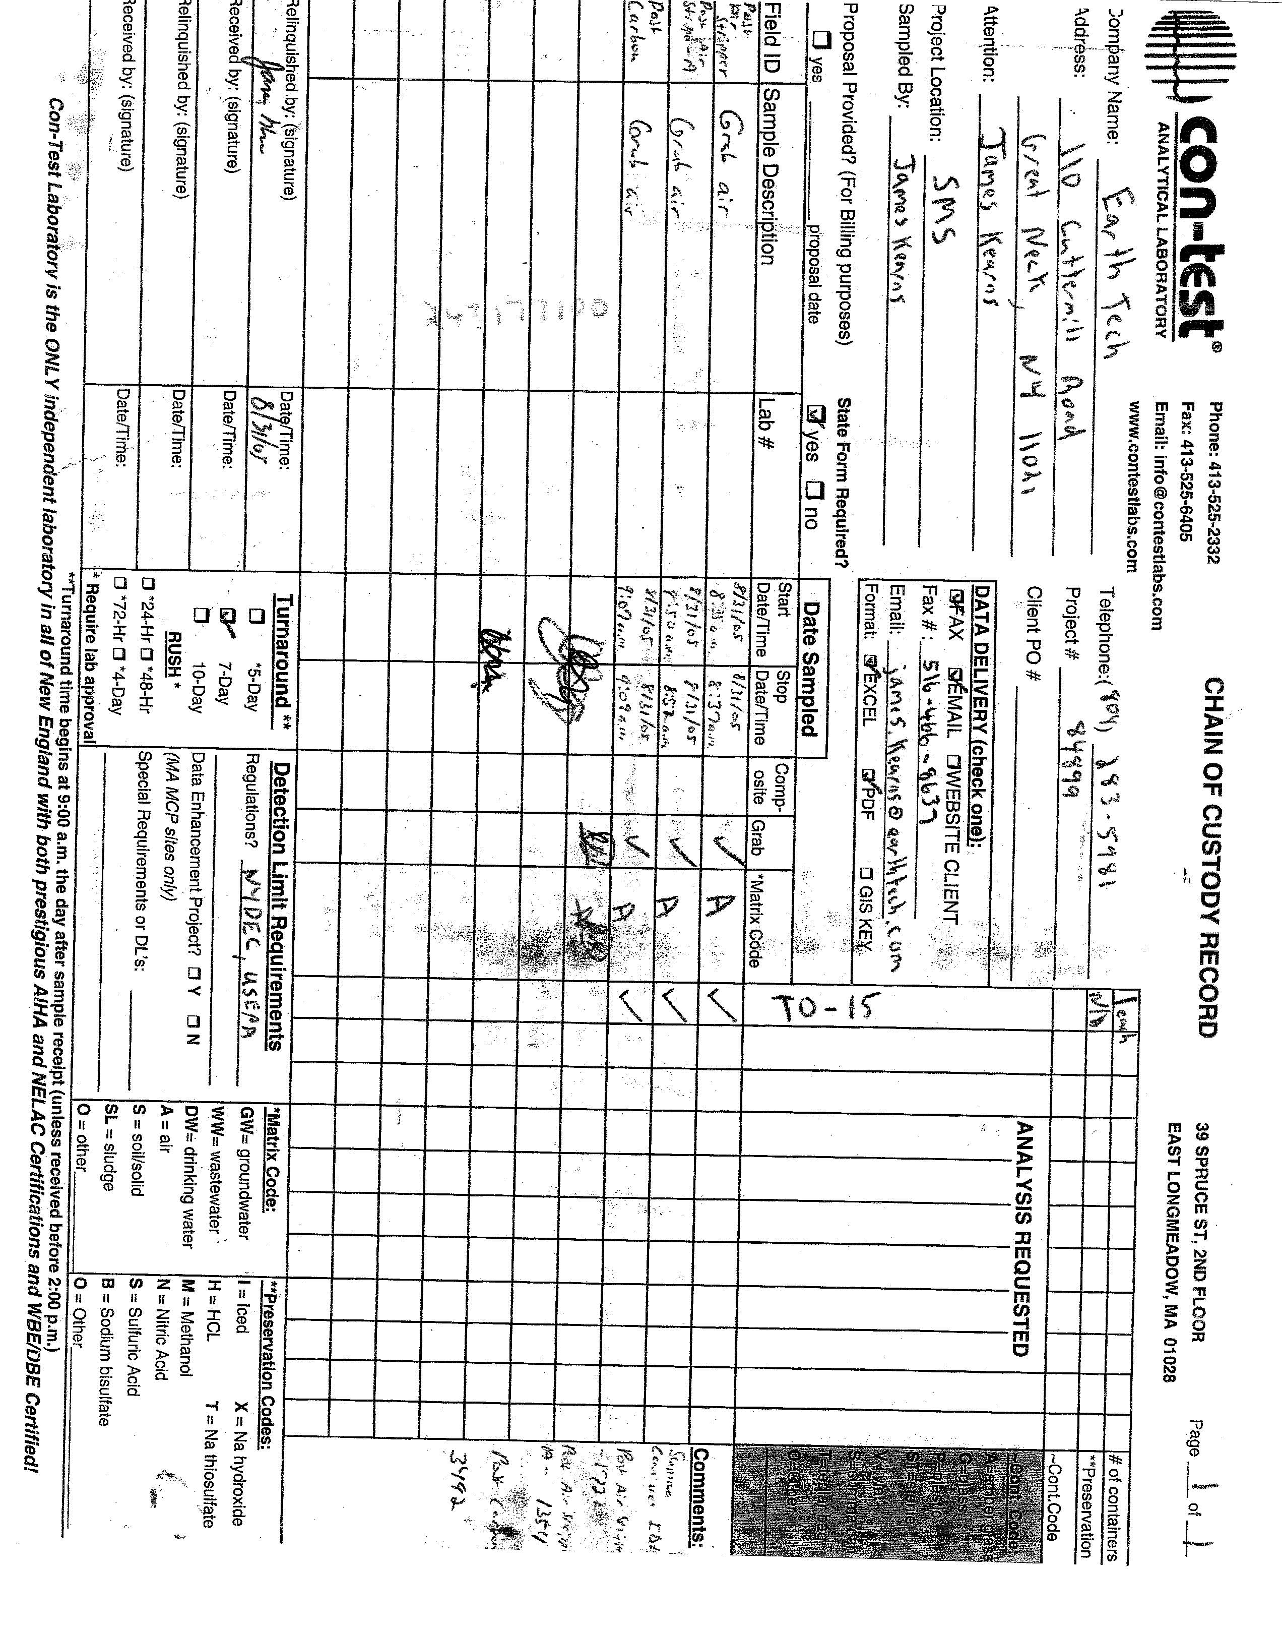

Appendix B
FedEx Air Bills
(August 31, 2005 System Sampling Event)

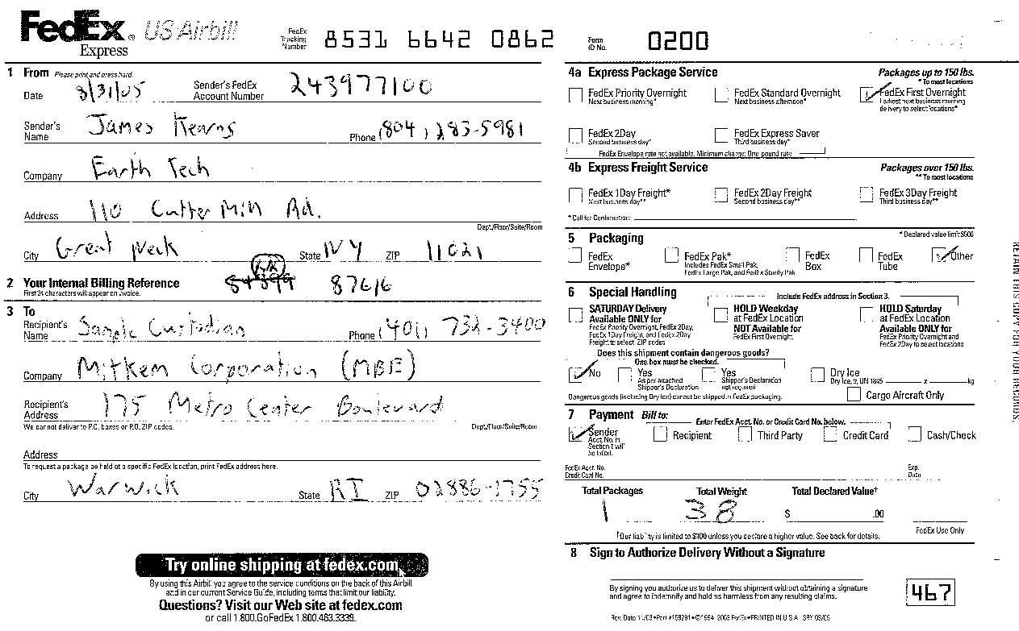

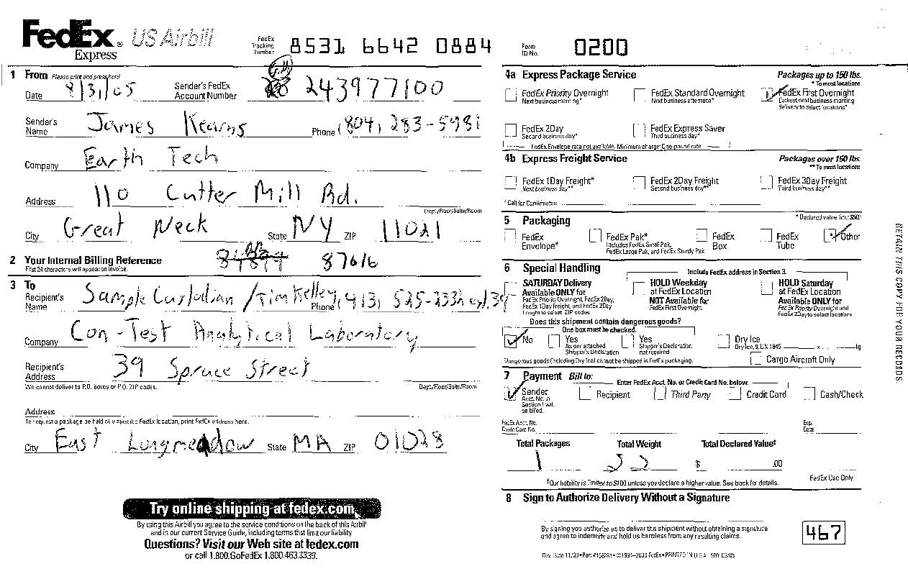

Appendix C
Summa Canister Sampling Data
(August 31, 2005 System Sampling Event)

P&T System Evaluation Sampling (Summa Canister)
SMS Instruments Site
August 31, 2005
Sample ID | Analytical Method | Location | Start Date / Time | End Date / Time | Total Time | Initial and Final Pressure | Summa Number | Valve Number
Post Air-Stripper | TO-15 | Post Air-Stripper  Pre-Carbon | 8/31/05  8:35 AM | 8/31/05  8:37 AM | 2 minutes | Initial: 27" Hg  Final: 0" Hg | 1722 | N/A
Post Air-Stripper-A | TO-15 | Duplicate of Post  Air-Stripper | 8/31/05  8:50 AM | 8/31/05  8:52 AM | 2 minutes | Initial: 25" Hg  Final: 0" Hg | 1354 | N/A
Post Carbon | TO-15 | Post Carbon | 8/31/05  9:07 AM | 8/31/05  9:09 AM | 2 minutes | Initial: 28" Hg  Final: 1" Hg | 3492 | N/A

Appendix D
Aqueous and Vapor Monitoring Data
(August 31, 2005 System Sampling Event)

GROUNDWATER TREATMENT SYSTEM AQUEOUS/VAPOR MONITORING DATA
SMS INSTRUMENTS SITE
EARTH TECH PROJECT NO. 87616
WATER DATA
 |  |  |  | pH | COND. | TURB. | DO | TEMP. | SALINITY | TDS | ORP
 | Influent |  |  | 6.23 | 0.275 | 220 | 12.80 | 15.1 | 0.0% | 0.18 | 54
 | Effluent |  |  | 5.11 | 0.366 | 120 | 10.50 | 19.3 | 0.0% | 0.23 | 190
AIR DATA
 |  |  |  | CO | VOC | Oxygen | H2S | LEL
 | Post Air Stripper-Front (Prior to GAC) |  |  | 1 | 0 | 20.9 | 0 | 0
 | Post Air Stripper-Back (Prior to GAC) |  |  | 2 | 0 | 20.9 | 0 | 0
pH- Measured in pH units. |  |  |  |  |  |  | GAC- Vapor phase granular activated carbon treatment units
COND. - Conductivity measured in milliSiemens per centimeter (mS/cm). |  |  |  |  |  |  | CO- Carbon monoxide measured in parts per million (ppm).
TURB. - Turbidity measure in nephelometric turbidity units (NTU). |  |  |  |  |  |  | VOC- Volatile organic compounds measured in parts
DO - Dissolved oxygen measured in milligrams per liter (mg/L). |  |  |  |  |  |  | per million (ppm).
TEMP. - Temperature measured in degrees Celsius. |  |  |  |  |  |  | Oxygen measured in percentage.
SALINITY - Salinity in percentage. |  |  |  |  |  |  | H2S measured in parts per million (ppm).
TDS- Total dissolved solids measured in gallons per meter (g/m). |  |  |  |  |  |  | LEL- Lower exposure limit measured in percent
ORP- Oxidation reduction potential measured in mV.
Comments: | 1) Horiba Calibration- at a pH of 3.90, a conductivity of 4.48, a turbidity of 0,
 | a dissolved oxygen content of 8.8, a temperature of 22.8, a salinity of 0.2, a TDS
 | of 2.9 and an ORP of 222.

