152108 - Liberty Industrial Finishing Site
500-550 Suffolk Avenue, Brentwood, NY

FIELD REPORT

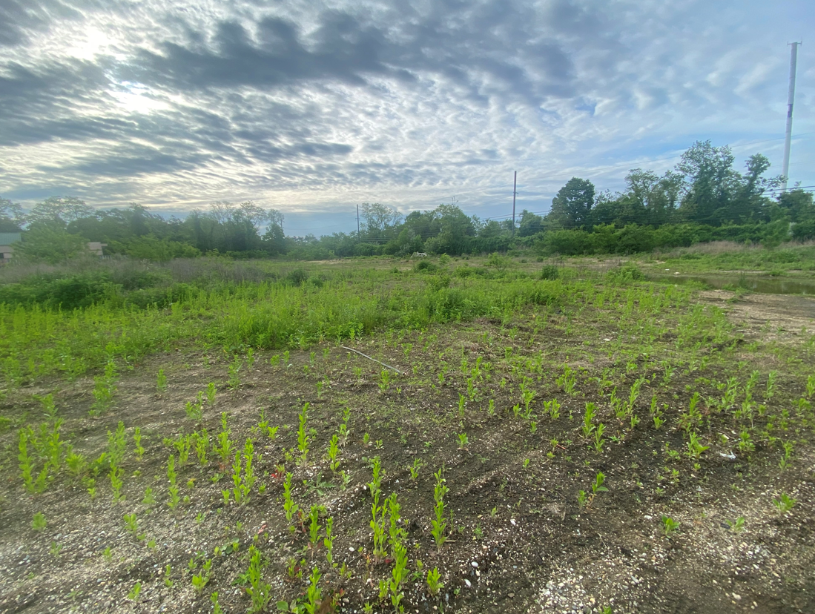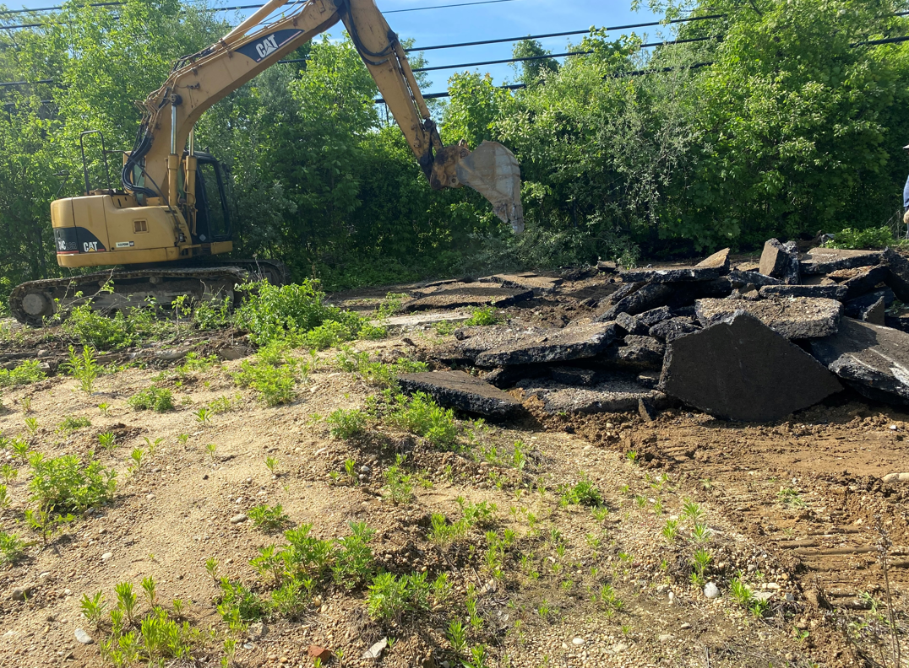
5/23/22 Excavation Location 5/23/22 Contractor is removing asphalt from the top of the excavation area. Removed asphalt had been stockpiled for upcoming removal
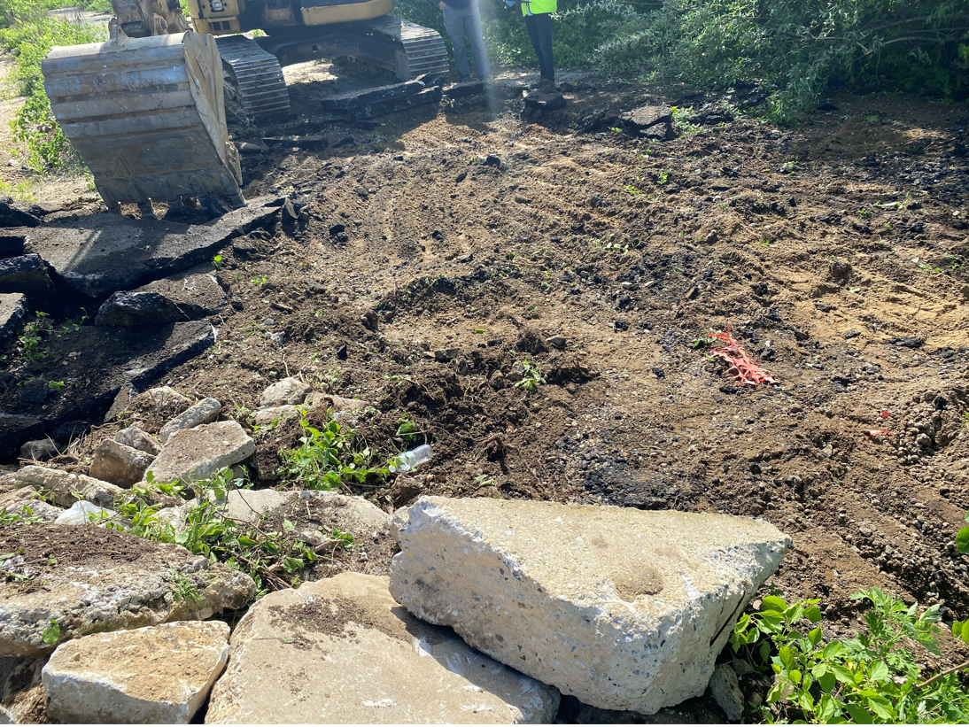
5/23/22 During removal of asphalt the crew exposed orange construction barrier indicating the contaminated soil right below.

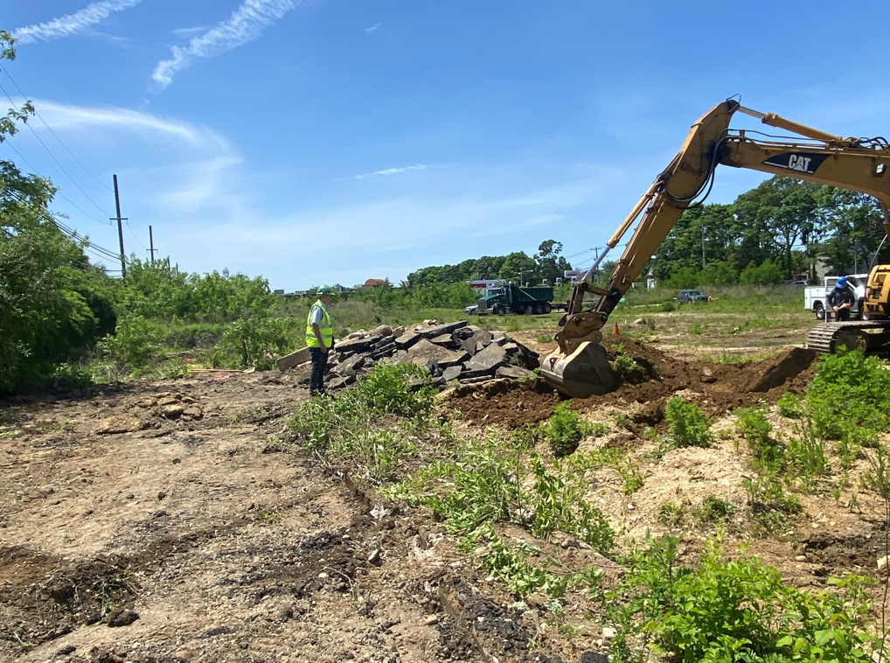
5/23/22 After completion of removing the asphalt, contractor begun excavation of the small area at SE (soil cap area). About first foot of soil had been confirmed by FPM consultant as clean, and that soil had been set aside for the future backfill. Soil below that depth had been stockpiled on the polyethylene sheet for the upcoming waste disposal. Contractor excavated about 3’ of the soil in that area. Dimension 150’ x 20’.

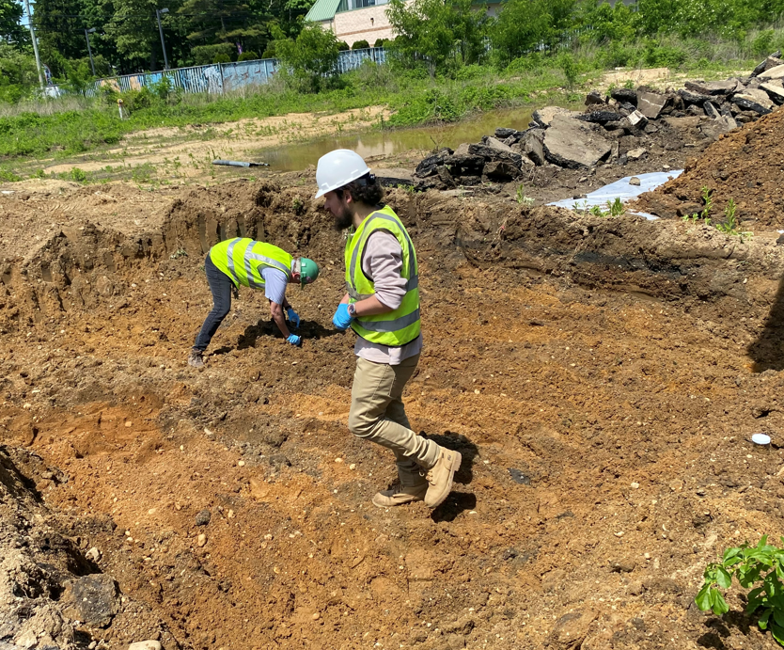
5/23/22 FPM’s consultants are collecting confirmation samples at the soil cap area.

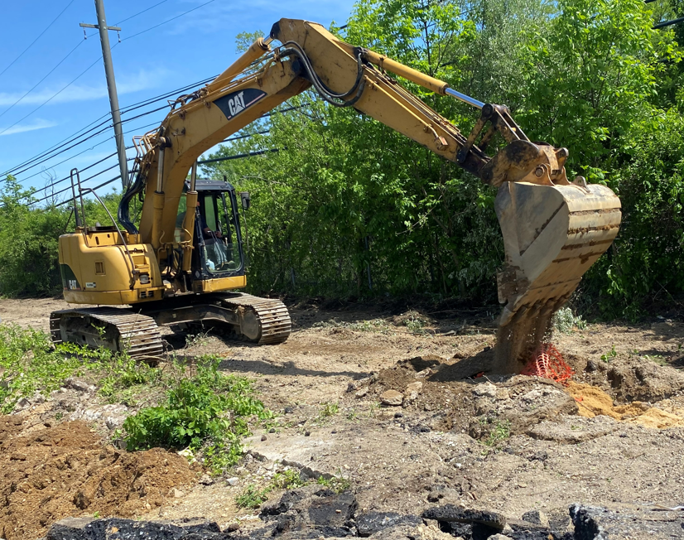
5/23/22 Contractor is excavating the area that covered with asphalt cap. Orange polyethylene barriers had been detected right beneath the asphalt therefore all soil excavated form that area will be stockpiled for upcoming waste removal.

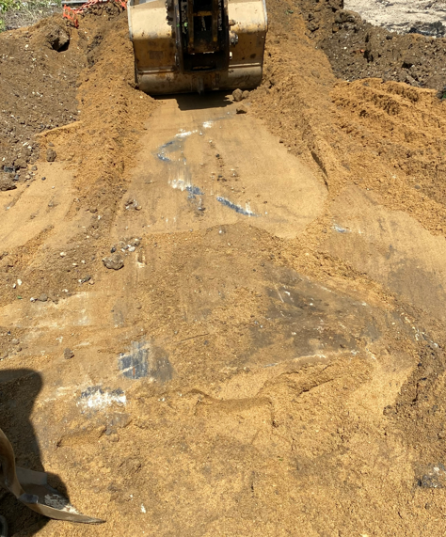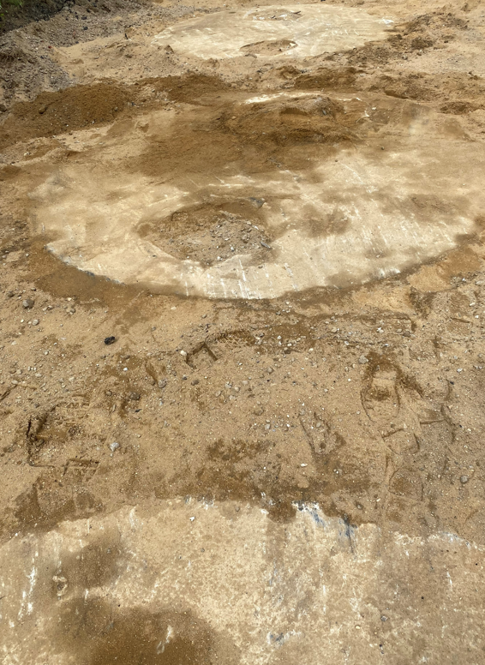
5/23/22 During the excavation of the area below the asphalt cap several concrete blocks had been detected in a depth 1’ -2’. Additionally, several tanks had been detected in about the same depth.

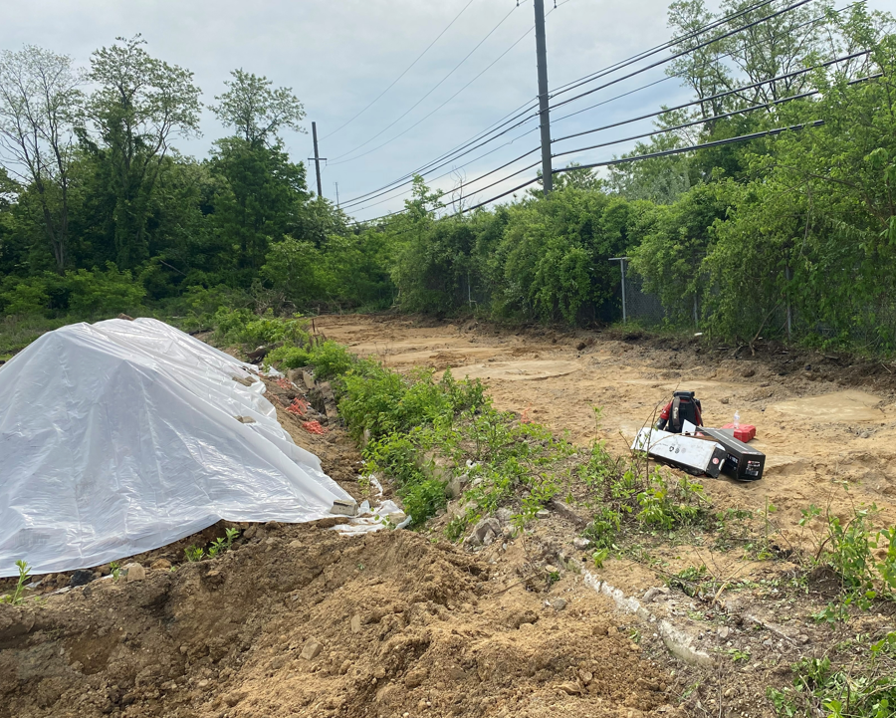

5/23/22 Before leaving the site contractor secure the stockpiled contaminated soil with polyethylene sheet.

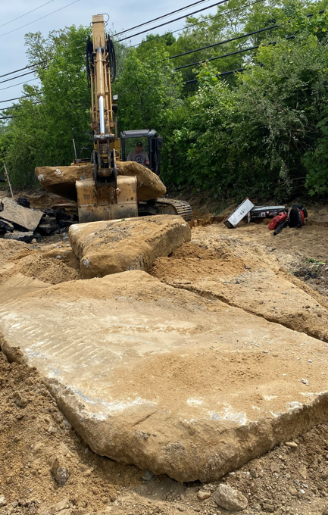
5/24/22 After confirmation with the consultants from FPM, the concrete blocks detected in the area below the asphalt cap was historically used as a backfill. Contractor removed the concrete blocks and will complete the excavation in the area. Consultants will sample the concrete blocks in order to determine if any cross contamination occurred. Tanks had not been removed.

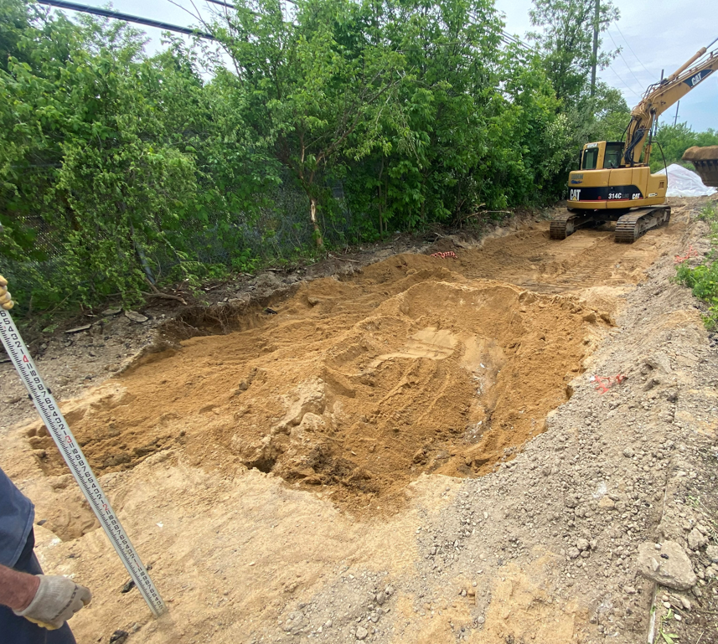
5/24/22 Contractor continue with excavation and is stockpiling excavated soil at secure area for upcoming waste disposal.

