Periodic Review Report For NYS DOH Wadsworth Center (Site No. 401031) Albany, New York
Prepared for
New York State Department of Environmental Conservation 625 Broadway Albany, New York 12233
2021 Report

Prepared by

David Hill, CIH,
Director of Safety
NYSDOH Wadsworth Center

CONTENTS
Page

LIST OF FIGURES AND TABLES…………………………………………………….. 2

1. EXECUTIVE SUMMARY ............................................................................................. 3

2. SITE OVERVIEW ........................................................................................................ 3

3. REMEDY PERFORMANCE, EFFECTIVENESS, AND PROTECTIVENESS ……....4
3.1 Institutional Controls/Engineering Controls Certification…………….........4
3.1.1 Institutional Controls, Requirements, and Compliance.................................4
3.2 Monitoring Plan Compliance Report.............................................................5
3.2.1 Groundwater Sampling..................................................................................5
4. CONCLUSIONS...............................................................................................................6
LIST OF FIGURES & TABLES
Figure # Title
1 Site location map.

1a Site and Site Boundaries
2 Site map with well monitoring locations.

3a Interpreted groundwater contour map (March 2019 sampling).

3b Interpreted groundwater contour map (August 2020 sampling).

4 Survey with Metes and Bounds
Table # Title

1 Summary of Detected VOC’s
1a Summary of PFOA and PFOS Detected
2 Summary of Ground Water Elevation and DTW Data

1. EXECUTIVE SUMMARY
This Periodic Review Report (PRR) has been prepared to document the ongoing performance, effectiveness, and protectiveness of the selected remedy at the NYS DOH Wadsworth Center site as required by 6 New York Code of Rules and Regulations Part 375. The Wadsworth Center site (New York State Department of Environmental Conservation [NYSDEC] Site No. 401031) is located in the city of Albany, at the rear of property at 120 New Scotland Avenue (Figures 1 and 1a).
The overall purpose of this report is to demonstrate that the remedy selected in the Record of Decision (ROD) issued in March 1992 is protecting groundwater and showing current contamination concentrations in ground water are not migrating, and therefore not impacting human health or the environment. Originally the groundwater monitoring program at the Wadsworth Center site consisted of collecting groundwater samples and recording groundwater elevations from three monitoring wells every fifth quarter. An additional well (12S) was installed to the West of the site on adjacent property, and another well (8S) on the adjacent property to the South. A site map showing the four active well locations is illustrated in Figure 2. The interpreted ground water map for the March 2019 and August 2020 sampling are illustrated in Figures 3a and 3b, respectively.

2. SITE OVERVIEW
After the Wadsworth Center reported past practices of ground disposal of chemical waste at 120 New Scotland Avenue, the location was listed as an inactive waste burial site. Environmental Resources Management (ERM) was the firm contracted to perform Remedial Investigation activities (performed in 1990 and 1991), develop the remedial plan, and perform required monitoring and testing. They were subsequently involved in all aspects of the program management for this inactive waste site until 2014 when Adirondack Environmental Services, Inc. was contracted to perform the 5th quarter groundwater sampling and analysis.
In 1992 the ROD was issued and the Remedial Plan developed. In August of 1993 the Order on Consent was issued. The Remedial Plan included installation of a geomembrane cap with vents and a ground water pump and treat system, and deed restrictions to eliminate disturbance of the cap area. The area covered by the cap would include a section of property owned by the Christian Brothers Academy (CBA). That piece of property was eventually purchased by DOH to maintain institutional control over the cap area.
The pump and treat system operated under the Operations and Maintenance Plan for roughly 7 years. Water analysis reports indicated that the system was not effectively removing contaminants as intended, so a request was made to DEC to allow DOH to remove the system. Approval for removal was granted in 2000, completed in 2001, and the decommissioning report approved in Spring 2002.
Secondary to the pump and treat system was fencing and access control. While the pump and treat system was operational, the plan was followed as required and fencing and access controls were maintained. When the pump and treat system was removed, the fencing and access controls were also eventually removed. As part of the pump and treat system removal plan, the original Order on Consent was modified to include a provision for monitoring ground water, whereby certain shallow wells would be sampled every fifth quarter to evaluate water levels and determine if contaminants were migrating from the original site. Three wells were monitored according to plan. Those Groundwater Reports are on file for Dec. ‘03, March ‘05, September ‘06, Dec. ‘07, March ‘09, June 2010, and September 2011. As mentioned above, a fourth well was added to the matrix, and the original well (8S) that was paved over has since been replaced and sampled as required. All four wells are currently able to be monitored.
Vapor intrusion was evaluated in 2009, through a combination of soil vapor point tests (Geoprobe), internal building air samples, and analysis of building construction, ventilation, and space uses. Sample results showed no abnormal levels that may be attributable to the inactive burial site, and the subsequent NFA memo from DEC was issued.
3. REMEDY PERFORMANCE, EFFECTIVENESS, AND PROTECTIVENESS
3.1 INSTITUTIONAL CONTROLS/ENGINEERING CONTROLS CERTIFICATION
Engineering Controls (EC) were approved for removal and are no longer applicable to the site, with the exception of the cover system, which is still in place.
Institutional Controls (IC) could not originally be certified as land use restrictions could not be verified as being listed on deed documents. In 2012 the Wadsworth Center had a survey completed to reduce the area of the site to be considered as the “controlled area” (indicated in Figure 2), where land use and deed restrictions would apply. Due to additional information that was discovered, the survey was revised in April of 2013, with deed restrictions, and subsequently filed with the Albany County Clerk’s Office.
3.1.1 Institutional Controls/Engineering Controls - Requirements and Compliance
The ICs/ECs applied at the site are in place as documented on the survey included as Figure 4. Land use restriction on deed documents have been recorded, along with the Declaration of Covenants and Restrictions document.
An area of chain link fence has been erected as a security barrier over a portion of the cap area, but the depth of footings was kept shallow so as not to impact the function/integrity of the site cap.

In 2015, excavation and soil sampling activities were completed for a 45 foot by 45 foot temporary repair work area associated with a portion of the David Axelrod Institute (DAI) parking lot above the cap area. Environmental oversight and sampling was conducted in accordance with the Site Management Plan.

In 2016, the entire DAI parking lot, with the exception of a small portion located beneath the All Hazards Receipt Facility (AHRF), was replaced. However, the construction project only involved milling of the old pavement, no soil removal, so environmental oversight and soil sampling was not required for this project.

Between 2017 and 2018, there were no activities conducted that could have impacted the cap area.

In 2019, the asphalt surrounding one stormwater drain (approximately 6’ x 6’) located on the edge of the controlled area needed emergency repairs due to deterioration and potential for collapse. However, the repair work only involved removal of the deteriorated asphalt and no soil was remove, so soils sampling was not required for this activity. A 6’ x 6’ concrete apron was poured around the stormwater drain.

The condition of the four monitoring wells is generally good, but the casing cap is missing from well MW-8SR. A second well (located under a metal plate) that is no longer in service was identified as needing repair or proper decommissioning during a 2019 site visit by representatives from DEC and DOH. Aztech Environmental (LaBella Associates) was contracted to repair both wells and the work was completed on March 19, 2021. The scope of work included the inspection, removal, and replacement of both road boxes with new, bolt-down, flush mounted steel traffic rated covers, with new concrete pads.

3.2 MONITORING PLAN COMPLIANCE
The Wadsworth Center has submitted a Site Management Plan to DEC. PRR submissions are now required every three years.

As set forth in the modified Order on Consent, fifth quarter well monitoring has, for the most part, proceeded according to schedule. It was previously noted in the 2016 PPR that groundwater testing was not completed during the fifth quarter cycle as required. As a result, the subsequent groundwater testing was conducted during the fourth quarter (i.e., Oct – Dec 2017) to ensure that we remained in compliance with the fifth quarter requirement/cycle. Since then, fifth quarter well monitoring as proceeded as required.

Also note, since well 8S to the South of the site is not on state-owned property, the Wadsworth Center periodically renews an access agreement with the property owner to permit access for continued monitoring and repairs as needed. Monitoring well locations are detailed in Figure 2.

3.2.1 Groundwater Sampling
Groundwater samples have routinely been collected by qualified firms and analyzed by a NYSDOH approved environmental testing laboratory. Historically, samples were only analyzed for VOCs by USEPA Method 8260B, in accordance with the NYSDEC Analytical Services Protocol. However, since March 2017 all samples have been analyzed for volatile organics by EPA Method 8260C, 1,4-Dioxane using EPA Method 8270D SIM and PFOA/PFOS using EPA Method 537 specified in the report. The additional requirement to include perfluoronated compounds (PFCs) and 1,4-Dioxane in our groundwater sampling efforts was added in March 2017 and all subsequent groundwater monitoring analyses have included both 1,4-Dioxane and PFOA/PFOS. All laboratory results are reviewed by the Adirondack Environmental Services, Inc., Quality Assurance Manager.

March 2019 Sampling:

During the previous March 2019 sampling event the compound 1,4-Dioxane was detected in each well, with well MW-8SR having, by far, the highest concentration detected at 2000 ug/L. PFOA/PFOS compounds were also detected in each of the wells (See Table 1a). The only other compound detected was Methyl-tert-butyl ether in MW-8SR at a level of 4.8 ug/L. No other Volatile Organics were detected above the laboratory reporting limits in the ground water samples collected from shallow monitoring wells. These previously reported sampling results are now compared (See Tables 1 and 1a) to the new NYSDEC Drinking Water Standards for public water systems adopted by New York State on August 26, 2020, which set maximum contaminant levels (MCLs) of 10 parts per trillion (10 ppt) each for perfluorooctanoic acid (PFOA) and perfluorooctanesulfonic acid (PFOS), and 1 part per billion (1ppb) for 1,4 dioxane. Note that a groundwater contour map (Figure 3a) was compiled using the March 2019 water level data for the four sampled shallow monitoring wells. At that time, the groundwater contour map indicated that the flow direction of shallow ground water on March 27, 2019 was generally toward the south-southeast.

The laboratory analytical data from the 2019 sampling event indicate that the concentrations of Per- and Polyfluoroalkyl Substances (PFAS) and 1,4-Dioxane detected in groundwater samples collected often exceeded the new MCLs for public water systems.

August 2020 Sampling:

During the most recent August 2020 sampling event the compound 1,4-Dioxane was detected in each well, with well MW-8SR being the highest at 190 ug/L. This value is significantly lower than the concentrations detected during the 2017 and 2019 sampling events (See Table 1). PFOA/PFOS compounds continued to be detected in each of the wells as well (See Table 1a). The only other compound detected was Methyl-tert-butyl ether in MW-8SR at a level of 3.1 ug/L. No other Volatile Organics were detected above the laboratory reporting limits in the ground water samples collected from shallow monitoring wells. These results are compared to the new NYSDEC Drinking Water Standards for public water systems adopted by New York State on August 26, 2020, which set maximum contaminant levels (MCLs) of 10 parts per trillion (10ppt) each for perfluorooctanoic acid (PFOA) and perfluorooctanesulfonic acid (PFOS), and 1 part per billion (1ppb) for 1,4 dioxane (See Tables 1 and 1a). Note that a ground water contour map (Figure 3b) was compiled using the water level data for the four sampled shallow monitoring wells. Consistent with previous contour maps, the 2020 groundwater contour map indicates that the flow direction of shallow ground water on August 14, 2020 was generally toward the south-southeast.

The laboratory analytical data from the 2020 sampling event indicate that the concentration of Per- and Polyfluoroalkyl Substances (PFAS) and/or 1,4-Dioxane detected in groundwater samples collected often exceeded the new MCLs for public water systems at all sampled wells.

All available historical data of detectable VOC’s from groundwater sampling reports are summarized in Table 1. Groundwater elevations and depth to water measurements for all sampling events are summarized in Table 2.

4. CONCLUSIONS
The groundwater sampling results from 2019 and 2020 show that the concentrations of methyl tert-butyl ether (MTBE) at MW-8S have decreased since the groundwater sampling in 2017, and therefore continue to remain below the NYSDEC Ambient Waste Quality Standard of 10 ug/L. MTBE was not identified at any other well. Given that the MTBE concentration at MW-8S has consistently decreased from December 2017 and still has not been detected in any of the other wells, this could suggest that the source of MTBE may be from vehicle fuel infiltration from the parking lot near the location of the well. Additionally, no other Volatile Organics were detected above the laboratory reporting limits in the ground water samples collected from shallow monitoring wells in both years, suggesting current contamination concentrations in groundwater are not migrating, and therefore not impacting human health or the environment.
Since the requirement to include perfluoronated compounds (PFCs) and 1,4-Dioxane in our groundwater sampling and analysis efforts was added in March 2017, elevated concentrations of 1,4-Dioxane above the new MCL for public water systems have consistently been detected in groundwater monitoring wells including in our periodic monitoring program. In particular, 1,4-Dioxane has been detected in monitoring well MW-8SR ranging from 190-2,000 ppb. The steady increase on 1,4 Dioxane concentrations detected in 2017 and 2019, follow-up by a significant drop-off in concentration in 2020 may suggest that there has been some migration of 1,4 Dioxane contaminants occurring at MW8S in a south-southeast direction, while the concentrations at the other three wells appear to remain stable. Concentrations of PFOA/PFOS compounds exceeding the new MCL for public water systems have also been detected at each of the monitoring wells with the highest concentration detected at 0.167ug/L for PFBA. Continued groundwater sampling is needed to monitor for any additional fluctuation in contaminant concentrations.
As stated in Section 3.1.1, the Wadsworth Center needed to repair the asphalt surrounding one stormwater drain (approximately 6’ x 6’) located on the edge of the controlled area due to deterioration and potential for collapse. However, the repair work only involved removal of the deteriorated asphalt and no soil was remove, so soils sampling was not required for this activity. A 6’ x 6’ concrete apron was poured around the stormwater drain. Additionally, two wells are scheduled for repair and the target completion date for the work is end of February 2021.

As noted in the 2016 PRR, the Wadsworth Center initiated and completed a construction project that involve replacement of the entire DAI parking lot asphalt, with the exception of a small section located beneath the existing All Hazards Receipt Facility (AHRF) located at the back of the site. The condition and integrity of that remaining section is evaluated each year for cracks and penetration by weeds or seedlings during the annual the site inspection and sealed using asphalt sealant as appropriate.

Based on our 2020 annual review of the site management plan and evaluation of the March 2019 and August 2020 groundwater sampling results, the current controls continue to be protective of public health and the environment and in compliance with requirements. However, given the potential migration of 1,4 Dioxane contaminants in a south-southeast direction, implementation of the NYSDEC Emergent Contaminant Sampling Initiative for this site may be prudent to determine whether there are any private/public water supply wells located in the vicinity of the site.

Figure 1 SITE LOCATION MAP

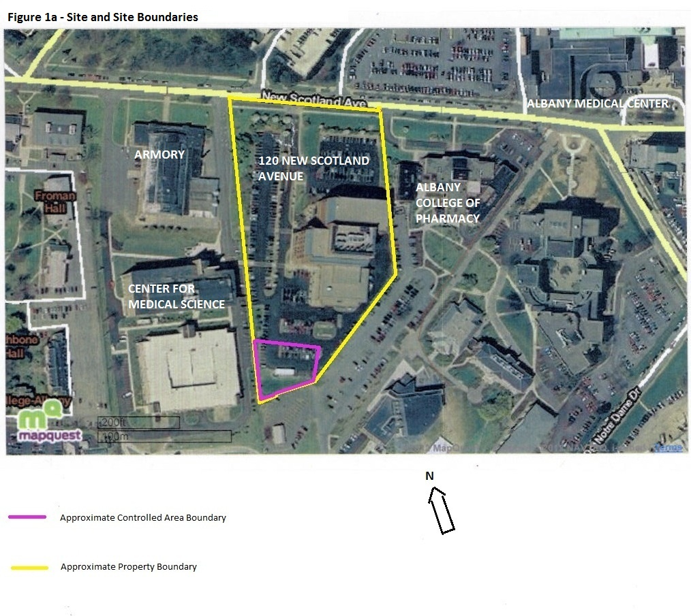

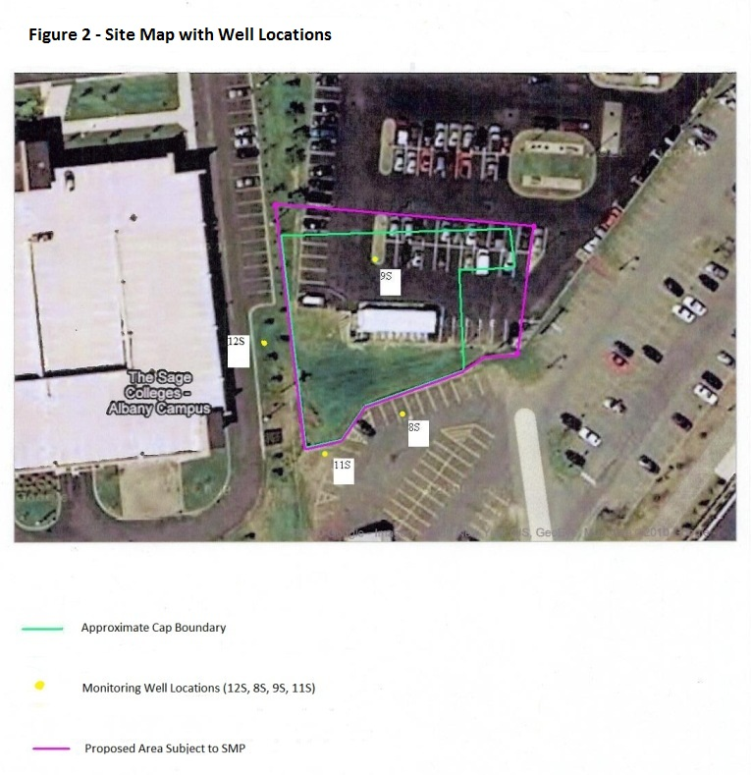

Figure 3a - Groundwater Contour Map (2019)

Figure 3b - Groundwater Contour Map (2020)

Figure 4 – Survey With Deed Restrictions
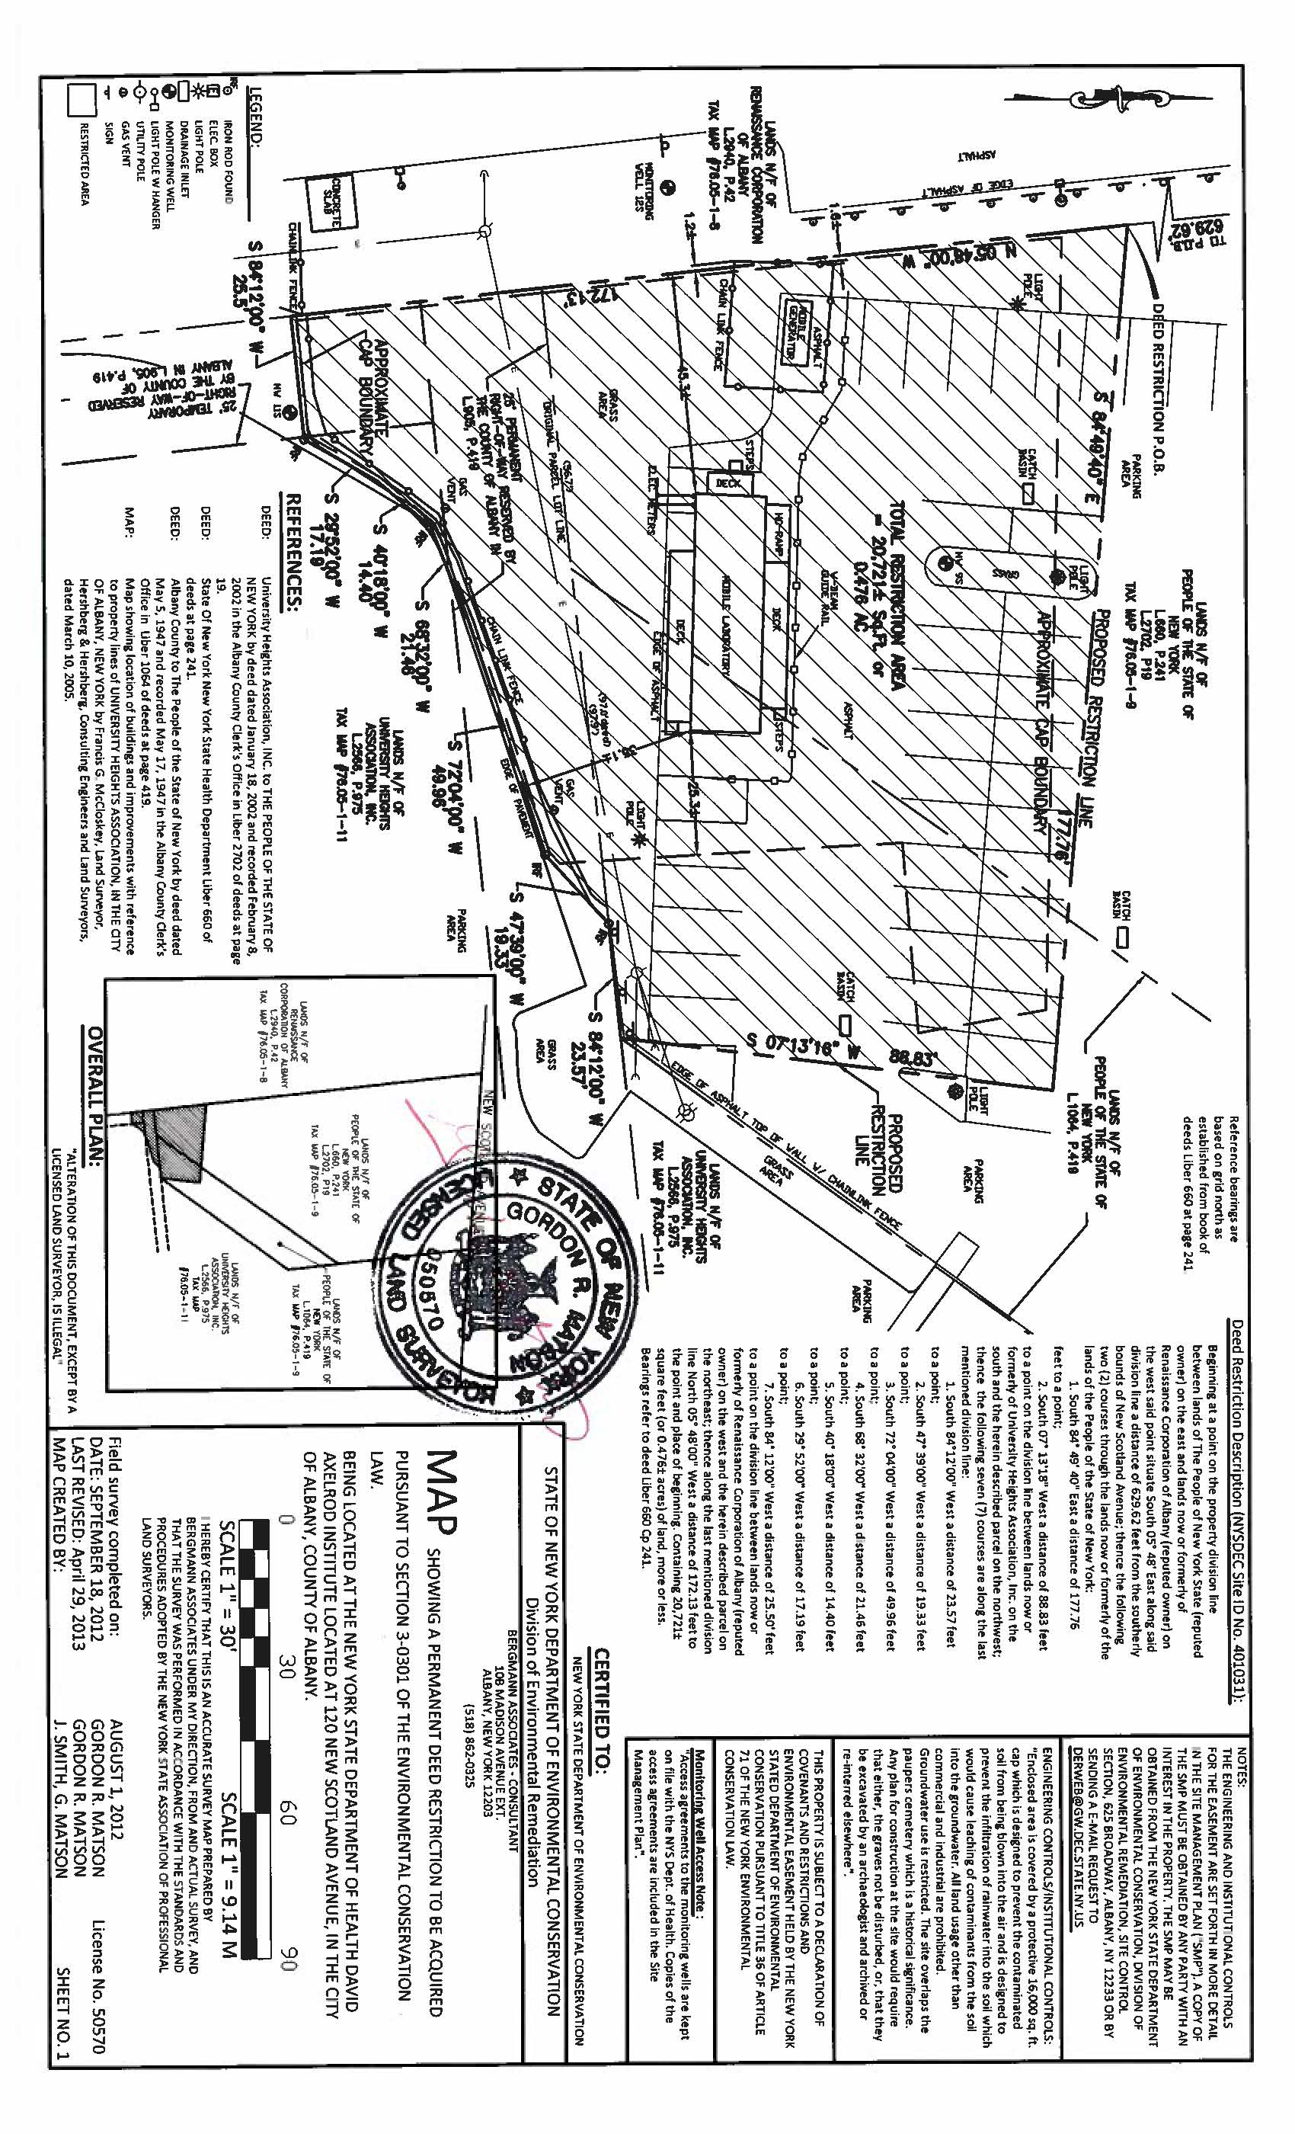

Table 1 – Summary of Volatile Organics Detected (2020)

Table 1a – Summary of PFOA/PFOS Organics Detected (2019 - 2020)

Table 2 – Summary of Groundwater Elevation Data (2020)

