**U.S. ENVIRONMENTAL PROTECTION AGENCY, REGION II**

Emergency and Remedial Response Division

Program Support Branch/Technical Support Section

290 Broadway, 18th Floor

New York, New York 10007-1866

Alvey.robert@epa.gov

212 -637-3666

**MEMORANDUM**

**TO: Damian Duda, RPM**

**FROM: Robert M. Alvey, P.G.**

**DATE:**  April 25, 2017

**SUBJECT:**  Site Reconnaissance Meeting

Vestal Water Well 1-1 Superfund Site

Vestal, NY

This memo documents the site meeting at the Industrial Park April 19 in Vestal, NY. The meeting was to view the facility and meet with the current building manager, NYSDEC representatives and USACE to discuss access of the site for sampling to be used for the Remedial Design.

Attendees included:

Damian Duda, EPA RPM

Rob Alvey, EPA Geologist

Payson Long, NYSDEC Project Manager

Jeremy Wycoff, NYSDEC Contractor Representative (Arcadis)

Travis Davis, USACE

Erin Hauber, USACE

Based on review of the site sampling data, including indoor vapor intrusion sampling conducted in January, additional soil samples may be prudent from beneath the building. It is currently used for auto restoration and repair. Nearly 100 vehicles were in various stages of repair. The manager also provided a brief tour of recently refurbished office facilities and a narrow section of the building that previously contained offices. Flooding of the nearby Susquehanna River had caused damage to the interior. The manager provided his contact information and expressed interest in collaborating to provide access for sampling. He was aware of the overall Remedial Action planned for excavation and thermal treatment.

On the northern side of the facility, the existing monitoring wells were observed and the valve houses and treatment plant for the existing, inactive SVE system. The maintenance contract for this facility expires in September. Based on discussions with USACE, an initial agreement was made that continued maintenance may not be necessary. Experience has shown that a thermal contractor usually prefers bringing in their own equipment, perhaps skid or truck mounted, for 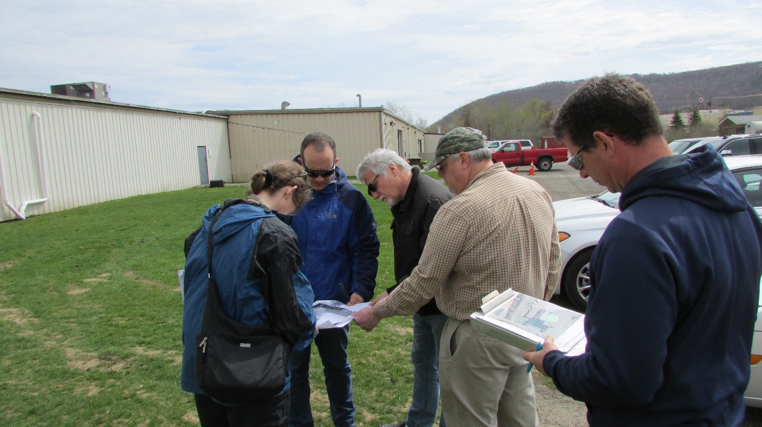vapor treatment for reliability concerns.

Site Recon meeting: Vestal Industrial Park. EPA, NYSDEC and USACE. April 19, 2017

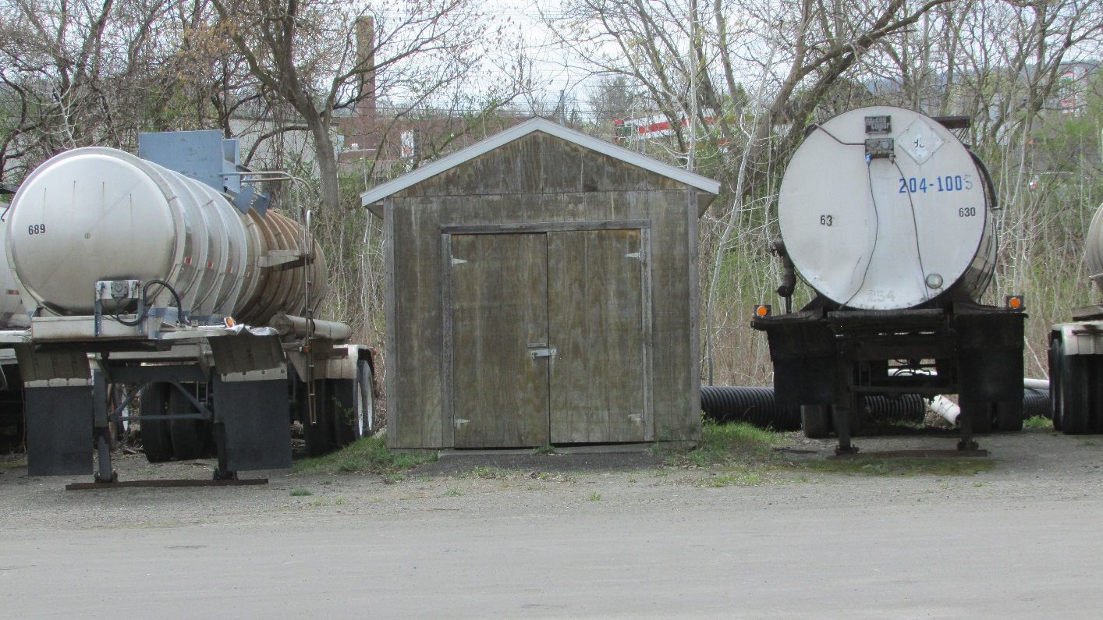View of 1 of 2 valve shelters for former SVE system. Vestal Industrial Park

Discussions with Payson Long, NYSDEC Project Manager for the groundwater OU, determined that they would collaborate providing their site “EDD” as to monitoring well locations and sampling results to EPA. NYSDEC continues to collect groundwater well monitoring samples. Cathy Lai with the EPA Region 2 EDD data management will be contacted to convert the data files into the current EPA version for uploading.

Adjacent to the west side of the Industrial Park is an undeveloped parcel containing cattails and vegetation. The surface elevation is roughly 4 feet below the industrial park property. Confirmation may be needed, but the property is believed to function as designated surface water drainage area. The USACE will review sampling data to determine the extent to which the thermal treatment on that side of the building will be planned. The actual property owner will need to be identified.

Payson and Jeremy also provided a brief tour for USACE and EPA of the inactive Vestal 1-1 public water well and treatment facility, the NYSDEC flood easement property, a view of the current wellfield and the local fire training facilities. The discharge from the well was disconnected from the Susquehanna River and redirected to the inland storm water diversion area. The USGS staging station was further elevated after the recent flooding, and is operational.