  NYSDEC  Division of Environmental Remediation |  |  |  |  |  |  |  |  |  |  |  |  |  |  |  |  | NYSDEC Contract No. D011107  Superintendent:  NYSDEC PM:  Consultant PM:  Consultant Site Inspectors:
Site Location: East Aurora, New York
Weather Conditions
General Description | Rain Showers |  |  |  |  |  |  | AM |  |  |  |  |  |  | PM
Temperature | 50-60’s |  |  |  |  |  |  | AM |  |  |  |  |  |  | PM
Wind | South 15 MPH |  |  |  |  |  |  | AM |  |  |  |  |  |  | PM

Health & Safety
If any box below is checked “Yes”, provide explanation under “Health & Safety Comments”.
Were there any changes to the Health & Safety Plan? |  |  |  |  |  |  |  |  |  |  |  |  |  |  |  |  |  | *Yes x |  | No |  |  |  | NA
Were there any exceedances of the perimeter air monitoring reported on this date? |  |  |  |  |  |  |  |  |  |  |  |  |  |  |  |  |  | *Yes |  | No x |  |  |  | NA
Were there any nuisance issues reported/observed on this date? |  |  |  |  |  |  |  |  |  |  |  |  |  |  |  |  |  | *Yes |  | No x |  |  |  | NA
Health & Safety Comments
Inclusion of COVID-19 GES and DEC documents and safe work plans.

Summary of Work Performed |  |  |  |  |  | Arrived at site: |  |  |  |  |  |  |  |  |  | Departed Site:
Weekly O&M.

Equipment/Material Tracking
If any box below is checked “Yes”, provide explanation under “Material Tracking Comments”.
Were there any vehicles which did not display proper D.O.T numbers and placards? |  |  |  |  |  |  |  |  |  |  |  |  |  |  |  |  |  | *Yes |  | No x |  |  |  | NA
Were there any vehicles which were not tarped? |  |  |  |  |  |  |  |  |  |  |  |  |  |  |  |  |  | * Yes |  | No |  |  |  | NA x
Were there any vehicles which were not decontaminated prior to exiting the work site? |  |  |  |  |  |  |  |  |  |  |  |  |  |  |  |  |  | * Yes |  | No |  |  |  | NA x
Personnel and Equipment
Individual |  |  | Company |  |  |  |  |  |  |  |  |  | Trade |  |  |  |  |  |  |  | Total Hours
Brandon Mikolin |  |  | GES |  |  |  |  |  |  |  |  |  | Geologist |  |  |  |  |  |  |  | 6
Equipment Description |  |  |  | Contractor/Vendor |  |  |  |  |  |  |  |  |  |  |  |  |  |  | Quantity |  | Used
Material Description |  | Imported/Delivered to Site |  |  | Exported off Site |  |  |  |  | Waste Profile  (If Applicable) |  |  |  | Source or Disposal Facility (If Applicable) |  |  |  |  |  |  |  |  | Daily Loads |  | Daily Weight (tons)*
NA
*On-Site scale for off-site shipment, delivery ticket for material received
Equipment/Material Tracking Comments:
N/A

Visitors to Site

Name |  |  |  |  |  |  | Representing |  |  |  |  |  |  |  |  |  |  | Entered Exclusion/CRZ Zone
None |  |  |  |  |  |  |  |  |  |  |  |  |  |  |  |  |  | Yes |  |  |  |  | No
 |  |  |  |  |  |  |  |  |  |  |  |  |  |  |  |  |  | Yes |  |  |  |  | No
 |  |  |  |  |  |  |  |  |  |  |  |  |  |  |  |  |  | Yes |  |  |  |  | No
 |  |  |  |  |  |  |  |  |  |  |  |  |  |  |  |  |  | Yes |  |  |  |  | No
 |  |  |  |  |  |  |  |  |  |  |  |  |  |  |  |  |  | Yes |  |  |  |  | No
 |  |  |  |  |  |  |  |  |  |  |  |  |  |  |  |  |  | Yes |  |  |  |  | No
 |  |  |  |  |  |  |  |  |  |  |  |  |  |  |  |  |  | Yes |  |  |  |  | No
 |  |  |  |  |  |  |  |  |  |  |  |  |  |  |  |  |  | Yes |  |  |  |  | No
 |  |  |  |  |  |  |  |  |  |  |  |  |  |  |  |  |  | Yes |  |  |  |  | No
Site Representatives
Name |  |  |  |  |  |  |  |  |  |  | Representing
Brandon Mikolin |  |  |  |  |  |  |  |  |  |  | GES
Project Schedule Comments
Weekly O&M on track. Rinse and dispose of 2 empty redux drums.

Issues Pending
Waste Disposal needed for 2 sludge drums. In work soliciting the bids.

Interaction with Public, Property Owners, Media, etc.
None. No visitors to the site.

Include (insert) figures with markups showing location of work and job progress

Site Photographs (Descriptions Below)
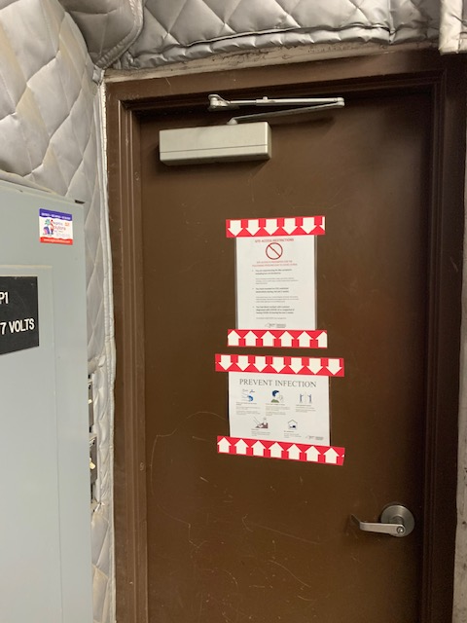

New DEC COVID-19 Required Posters have been posted at the site. Site access is controlled and requires a key.

Comments
Site Inspector(s): |  | Date:

DAILY HEALTH CHECKLIST

Is social distancing being practiced? | Yes ☒ | No ☐
Is the tail gate safety meeting held outdoors? | Yes ☒ | No ☐
Are remote/call in job meetings being held in lieu of meeting in person where possible? | Yes ☒ | No ☐
Were personal protective gloves, masks, and eye protection being used? | Yes ☒ | No ☐
Are sanitizing wipes, wash stations or spray available? | Yes ☒ | No ☐
Have any workers/visitors been excluded based on close contact with individuals diagnosed with COVID-19, have recently traveled to restricted areas or countries, or are symptomatic (fever, chills, cough/shortness of breath)? | Yes ☐ | No ☒
Comments:

REMEDIAL ACTIVITIES AT PROPERTIES

- Have anyone at this location been tested and confirmed to have COVID-19? | Yes ☐ | No ☒
- Is anyone at this location isolated or quarantined for COVID-19? | Yes ☐ | No ☒
- Has anyone at this locaton had contact with anyone known to have COVID-19 in the past 14 days? | Yes ☐ | No ☒
- Does anyone at this locaton have any symptoms of a respiratory infection (e.g., cough, sore throat, fever, or shortness of breath)? | Yes ☐ | No ☒
- Does the Department and its contractors have your permission to enter the property at this time? | Yes ☒ | No ☐
If Yes to any of 1-4 above: N/A  - If it is not critical that service/entry be carried out immediately and can be postponed until the risk of COVID-19 is lower, or can be accomplished remotely/without entry, postpone or conduct service without entry.  - If it is critical that service/entry be carried out immediately, advise occupants that as a precaution and for our own protection, project personnel will be donning appropriate PPE* (including respiratory protection) - and do so prior to entry. | Yes ☐ | No ☐
Comments:
I am a lone worker on a weekly O&M site. No interaction with anyone else on the site all day.

NUISANCE CHECKLIST

Were there any community complaints related to work on this date? | Yes ☐ | No ☒ | N/A☐
Were there any odors detected on this date? | Yes ☐ | No ☒ | N/A☐
Was noise outside specification and/or above background on this date? | Yes ☐ | No ☒ | N/A☐
Were vibration readings outside specification and/or above background on this date? | Yes ☐ | No ☒ | N/A☐
Any visible dust observed beyond the work perimeter on this date? | Yes ☐ | No ☒ | N/A☐
Any visible contrast (turbidity) beyond engineering controls observed on this date? | Yes ☐ | No ☒ | N/A☐
Was turbidity checked at the Montauk Highway outfall? | AM ☐ | PM ☐ | N/A☒
Were any property owners NOT provided advance notice for work performed on this property on this date? | Yes ☐ | No ☒ | N/A☐
Was the temporary fabric structure closed at the end of the day? | Yes ☐ | No ☐ | N/A☒
Has Contractor failed to protect all foundations and structures adjacent to and adjoining the site which are affected by the excavations or other operations connected with performance of the Work? | Yes ☐ | No ☐ | N/A☒
If yes, has Contractor been notified? | Yes ☐ | No ☐ | N/A☒
Comments:
No issues noted.

