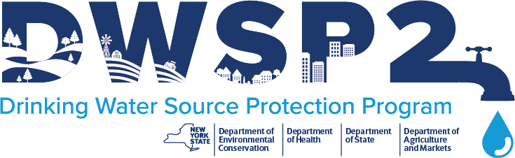
Source Water Summary - surface

To kick off a municipality’s DWSP2 plan, the technical assistance provider and municipality must complete the applicable Source Water Summary worksheet(s). The Source Water Summary worksheet(s) to be completed are dependent on your type(s) of source water (groundwater or surface water).
This worksheet gathers necessary data to begin the plan and is to be filled out by a technical assistance provider, with assistance from stakeholders. Most of this information can be pulled from publicly available data, the data that the drinking water system operator collects, the Annual Water Quality Report (AWQR), NYSDEC reports, or the local health department. Resources are also available in the Drinking Water Source Protection Program Framework. The Source Water Summary will include basic information about the source, water quality and quantity. Information from this worksheet can be used to select appropriate methods to determine drinking water source protection areas and help focus protection measures.
This worksheet will be finalized with a technical assistance provider, and will help guide your plan and be a part of the final report.

Public Water System Identification
Water system name: | X Water District
NYS Public Water System ID: | NYXXXXXXX
Type of water system (e.g. community, non-community, transient, non-transient): | Community
Description
Name of the community, or communities, that are served by the system: | Town of X
Name of the community, or communities, that purchase water from the system: | Village of X
Name of the community, or communities, that have emergency interconnections to the system: | N/A
Name of the company or organization that operates the system (if not the Owner): | N/A
Population served by the system: | X,XXX
Number of service connections: | XXX
Summary of intakes, depth(s), screen length and pumping rates: | Summary of intakes, depth of XX feet, XX feet offshore, pumping rate of XXX (units), XXX of miles from wastewater treatment plant (WTP), etc.

Description Continued
Description of the type(s) of treatment that the water receives before entering the distribution system: | Raw water entering the plant is treated with the following X processes and descriptions of processes, treated water is pumped to X.
Characteristics of the waterbody and surrounding watershed: | Waterbody is X acres and X feet deep at the deepest point, average depth is X, X river discharges into the source, reservoir capacity of X gallons, waterbody is used for X purpose(s) (such as recreation), waterbody is located in X municipality(s), geographical setting.
Water Quality Summary¹
Water quality summary of any ambient water quality information (Trophic status, lake classification, watershed to lake ratio, occurrence of HABs, parameters of excursions of the Water Quality Standards): | Review information from publicly accessible data, including levels of phosphorus and nitrogen, trophic status, Classification X, Watershed ratio X:Z, HABs reports in X, Y, Z, excursions in X, Y.
Summary of any finished water detections and/or history of maximum contaminant level (MCL) violations:: | Exceeded the MCL for X for the past X years, MCL value and violation value, emergent contaminants detected, contamination susceptibility (if applicable).
Water Quantity Summary²
Current water withdrawal permit expiration date(s) | ___ / ___ / _____
Total permitted water withdrawal capacity | _______MGD
Average daily water demand | _______MGD
Maximum daily water demand (Unofficial 3-day average in peak month – e.g. July) | _______MGD
Annual water losses | _______%
Existing Plan Review³
Relevant documents or plans | Identify the relevant documents and/or plans that were reviewed. Relevant plans may include other Clean Water Plans, Comprehensive Plans, Natural Resource Inventory, AWQR, SWAP Plans, etc.

- Information can be obtained from NYSDEC Water Reports by County, through DECInfo Locator, or review resources in the Drinking Water Source Protection Program Framework
- Information can be obtained from the Water Withdrawal Permit of Water Conservation Program Form
- Reference list of potential relevant documents or plans and their relevance to DWSP2 in the Drinking Water Source Protection Program Framework
CONTACT INFORMATION
New York State Department of Health  Corning Tower. Empire State Plaza, Albany, New York 12237  P: (518) 402-7650 | F: (518) 402-7599 | bpwsp@health.ny.gov  www.health.ny.gov/DrinkingWater | New York State Department of Environmental Conservation  625 Broadway. Albany, New York 12233  P: (518) 402-8086 | F: (518) 402-9029 | source.water@dec.ny.gov  https://www.dec.ny.gov/chemical/115250.html

