|  |  |  |
| --- | --- | --- |
|  | | |
|  | Insert Community Logo Here |  |
|  | [Community Name] Substantial Damage Plan  [DATE] [Version no.] |  |
|  | | |

Table of Contents

1 Introduction 1

2 Plan Implementation 2

3 Community Rating System and Substantial Damage 3

4 Regulatory and Legislative Authority 4

4.1 Definitions 6

4.2 Duties and Responsibilities of the Local Floodplain Administrator and Enforcement 8

5 Assessment of Vulnerability to Substantial Damage 11

5.1 Description of Previous Substantial Damage and Substantial Improvement Determinations 11

5.2 Community Flood History 12

5.3 Historic Flood Events 14

5.4 Primary Flood Risk Areas 15

5.4.1 Potential Substantial Damage Areas 15

5.4.2 Regulated Properties 16

5.4.3 Repetitive Loss Properties 18

5.4.4 SFHA properties with their first-floor elevation below BFE 19

5.4.5 Flagged Properties 19

5.4.6 Potential Substantial Damage Properties Inventory 20

6 The Substantial Damage Management Team 22

6.1 Other Personnel Resources 25

7 Post-Event Actions 26

7.1 Step 1: Initial Data Preparation 28

7.2 Step 2: Communicate with Elected Officials and Property Owners 28

8 Substantial Damage Determination and Process 32

8.1 Step 3: Determine Substantial Damage Areas 32

8.2 Step 4: Meet with Substantial Damage Team and Assign Areas of Responsibility 33

8.3 Step 5: Complete Damage Assessments 35

8.4 Step 6: Review Damage Determinations 41

8.5 Step 7: Update Potential Substantial Damage Properties Inventory and Notify Property Owners 41

8.6 Step 8: Rebuilding After Substantial Damage 43

8.7 Step 9: Substantial Damage Data Archiving & Mitigation Measures 44

8.8 Step 10: Monitor and Enforce SD Compliance 45

9 Potential Substantial Damage Property Inventory 48

10 Pre-Event Action on Substantial Damage 51

10.1 Annual Training of Substantial Damage Team Members 51

10.2 Communication with Elected Officials on SD and SI Responsibilities 52

11 Plan Implementation 53

12 Evaluation and Update of the Plan 53

12.1 Annual Evaluation Procedure 53

12.2 Post-Event Evaluation Procedure 55

13 Considering Mitigation Options 55

13.1 Mitigation Options 55

13.2 Outreach 58

13.3 Potential Funding 59

Appendix A: Potential Substantial Damage Properties List 60

Appendix B: Letters to Property Owners 61

Sample Letter for Damage Assessments Notification 61

Sample Letter to Notify Property Owner SD Determinations Have Been Completed 63

Sample Letter to Notify Property Owners of Substantial Damage Determination 64

Sample Letter to Notify Property Owner Structure is Not Substantially Damaged 66

Appendix C: Substantial Damage Fact Sheet 67

Appendix D: Sample Press Release 69

Appendix E: Social Media Messages for Flood-Related Events 72

Appendix F: Notice of Damage and Permits Required 74

Appendix G: Notice of Occupancy 75

Appendix H: Included/Excluded Costs for Substantial Improvements and Repair of Substantial Damage 76

Appendix I: Blank SDE Damage Assessment Worksheets 79

Residential Structure Assessment Worksheet 80

Non-Residential Structure Assessment Worksheet 87

Appendix J: Flood Protection for Homes and Businesses 93

Appendix K: Additional Post-Flood Resources 96

Flood Insurance Claims and Increased Cost of Compliance 96

National Flood Insurance Program Flood Insurance Claims 96

FEMA Grant Programs 98

Appendix L: NFIP “Substantial Damage” Fact Sheet 101

Appendix M: Public Notice 103

Public Notice Template 103

Appendix N: Annual Plan Evaluation Report Template 104

Figures

Figure 1: [Community Name]'s Location 13

Figure 2: Potential Substantial Damage Areas 16

Figure 3: [Community Name] Repetitive Loss Neighborhood Map 18

Figure 4: Post-Event Coordination and Communication Steps Overview 27

Tables

Table 1: [Community Name] Historical Flood Events 14

Table 2: [Community Name]'s Flood Map Panels 17

Table 3: Potential Substantial Damage Property Descriptions 21

Table 4: Costs to Include and Exclude in Cost of Repair 36

Table 5: Structural Elements and Percent of Overall Structure 37

Table 6: Actions for Rebuilding After Substantial Damage 43

Table 7: Mitigation Measures for Flood Protection 56

**Acronyms**

|  |  |
| --- | --- |
| ACV | Actual Cash Value |
| BFE | Base Flood Elevation |
| CIS | Community Information System |
| CRS | Community Rating System |
| CSI | Cumulative Substantial Improvement |
| FEMA | Federal Emergency Management Agency |
| FIRM | Flood Insurance Rate Map |
| GIS | Geographic Information Systems |
| ICC | Increased Cost of Compliance |
| LSI | Lower Substantial Improvement |
| NFIP | National Flood Insurance Program |
| NYSDEC | New York State Department of Environmental Conservation |
| PII | Personally Identifiable Information |
| SD | Substantial Damage |
| SDE | Substantial Damage Estimator |
| SDP | Substantial Damage Management Plan |
| SFHA | Special Flood Hazard Area |
| SI | Substantial Improvement |

# Introduction

All New York State communities are strongly encouraged to prepare a Substantial Damage Plan. Taking this proactive step will help ensure community officials have the guidance and resources needed to effectively respond to and recover from flood emergencies while meeting Substantial Damage/Substantial Improvement requirements of you Flood Damage Prevention ordinance. As an added bonus, communities participating in the Community Rating System (CRS) can receive credit for their efforts.

**Instructions**

This section of the plan discusses the community’s motivation for undertaking a strategy for managing substantial damage, definitions, and other information to provide background. It also provides information on FEMA’s CRS program and credit available for adopting a Substantial Damage Management Plan.

The **[Community Name]** is taking proactive steps to protect their community from the potentially devastating impacts of disasters by developing and implementing a Substantial Damage Management Plan (SDP). When heavy rains, flooding, and other disasters strike, the **[Community Name]** will have the tools to more effectively address immediate community needs and responsibilities.

**What is Substantial Damage?**

Substantial Damage (SD) means damage of any origin sustained by a structure whereby the cost of restoring the structure would equal or exceed 50 percent of the market value of the structure before the damage occurred.

As a Federal Emergency Management Agency (FEMA) National Flood Insurance Program (NFIP) participating community, **[Community Name]** has adopted and enforces regulations and codes that apply to new development in the Special Flood Hazard Area (SFHA), including regulations for substantial damage and substantial improvement. The NFIP floodplain management regulations contain minimum requirements for proposed repair of substantially damaged properties. This SDP outlines the **[Community Name]**'s substantial damage regulations and presents a workflow for completing substantial damage assessments.

Following a disaster or major flood event, **[Community Name]** officials inspect homes in the SFHA to determine whether a structure was damaged to the extent that the cost of repairing the structure is 50 percent or more of its market value before the event. If the structure meets this qualification, it is deemed substantially damaged and if repaired must comply with current code. When buildings undergo repair or improvement, it is an opportunity for local floodplain management programs to reduce future flood damage to existing structures.

The Plan outlines each step involved in the substantial damage determination process. These steps include a workflow to prepare for the next disaster and ensure that post-disaster substantial damage responsibilities are met.

**Note**

While this plan has been developed to guide substantial damage determinations following a disaster or flood event, the information and steps in this guidance are applicable to any structure within the SFHA that sustains substantial damage from any origin at any time.

# Plan Implementation

This plan was implemented by **[Community Name]** to assist with meeting requirements of the FEMA NFIP regarding substantial damages (SD) and improvements. This plan outlines the **[Community Name]**'s definition of SD and substantial improvement (SI) requirements, describes vulnerable areas, and outlines steps to take before and after a disaster. SI refers to any reconstruction, rehabilitation, addition, or other improvement of a structure, the cost of which equals or exceeds **[adjust if your community has adopted a lower threshold of less than 50%]** 50 percent of the market value of the structure before the start of construction of the improvement.

**How do SD and SI relate?**

Substantial damage and substantial improvement go hand-in-hand. A substantially damaged property becomes a substantial improvement when repair of the property is proposed/occurs. See the full definition for SI in the Regulatory and Legislative section below.

# Community Rating System and Substantial Damage

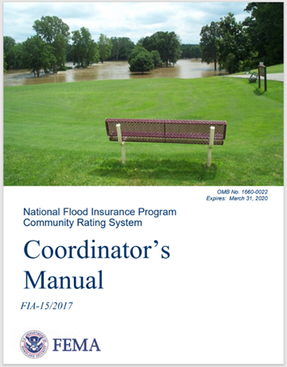The Community Rating System (CRS) is a voluntary program developed by FEMA that provides discounts on flood insurance for property owners in communities that go beyond the basic requirements of the NFIP. Communities receive discounts in flood insurance premiums for its residents and business owners by meeting criteria outlined in the CRS Coordinator’s Manual and earning credits. The number of credits earned correlates with different class levels which each provide a different level of premium discount, to a maximum of 45%.

The goals of the CRS program include reducing flood damage to insurable property, strengthening the insurance aspects of the NFIP, and fostering comprehensive floodplain management.

This SDP was developed using the process outlined in the CRS Coordinator’s Manual addendum for developing an SDP. Following the criteria for CRS credits for an SDP, this plan addresses the following:

* Defines SD and identifies where it is found in the **[Community Name]**'sFlood Damage Prevention Code.
* Was developed using the six-step planning process and is organized into sections according to each of the six steps. The steps for developing a CRS-credited SDP are as follows:

1. Assess the community’s vulnerability to substantial damage.
2. Identify the community’s team for the management of substantial damage properties.
3. Identify post-event efforts related to substantial damage.
4. Build a property database for substantial damage estimates.
5. Identify the actions the community can take to address potential substantial damage.
6. Determine the implementation steps and procedures for updating the plan.

Three levels of SDP credit are available. The basic credit is 40 points for the development of a SDP. An additional 50 points are available if FEMA’s Substantial Damage Estimator (SDE) is pre-populated for all properties with the potential to be substantially damaged. Another 50 points are provided for communities that consider pre-flood mitigation alternatives.

**Instructions**

Choose one of the paragraphs below to reflect your community’s status in the CRS program. This could include information on efforts to join, or a decision to forego participation, as applicable.

[Use the following paragraph if your community is participating in the CRS program] **[Community Name]** entered the CRS Program effective **[Date of Entry]**. The community is rated as a Class **[CRS Class #]**, with a **[Discount %]** discount for flood insurance premiums.

[Use the following paragraph if your community is not participating in the CRS program] **[Community Name]** is not currently participating in the CRS program. [Include reasoning for your community's decision to forego participation in the program].

# Regulatory and Legislative Authority

**Instructions**

This section of the plan includes a review of the community’s legal authority for regulating substantial damage/improvements (ordinance, building codes, etc.) and its adopted definitions that meet or exceed the NFIP minimum standards.

A primary goal of the NFIP is to break the damage - rebuild - damage cycle by requiring all new, substantially improved, and substantially damaged structures within mapped flood hazard areas to be constructed in a manner that is reasonably safe from flooding. That requires proper building elevation and protection techniques.

The NYS Uniform Code includes flood provisions that meet or exceed the NFIP requirements for buildings and structures, including substantial improvements or repairs of substantial damage. All counties, cities, towns and villages are required to enforce the Uniform Code. Some communities enforce “higher standards” than those required by the Uniform Code. New York City adopts its own code.

The [Building Code of New York State (BCNYS)](https://codes.iccsafe.org/content/NYSBC2020P1) contains flood provisions, primarily in Section 1612 Flood Loads, which refers to the standard *Flood Resistant Design and Construction* ([ASCE 24](http://www.fema.gov/emergency-managers/risk-management/building-science/building-codes/flood)).

The [BCNYS Appendix G](https://codes.iccsafe.org/content/NYSBC2020P1/appendix-g-flood-resistant-construction) is informative only, and may be locally adopted. This includes flood map duties, variances, and development other than buildings, including subdivisions, site improvements, floodway encroachments, watercourse alterations, manufactured homes, recreational vehicles, tanks, temporary storage and structures, and miscellaneous structures.

The [Residential Code of New York State](https://codes.iccsafe.org/content/NYSRC2020P1) contains flood provisions primarily in Section R322 Flood-Resistant Construction, as well as additional requirements in several other sections.

The [Existing Building Code of New York State (EBCNYS)](https://codes.iccsafe.org/content/NYSEBC2020P1) contains flood provisions in sections on repairs, alterations, additions, and historic structures, and in sections on prescriptive and performance compliance methods.

Additionally, the [Plumbing](https://codes.iccsafe.org/content/NYSPC2020P1), [Mechanical](https://codes.iccsafe.org/content/NYSMC2020P1), and [Fuel Gas](https://codes.iccsafe.org/content/NYSFGC2020P1) Codes of New York State contain flood provisions in a number of sections.

The NYS Uniform Code includes requirements that may differ from NFIP and local floodplain management regulations – the more restrictive prevail.

The NYS Department of Environmental Conservation (NYSDEC) has three model local laws for flood damage prevention that communities adopt to join the NFIP.

The flood damage prevention local law indicates that if a municipality has mapped flood hazard areas and if development is to occur in those flood hazard areas, then the development is required to be built to certain standards, identified in the NFIP's regulations and the Uniform Code. If development is being considered for a SFHA, then the local floodplain administrator, an office or title designated in the local law, reviews the development to ensure that construction standards have been met before issuing a floodplain development permit. Non-structural development within a SFHA is also subject to a local floodplain development permit.

The three models are as follows:

* **Model Local Law A** is for communities that do not have a flood map. It is designed to comply with the floodplain management requirements of the NFIP contained in 44 CFR 60.3(a).
* **Model Local Law D** is for communities that have flood maps but no coastal wave runup zones. It is designed to comply with the floodplain management requirements of the NFIP contained in 44 CFR 60.3(a) through (d).
* **Model Local Law E** is for communities with coastal wave runup zones. It is designed to comply with the floodplain management requirements of the NFIP contained in 44 CFR 60.3(a) through (e).

In addition to the three Model Local Laws for Flood Damage Prevention, NYSDEC has optional additional language that may also be included for higher protection from flooding.

The **[Community Name]** has adopted and enforces Model Local Law **[choose one: A, D, or E] [Include the following sentence if applicable to your community; delete if not]** including language for higher protection standards. Relevant excerpts from the **[Community Name]**'sadopted floodplain regulations are noted in the section that follow.

**Instructions**

Keep the following definitions and substantial damage/improvement requirements if your community has adopted the minimum New York State Model Law language and remove the content related to higher standards in the sections following the next call out box of instructions.

## Definitions

**Substantial damage**: Damage of any origin sustained by a structure whereby the cost of restoring the structure to its before-damaged condition would equal or exceed fifty (50) percent of the market value of the structure before the damage occurred.

**Substantial improvement**: For the purpose of determining compliance with the flood provisions of this code, any repair, alteration, addition, or improvement of a building or structure, the cost of which equals or exceeds 50 percent of the market value of the structure, before the improvement or repair is started. If the structure has sustained substantial damage, any repairs are considered substantial improvement regardless of the actual repair work performed. The term does not, however, include either of the following:

1) Any project for improvement of a building required to correct existing health, sanitary, or safety code violations identified by the building official and that is the minimum necessary to ensure safe living conditions.

2) Any alteration of a historic structure, provided that the alteration will not preclude the structure's continued designation as a historic structure.

**Instructions**

If your community has adopted higher standard ordinance language, use the following definitions for substantial damage/improvement requirements and remove the definitions above.

**Note**: Adjust the language below according to your adopted higher standards. This could be a threshold lower than 50-percent. It may also include a cumulative tracking period such as in the example language below.

**Substantial damage**: Damage of any origin sustained by a structure whereby the cost of restoring the structure to its before-damaged condition would equal or exceed fifty (50) percent of the market value of the structure before the damage occurred. Substantial damage also means flood-related damages sustained by a structure on two separate occasions during a 10-year period for which the cost of repairs at the time of such flood event, on the average, equals or exceeds 25 percent of the market value of the structure before the damage occurred.

**Substantial improvement**: Any reconstruction, rehabilitation, addition, or other improvement of a structure, the cost of which equals or exceeds 50 percent of the market value of the structure before the "start of construction" of the improvement. Substantial improvement also means “cumulative substantial improvement.” The term includes structures which have incurred "substantial damage", regardless of the actual repair work performed. The term does not, however, include either:

1) Any project for improvement of a structure to correct existing violations of state or local health, sanitary, or safety code specifications which have been identified by the local code enforcement official and which are the minimum necessary to assure safe living conditions; or

2) Any alteration of a "Historic structure", provided that the alteration will not preclude the structure's continued designation as a "Historic structure".

**Instructions**

In addition, there must be a definition for “Cumulative Substantial Improvement" if you have enacted this higher standard. Adjust language as shown in your adopted ordinance.

**Cumulative Substantial Improvement**: Any reconstruction, rehabilitation, addition, or other improvement of a structure that equals or exceeds 50 percent of the market value of the structure at the time of the improvement or repair when counted cumulatively for 10 years.

## Duties and Responsibilities of the Local Floodplain Administrator and Enforcement

**Instructions**

Include the following sections on the duties and responsibilities of the Local Administrator, ordinance enforcement, and records to be maintained.

Section **[Insert ordinance section number]** of the **[Community Name]**'s adopted Flood Damage Prevention Ordinance designates the duties and responsibilities of the floodplain administrator as they relate to substantial damage:

* **Permit Application Review**

The Local Administrator shall conduct the following permit application review before issuing a floodplain development permit:

1. Review all applications for completeness, particularly with the requirements of **[Insert ordinance section number]**, Application for a Permit, and for compliance with the provisions and standards of this law.

2. Review subdivision and other proposed new development, including manufactured home parks to determine whether proposed building sites will be reasonably safe from flooding. If a proposed building site is located in an area of special flood hazard, all new construction and substantial improvements shall meet the applicable standards of Section **[Insert ordinance section number for Construction Standards**], Construction Standards,and, in particular, sub-section **[Insert ordinance sub-section number for Subdivision Proposals]**, Subdivision Proposals.

* **Construction Stage**

1. In Zones A1-A30, AE and AH, and also Zone A if base flood elevation data are available, upon placement of the lowest floor or completion of flood proofing of a new or substantially improved structure, obtain from the permit holder a certification of the as-built elevation of the lowest floor or flood proofed elevation, in relation to mean sea level. The certificate shall be prepared by or under the direct supervision of a licensed land surveyor or professional engineer and certified by same. For manufactured homes, the permit holder shall submit the certificate of elevation upon placement of the structure on the site. A certificate of elevation must also be submitted for a recreational vehicle if it remains on a site for 180 consecutive days or longer (unless it is fully licensed and ready for highway use).

2. Any further work undertaken prior to submission and approval of the certification shall be at the permit holder's risk. The Local Administrator shall review all data submitted. Deficiencies detected shall be cause to issue a stop work order for the project unless immediately corrected.

* **Inspections**

The Local Administrator and/or the developer's engineer or architect shall make periodic inspections at appropriate times throughout the period of construction in order to monitor compliance with permit conditions and enable said inspector to certify, if requested, that the development is in compliance with the requirements of the floodplain development permit and/or any variance provisions.

* **Stop Work Orders**

1. The Local Administrator shall issue, or cause to be issued, a stop work order for any floodplain development found ongoing without a development permit. Disregard of a stop work order shall subject the violator to the penalties described in **[Insert ordinance section number]**. Penalties for Non-Compliance of this local law.

2. The Local Administrator shall issue, or cause to be issued, a stop work order for any floodplain development found non-compliant with the provisions of this law and/or the conditions of the development permit. Disregard of a stop work order shall subject the violator to the penalties described in **[Insert ordinance section number]**-Penalties for Non-Compliance of this local law.

* **Certificate of Compliance**

1. In areas of special flood hazard, as determined by documents enumerated in **[Insert ordinance section number]**-Basis for Establishing the Areas of Special Flood Hazard, it shall be unlawful to occupy or to permit the use or occupancy of any building premises, or both, or part thereof hereafter created, erected, changed, converted or wholly or partly altered or enlarged in its use or structure until a certificate of compliance has been issued by the Local Administrator stating that the building or land conforms to the requirements of this local law.

2. A certificate of compliance shall be issued by the Local Administrator upon satisfactory completion of all development in areas of special flood hazard.

3. Issuance of the certificate shall be based upon the inspections conducted as prescribed in **[Insert ordinance section number]** (E) – Inspections, and/or any certified elevations, hydraulic data, flood proofing, anchoring requirements or encroachment analyses which may been required as a condition of the approved permit.

* **Information to Be Retained**

The Local Administrator shall retain and make available for inspection, copies of the following:

1. Floodplain development permits and certificates of compliance;

2. Certifications of as-built lowest floor elevations of structures, required pursuant to **[Insert ordinance section number]** and **[Insert ordinance section number]**, and whether or not the structures contain a basement;

3. Flood proofing certificates required pursuant to **[Insert ordinance section number]**, and whether or not the structures contain a basement;

4. Variances issued pursuant to **[Insert ordinance section number]**; and,

5. Notices required under **[Insert ordinance section number]**.

# Assessment of Vulnerability to Substantial Damage

**Instructions**

This section of the plan corresponds to Step 1 of the CRS planning process. It should describe and track previous substantial damage or substantial improvements in the community; identify and characterize areas and structures within the Special Flood Hazard Areas that are potentially vulnerable to substantial damage; describe other vulnerable buildings or areas; and discuss other flood factors that were considered during the assessment.

This plan identifies vulnerable areas in [Community Name] that may be more likely to experience substantial damage. In this plan, a structure’s vulnerability is assessed in terms of location within the floodplain, and other flood factors that may impact the structure. Identifying areas that are more vulnerable can help focus efforts to those areas that may need the most attention post disaster.

## Description of Previous Substantial Damage and Substantial Improvement Determinations

**Instructions**

This section should describe the circumstances, locations, and dates of your community previously conducted substantial damage determinations. Describe how the situation was addressed (e.g. was the building restored and brought up to code, demolished, or bought out). Are there buildings determined to be substantially damaged you are tracking where no permitting action has happened to date? Include these buildings and details in your Potential Substantial Damage Property Inventory spreadsheet (see Appendix A: Potential Substantial Damage Properties List). Also see Section 9 of this plan for the information to be collected and recorded for each property.

An example paragraph is provided as option 1 for communities that have made SD determinations in the past. This is only intended as an example. Tailor content to fit the details of your community.

If your community has no available record of prior substantial damage determinations skip to option 2. If your community has not kept good records, own it. You are taking steps to remedy it through the development of this plan.

[Option 1: Example content for communities where prior SD determinations apply] In 2022, near-record flooding occurred in The Town of Anytown and teams were assembled to conduct over 40 damage assessments. Following this event, 18 structures were determined to be substantially damaged. Since then, 14 structures were rebuilt to current code and two single-family homes were bought out, demolished, and the land returned to open space. Permits have yet to be filled for the remaining two properties. The property owners have been notified of the substantial damage requirements and these two properties have been flagged in the Town’s permitting files to ensure when a permit is received, appropriate building standards are met to bring the building up to code.

[Option 2: Use this sentence if you have no record of prior SD determinations in your community] As of [insert date data retrieved], there are no (0) substantial damage properties in [Community Name] that have been documented.

## Community Flood History

**Instructions**

Provide a short description of your community's geographic location and major flooding sources.

**TIP:** Your Community’s FEMA Flood Insurance Study or local Hazard Mitigation Plan will contain some content you can draw from in developing this section.

The [Community Name]is located in [describe relative geographic location].

[**Describe community's topography here and major water bodies.**]

**Instructions**

Insert optional map of your community's geographic location below. Edit caption as indicated.



Figure 1: [Community Name]'s Location

[Community Name] is subject to flooding from multiple sources: [list relevant flooding sources for your community, i.e. urban flooding, overbank flooding, and/or coastal flooding].

**Instructions**

Include below definitions of flood sources as applicable to your community.

**Overbank flooding**, or the increase in the volume of water in a stream or river onto adjacent low-lying areas, is also common in [Community Name]. There are numerous tributaries of the [insert relevant flood sources in your community] throughout [Community Name] that commonly flood due to heavy rains occurring at any time of year. Flooding can also occur as a result of intense rainfall produced by local summer thunderstorms or tropical disturbances such as hurricanes which move into the area.

**Urban flooding**, also known as surface water runoff from excess precipitation in a watershed, occurs when rates of rainfall are higher than what can be evaporated or penetrated into the soil and is exacerbated by impervious surfaces in an area. Older storm conveyance systems installed based on less stringent or no standards are often inadequate for heavy rainfalls. In urban flooding scenarios, water can flow as sheets across surfaces, picking up contaminants and eroding soils and when the amount of water flows into streams and rivers greater than it can carry, water overflows the banks, flooding low-lying adjacent areas.

**Coastal flooding** occurs when dry and low-lying land is submerged by sea water. [Community Name] is subject to coastal flooding and storm surge. Storm surge is caused by large amounts of tidally influenced water being pushed inland by the winds of storms such as hurricanes and Nor’easters. Battering waves can cause erosion and damage to coastal buildings and their foundations, as well as to roads, bridges, marinas, and piers. Nor’easters are ocean storms capable of causing substantial damage to coastal areas in the Eastern United States due to their strong winds and heavy surf.[1] Additionally, the coastal areas of [Community Name]are subject to tidal flooding from major storms.

**Great Lakes Flooding** is a significant source of flood risk to [Community Name]. The most severe flood events occur when high lake levels are combined with strong winds that drive water and waves onshore. When large waves are paired with elevated lake levels, the waves are able to reach farther onshore, eroding the backshore, and potentially reaching developed lakefront areas.

## Historic Flood Events

A list of significant flooding events that have been recorded in [Community Name]can be found in Table 1 below.

**Instructions**

Insert historical flood data for your community in the table below.

**TIP**: You can find this information using your local or county Hazard Mitigation Plan.

Table 1: [Community Name] Historical Flood Events

| **Date of Occurrence** | **Event Description** | **Impact** |
| --- | --- | --- |
| Example: August 1982 | *Flood* | *Greatest known flood in the area occurred as a result of a hurricane which swept north past [Community Name].* |
| *Example: March 1986* | *Flood* | *Second largest recorded flood event occurred as a result of a nor’easter.* |
| *Example: September 2021* | *Hurricane Ida* | *Remnants of Hurricane Ida caused disastrous flooding in the state of New York including areas within [Community Name].* |
|  |  |  |
|  |  |  |
|  |  |  |
|  |  |  |

## Primary Flood Risk Areas

It is important to identify areas in [Community Name] that experience a greater risk of flooding impacts because these areas are high priority for substantial damage assessments. These primary flood risk areas and properties are described in the following section.

### Potential Substantial Damage Areas

**Instructions**

In this section, list your community's potential substantial damage areas. Describe how the substantial damage areas were defined and include references to source materials. Remove any bullets that do not apply and add to the list as appropriate for your community.

**TIP:** Talk to your Highway Department. They often have a good handle on where the problem areas are.

The [Community Name]'s potential substantial damage areas are identified as:

* Regulated Special Flood Hazard Areas (SFHA) as shown on the effective Flood Insurance Rate Maps (FIRMs) and locally adopted studies or mapping.
* Repetitive Loss (RL) properties and Severe Repetitive Loss (SRL) Properties.
* SFHA properties with their first-floor elevation below BFE.
* Flagged Buildings reviewed for potential Substantial Damage in the past that did not meet the threshold at the time.

**Repetitive Loss:** Any insurable building for which two or more claims of more than $1,000 have been paid by the NFIP within any 10-year period, since 1978. An RL property may or may not be currently insured under the NFIP.

**Severe Repetitive Loss Property:** defined by the Flood Insurance Reform Act of 2004, are 1-4 family residences that have had four of more claims of more than $5,000 or at least two claims that cumulatively exceed the building’s value. The Act created new funding mechanisms to help mitigate flood damage for these properties.

**Base Flood Elevation**

The elevation of surface water resulting from a flood that has a 1% chance of equaling or exceeding that level in any given year.

Figure 2 depicts the potential substantial damage areas in **[Community Name]**. Structures in each of the identified areas fit one or more of the criteria for potential substantial damage outlined in the **Potential Substantial Damage Properties Inventory** section below.

**Instructions**

Use the figure placeholder below to insert a map of potential substantial damage areas in your community.

**TIP:** This map should show the general areas of potential flood risk. Refer to the Potential Substantial Damage Property Inventory spreadsheet in creating this map. Keep in mind, individual structures should not be identifiable in the map or in this plan.



Figure 2: Potential Substantial Damage Areas

### Regulated Properties

**Instructions**

Insert your community's list of effective FIRM panels in the table below. Edit table caption as indicated. You can find this information using your FEMA Flood Insurance Study or on [FEMA's Map Service Center](https://msc.fema.gov/portal/home).

SFHAs are determined by FEMA in scientific and engineering reports called Flood Insurance Studies and are accompanied by FIRMs. Table 2 includes the effective FIRM Panels used by **[Community Name]** to determineareas and buildings at risk during the 1% annual chance flood.

Table 2: [Community Name]'s Flood Map Panels

| **Map Panel #** | **Effective Date** |  | **Map Panel #** | **Effective Date** |
| --- | --- | --- | --- | --- |
| Ex. 510103IND0A | 12/09/2014 |  |  |  |
| Ex. 5101030019D | 12/09/2014 |  |  |  |
| Ex. 5101030029D | 12/09/2014 |  |  |  |
|  |  |  |  |  |
|  |  |  |  |  |
|  |  |  |  |  |
|  |  |  |  |  |
|  |  |  |  |  |

**Instructions**

If your community has adopted and regulates areas using other maps in addition to the FIRMs include a paragraph that describes those areas. This could include locally developed flood hazard studies, coastal erosion setbacks, FEMA Base Level Engineering (BLE) mapping, or preliminary FIRMs.

### Repetitive Loss Properties

**Instructions**

In this section, provide a summary of your community's repetitive loss properties and severe repetitive loss properties if applicable. You can request aggregated information about the number of repetitive loss properties from NYS Department of Environmental Conservation (DEC). More comprehensive property-specific information can be requested each year from FEMA Region 2. To obtain this sensitive information, the community must execute an Information Sharing Access Agreement with FEMA and agree to safeguard personally identifiable information (PII).

**TIP:** You may find general repetitive loss information (and potentially a map) in your latest local or County Hazard Mitigation Plan. Further, some CRS communities in New York may have prepared a Repetitive Loss Area Analysis (RLAA) and identified neighboring properties that face similar risk. If this applies to your community, share your findings and RLAA maps in this section.

As of **[date data retrieved]**, there were **[# of RL properties]** RL properties in **[Community Name]**. Out of the **[# of RL properties]** RL properties, **[# of SRL Properties]** were SRL properties. Losses for these properties total **[$ value of losses]**.

**Instructions**

Include optional RLAA map for the figure below.

The location of RL neighborhoods are shown in Figure 3 below.



Figure 3: **[Community Name]** Repetitive Loss Neighborhood Map

### SFHA properties with their first-floor elevation below BFE

**Instructions**

Include this section if you have buildings in the SFHA that were constructed before your first FIRMs went into effect. Approximate the number constructed before that date and include that percentage below.

**TIP:** Your County GIS Department may be able to assist with this process. Keep in mind, most FIRMs in New York State were issued in the late 1970s or early 1980s. In the absence of better data, for this purpose, you can safely assume that buildings constructed before the late 1970s or early 1980s are Pre-FIRM.

As of **[date data retrieved]**, there were **[# of buildings]** buildings in the **[Community Name]**’sSFHA. Of those properties, an estimated **[% of buildings]** percent of those buildings were built before the FIRMs went into effect. These buildings are referred to as pre-FIRM and are assumed to have been built without flood protection measures and likely with their first-floor elevation below BFE. Buildings built after the FIRM went into effect are referred to as post-FIRM and will have been built to design standards that include flood protection measures. Given the likelihood that the first-floor elevation of Pre-FIRM buildings is below BFE, these buildings will be prioritized for Substantial Damage assessment.

### Flagged Properties

**Instructions**

This section should include buildings reviewed for potential Substantial Damage in the past that did not meet the threshold for SD at the time. Remove this section if you have no record of Substantially Damaged properties in your community.

**TIP:** This section is applicable to communities that have adopted higher standards and are tracking Cumulative Substantial Damage.

As of **[date data retrieved]**, there were **[# of buildings]** buildings in **[Community Name]** that sustained damage during prior disaster events. Those damages did not meet the threshold to be considered substantially damaged at the time but will be reviewed for Cumulative Substantial Damage even if in an area which sustains minimal to moderate damage in future events.

### Potential Substantial Damage Properties Inventory

**Instructions**

A summary of potential substantial damage properties should be included in this section. Tailor the content in two paragraphs that follow based on the primary flood risk areas applicable to your community.

**TIP:** The detailed inventory list should not be included in the SDP due to its inclusion of personally identifiable information (PII). It is recommended that this data be maintained in a secure file that is accessible to your community representatives. The inventory can be kept in a password protected file and linked in this document as appropriate.

Structures located in the SFHA will likely be inundated by a flood event having a 1 percent chance of being equaled or exceeded in any given year. Structures located below BFE, particularly with a below-grade crawl space or basement, also have a high risk of flooding. RL properties are located in areas that flood regularly, and therefore are more vulnerable to flooding and potential substantial damage.

The [Community Name]'s list of potential substantial damage properties, including buildings in the SFHA, properties suspected to be below the Base Flood Elevation (BFE), and RL properties are included in a secure file separate from this document. These properties were pre-identified for their vulnerability to substantial damage based on their higher risk of flooding. The list of potential substantial damage properties excludes accessory structures such as garages and sheds.

**Instructions**

Give a general description of the buildings on your community’s potential substantial damage list, such as proportion of residential compared to commercial, occupancy category (single vs. multi-family, etc.), and/or type of construction (manufactured home, slab-on-grade, etc.) Use the example table below to fill in this information for your community.

Table 3 shows the general building description of potential substantial damage properties. The majority of the structures located within the [Community Name] SFHA are [provide a recap of key insights from the table here and other insights from your SD Property Inventory List. This recap could include details such as predominant foundation type and percentage of pre-FIRM and post-FIRM construction.]

Table 3: Potential Substantial Damage Property Descriptions

|  |  |
| --- | --- |
| **Property Type** | **Number of Properties** |
| Single-family residential | 756 |
| Two-to-four family residential | 21 |
| Apartment (over four dwellings) | 19 |
| Commercial | 11 |
| Critical Facility | 17 |

[Remove the following sentence if not available in your community] These structures are also represented on maps, which are available upon request from the [list appropriate location/ office/ department] as an ArcGIS file.

Identifying these structures and additional information ahead of time will focus efforts where they are most needed post-disaster and will speed up the substantial damage determination process.

**Instructions**

Describe the procedure for reviewing your community’s inventory of structures and the map, and how both will be updated. Give a specific time frame or schedule and identify the person/position/department that is responsible for the review and update.

The [list appropriate community official, ex. Floodplain Administrator] will review the community’s inventory of structures and any supporting maps on an as needed basis such as following a flood event. Updates will also be made following FIRM updates to add and remove buildings mapped into or out of the SFHA. The inventory and map will be updated within [give timeframe, ex. two months]of each disaster that causes substantial damage or map update.

# The Substantial Damage Management Team

**Instructions**

This section of the plan corresponds to Step 2 of the required CRS planning process. It must describe how the community’s substantial damage management team was formed, what roles and tasks constitute the continuous management, how the team will function if a flood or other damaging event occurs, and how the team will be augmented with additional resources if needed.

Several different [Community Name] offices and local officials are involved in the disaster recovery process. The substantial damage team established by [Community Name] ensures a quick and comprehensive response following a disaster.

Based on the regulatory authority found in Section [Insert ordinance section number] of the **[Community Name’s]** adopted floodplain regulations, the local Floodplain Administrator (FPA) is responsible for overall implementation of [Community Name]’s substantial damage management strategy and plan.

**Instructions**

Use the example bulleted list below of post-disaster responsibilities and adjust as applicable for your community.

The FPA is responsible for completing the following responsibilities post-disaster, or delegating these responsibilities to ensure they are completed post-disaster:

* Determine whether buildings and structures that are located in flood hazard areas and that are damaged by any cause have been substantially damaged.
* Notify owners of substantially damaged structures of the need to obtain a permit to repair, rehabilitate, or reconstruct, and prohibit the non-compliant repair of substantially damaged buildings except for temporary emergency protective measures necessary to secure a property or stabilize a building or structure to prevent additional damage.
* Issue press releases, public service announcements, and other public information materials related to permit requests and repair of damaged structures.
* Coordinate with other federal, state, and local agencies to assist with substantial damage determinations.
* Provide owners of damaged structures information related to the proper repair of damaged structures in special flood hazard areas.

**Instructions**

This Section should include a list of the team members, along with their Department name or title and their associated responsibilities. Note that for CRS purposes, the names of specific individuals are not needed here. However, you are free to add details, an organizational chart, and contact list should you desire.

If a table or matrix is generated to track training, availability, or expertise, it could also be included in this section.

Use the example bulleted list below and adjust as applicable for your community.

This section should also describe other personnel, or sources of personnel, potentially available for damage determinations if a major event occurs (mutual aid agreements, state team, etc.).

[Community Name] will also make use of the following staff and/or departments to conduct damage determinations after a damaging event.

Additional members of the [Community Name] substantial damage team and their responsibilities are as follows:

Code Enforcement **[Edit list as appropriate for your community]**

* Provide substantial damage training and outreach to the staff and contractors
* Identify available resources
* Plan the SI/SD field assessments including initial field surveys, establishing damage trends, preparing cost information, and collecting data
* Complete substantial damage assessments and determinations
* Hire, train, supervise, certify and license staff for field operations
* Ensure follow-up coordination with structure owners is completed
* Coordinate final storage of SI/SD files
* Review elevation certificates
* Process, maintain, and track temporary occupancy permits and inspect temporary occupancy buildings
* Take corrective action necessary to ensure compliance
* Determine if damaged structures have been designated as historic or that may be eligible for such designation

Floodplain Administrator

* Review permit applications for structures within the Special Flood Hazard Area

Tax Assessor [or Tax Assessor Database]

* Assist in establishing market value for structures by providing tax assessed structure values

**Emergency Management [Edit list as appropriate for your community]**

* Assist in communicating to public before and after disaster

## Other Personnel Resources

**Instructions**

This Section details mutual aid support and agreements that allow communities to augment their personnel in times of need. It also provides links to where further information on reimbursable expenses under Section 1206 of the Disaster Recovery Act can be found.

The [Community Name] will also make use of other personnel resources, when necessary, post disaster.

Because most building departments do not maintain sufficient personnel levels to handle the influx of post-disaster inspections, permitting and enforcement tasks, mutual aid agreements allow building departments to augment their personnel in times of need. To utilize mutual aid support on an as needed basis, the [Community Name] will request assistance through an established mutual aid agreement that describes the terms and conditions of the service. These agreements between states and among jurisdictions provide a mechanism to quickly obtain assistance in the form of personnel. The primary objective is to facilitate the rapid, short-term deployment of emergency support prior to, during, and/or after an incident. Further information on Mutual Aid in Region 2 can be found on [FEMA’s website](https://www.fema.gov/emergency-managers/risk-management/building-science/bcat/fact-sheets).

The Department of State Division of Building Standards and Codes (BSC) [Code Enforcement Disaster Assistance Response (CEDAR) Program](https://dos.ny.gov/code-enforcement-disaster-assistance-response-cedar-program) provides requesting communities with post-disaster assistance, including performing Rapid Evaluation Safety Assessments of damaged structures in affected communities for use as part of the application process to request federal disaster assistance through FEMA. The CEDAR program’s long-term disaster response provides a unified method that allows communities to access the broad range of resources available within and beyond the Department of State.

Additionally, [Section 1206 of the Disaster Recovery Reform Act (DRRA)](https://www.fema.gov/sites/default/files/documents/fema_drra-1206-companion-document.pdf), Building Code and Floodplain Management Administration and Enforcement, provides reimbursement assistance to communities after a disaster declaration for building code and floodplain administration and enforcement, including inspections for substantial damage compliance and wages for extra hires to facilitate the implementation and enforcement of adopted building codes. Communities should consult [Section B.3 of the DRRA 1206 policy](https://www.fema.gov/assistance/public/policy-guidance-fact-sheets/section-1206-building-code-and-floodplain-management-administration-and) to review a list of example activities eligible under DRRA 1206. Activities not included on the list will be evaluated on a case by-case basis. Activities occurring **up to 180 days** after a major disaster declaration may be eligible for reimbursement through this program.

# Post-Event Actions

**Instructions**

This section of the plan corresponds to Step 3 of the required CRS planning process. Here the community should lay out the specific actions needed to complete damage inspections in the field after a flood or other event, as well as the administrative process for making determinations of substantial damage. Also covered in this section is communication with property owners and community officials.

This section should also describe how the substantial damage team will be trained, with what resources, by what process, and on what schedule.

This plan identifies the post-event actions that the [Community Name] will take to complete damage determinations after a flood or other event as well as the administrative process for making determinations of substantial damage. This section includes step-by-step instruction on [Community Name]’s substantial damage process.

Following a flood, or other disaster event, there are multiple steps involved in completing substantial damage determinations. The following is a list of steps for [Community Name] to follow after a disaster. An overview of the substantial damage determination process is shown in Figure 4.

**Instructions**

Use the fillable flow diagrams below to customize your community's post-event coordination and communication steps. (The fillable flow diagrams are also included in a separate, customizable PowerPoint file for your convenience.)

Please use these numbered sections as an example guide, including best practices for post-event coordination and communication, and edit each section as applicable to your community.

**STEP 1**

**Initial Data Preparation**

**STEP 2**

**Communicate with Elected Officials & Property Owners**

**STEP 3**

**Determine Substantial Damage Areas**

**STEP 4**

**Meet with Substantial Damage Team & Assign Areas of Responsibility**

**STEP 5**

**Complete Damage Assessments**

**STEP 6**

**Review Damage Determinations**

**STEP 7**

**Update Potential Substantial Damage Properties Inventory & Notify Property Owners**

**STEP 8**

**Coordinate Rebuilding & Mitigation Efforts**

**STEP 9**

**Substantial Damage Data Archiving**

**STEP 10**

**Monitor & Enforce Substantial Damage Compliance**

**DISASTER EVENT OCCURS**

Figure 4: Post-Event Coordination and Communication Steps Overview

## Step 1: Initial Data Preparation

Create Event Name for all documentation of substantial damage determinations

**STEP 1**

***Create Event Name***

After a disaster occurs, the [community staff, ex. floodplain administrator] will create a new name for the flood or disaster event that will be used as an identifying attribute for all recorded substantial damage.

## Step 2: Communicate with Elected Officials and Property Owners

Coordinate safety protocols with City Police Department or related department

**STEP 2**

Notify residents that inspectors will be doing substantial damage inspections

Communication with elected officials

Notify residents of what substantial damage is

Send out letters, press releases, social media posts

The [community staff, ex. floodplain administrator] will communicate with elected officials and coordinate safety protocols with the [community department, ex. Police Department]. Additionally, the [community staff, ex. floodplain administrator] will notify residents that inspectors will be conducting assessments; providing background information on substantial damage; and sending out letters, press releases, and social media posts.

***Communicate with Elected Officials***

Communication with elected officials is essential prior to completing substantial damage assessments to ensure all officials are aware of the [Community Name]’s obligations regarding substantial damage following a disaster, including:

* Sharing expectations for needed support from SD team members and others such as Police Department staff.
* Make substantial damage determinations for buildings that are located in the mapped SFHA.
* Explain what it means to bring a substantially damaged building into compliance with current floodplain management standards.
* Issue permits for repair and reconstruction.
* Share the materials developed to communicate with citizens.

***Coordinate Safety Protocols***

The [community staff, ex. floodplain administrator] will notify the [community department, ex. Police Department] that assessments will be occurring throughout the [Community Name]. The [community department, ex. Police Department] can then distribute warnings and information to residents through emergency notification systems [note here any specific emergency notification systems your community uses].

***Notify Residents***

After a disaster, the [community staff, ex. floodplain administrator] will send out notifications to residents via letters informing them of permitting procedures, substantial damage requirements, and of upcoming assessments of structures. Property owners in flood zones will be advised of the requirement to inspect damaged buildings. Appendix B: Letters to Property Owners includes example language to be shared with residents who require damage assessments or have structures with potential substantial damage. The Substantial Damage Fact Sheet in **Appendix C: Substantial Damage Fact Sheet** can be included in letters to property owners for more information on substantial damage and links to helpful resources.

***Press Release***

After a disaster, it is important to get the word out to residents about rebuilding requirements and resources they may need. Appendix D: Sample Press Release contains example text for press releases that can be altered to fit the disaster situation. A few important items to be included and considered include the following.

* Permit requirements;
* Substantial damage requirements including information on elevation and freeboard ordinance requirements;
* Safety hazards;
* Update on public utilities (i.e. what is working and what is not, a timeline of when things will be restored, etc.);
* Locations for resources, shelters and food;
* State and Federal Assistance;
* NFIP Increased Cost of Compliance (ICC) procedure; and
* Phone number or email address of [Community Name] office/employee where questions can be directed.

Freeboard is an additional height above the Base Flood Elevation used as a factor of safety in determining the level at which a structure's lowest floor must be elevated or floodproofed. Within Zones A1-A30, AE, AH if base flood elevation data are available, new con­struction and substan­tial improve­ments shall have the top of the low­est floor (in­clud­ing base­ment) ele­vated to or above two feet above the base flood elevation as per New York State standards.

To help cover the costs of meeting state and local requirements, the NFIP makes available Increased Cost of Compliance (ICC) coverage for all new and renewed standard flood insurance policies. For substantially damaged structures, policyholders can receive up to $30,000 to cover structure elevation, relocation, demolition, or for non-residential buildings, floodproofing. A factsheet on ICC is included in **Appendix K: Additional Post-Flood Resources** for use in making residents aware of this coverage.

***Social Media***

**Instructions**

**Best Practice Tip**: Customize the following section if your community has active social media accounts. Use example social media messaging shown below and in Appendix E: Social Media Messages for Flood-Related Events to share information with residents pre-and post-flood.

The [community staff, ex. floodplain administrator] will work with the [community department, ex. Emergency Management or Public Information Officer] to disseminate flood hazard and preparedness information. [Community Name] has active accounts on [list active social media platforms as applicable]. These accounts will be used to share information with residents pre- and post-flood. Pre-scripted messages have been developed that can be shared before or after a flood event to help keep residents safe and informed of rebuilding requirements and opportunities to mitigate their future flood risk exposure. Triggers for social media messaging include the following.

* **Before the Flood**: If a major storm is reported by news media to be approaching.
* **Before the Flood**: The [Community Name] sustains a rainfall event in excess of 2 inches within two hours.
* **After the Flood**: When a flood event results in flooded buildings.

The messages will vary by the triggering event and the audience. Pre-scripted Example messages for events are shown in **Appendix E: Social Media Messages for Flood-Related Events**.

# Substantial Damage Determination and Process

**Instructions**

In this section, describe how preliminary damage inspections are done, who has responsibility for which tasks, etc. If a “triage” method of screening and categorizing buildings according to the extent of estimated damage is used, that can be reported here.

Describe how inspections are accomplished, and how determinations of substantial damage will be done, both in the field and in the office, and who has responsibility for which tasks.

Following the initial post-event coordination and communication steps to inform the community about substantial damage and the upcoming assessments, the **[community official, ex. floodplain administrator]** will begin the substantial damage determination process.

## Step 3: Determine Substantial Damage Areas

**STEP 3**

Review substantial damage plan to initiate substantial damage process

Use Potential SD Properties Inventory to determine likely substantial damage areas

Provide list of potential substantial damage areas to Code Enforcement/SD Team

The [community official, ex. FPA and/or Code Enforcement Officer] will review the SDP to initiate the substantial damage determination process and will ensure that all members of the substantial damage team are familiar with the SDP.

The [community official, ex. FPA and/or Code Enforcement Officer] will use the previously developed Potential Substantial Damage Properties Inventory (**Appendix A: Potential Substantial Damage Properties List**) to direct inspectors to potential substantial damage areas. During significant disaster events, Preliminary Damage Assessments will also be used to identify areas where significant damage has occurred.

**Preliminary Damage Assessments** Following a Disaster Declaration, FEMA and/or State will step in to broadly characterize the extent of damage. These are not SD determinations but can help inform where SD inspections are needed.

The [community official, ex. FPA and/or Code Enforcement Officer] will then provide a list of potential substantial damage areas to the substantial damage team.

**Factors that may Result in Substantial Damage**

1. Flooding above first floor

2. Extended duration of flooding

3. High velocities of flood waters

4. Damage of any origin (flooding, wave action, tornado, fire, high winds) resulting in structural damage

## Step 4: Meet with Substantial Damage Team and Assign Areas of Responsibility

**STEP 4**

Code Enforcement officer ensures all members of the substantial damage team are trained and assigns teams to areas for inspections

Establish timeframe and number of resources needed to complete all damage assessments

The [community department, ex. Code Enforcement] will lead the next steps in the substantial damage determination process to ensure the substantial damage team is prepared for assessments.

***Substantial Damage Team Training***

The [community official, ex. Code Enforcement Officer] will identify any member of the substantial damage team that has not been through training or needs additional training. The substantial damage team should receive training well before a disaster happens. All team members must understand what substantial damage is, what their roles are regarding the substantial damage management process, and how to carry out their responsibilities both before and after a flood. New team members should be trained on the substantial damage process and know what to expect after a flood or other event. Pre-event training is discussed in the **Annual Training of Substantial Damage Team Members** section of this document.

The [community official, ex. Code Enforcement Officer] will then establish the timeframe and number of resources needed to complete all damage inspections.

***Substantial Damage Team Assignments***

The substantial damage team members and their areas of responsibility are defined in **The Substantial Damage Management Team** section of this document. The [Community Name] will ensure that properties are inspected, and preliminary damage estimates are conducted within [timeframe, ex. 72 hours] following a disaster event.

After a disaster, the [community official, ex. Code Enforcement Officer] will schedule a meeting with the team to review roles and responsibilities and ensure all members are trained and have all necessary tools to carry out their work. The substantial damage team will be comprised of [community department, ex. Code Enforcement] department staff members. Depending on the scale of the event, this substantial damage team will be broken up into smaller groups to assess the floodplain and structure damages or will acquire additional help and delegate these assessments.

The [community official, ex. Code Enforcement Officer]'sroles and responsibilities as the lead of the substantial damage team are as follows.

* Identify available personnel for substantial damage team;
* Notify elected officials and community departments [list community departments, ex. fire, police, and emergency services, planning, and building code] of the upcoming fieldwork;
* Collect necessary materials for field inspections, including safety clothing, iPads, communication materials to be shared with residents;
* Plan the SI/SD field assessments;
* Organize and train the inspectors;
* Supervise field operations;
* Ensure follow-up coordination with structure owners is completed;
* Coordinate final storage of SI/SD files.

***Preliminary Notifications***

It is recommended by FEMA that local officials begin damage assessments as soon as possible after a disaster, whenever determined to be safe. As soon as it is safe to enter the affected areas, notices will be posted on structures by [community official, ex. Police Department] notifying the owners that damage has occurred and that there is a need for inspection before the house is occupied again or repair work is done. The notice that will be used is provided in Appendix F: Notice of Damage and Permits Required.

## Step 5: Complete Damage Assessments

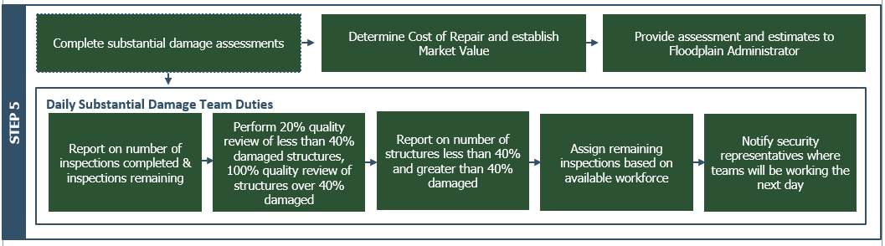

Once the substantial damage team is prepared for assessments, they will begin substantial damage determinations. The team will perform a number of daily duties, outlined in the steps below.

***Conduct Assessments and Make Occupancy Assessments***

When prioritizing where teams will conduct assessments, more experienced teams will be sent to areas with structures likely to have between 40-60% damage. It is important to remember that the damage estimate needs to include all costs to return the structure to its pre-damaged condition regardless of whether the owner plans to have all of the work done or not.

During this time, teams will also make occupancy determinations for the structures. If a structure is unsafe, the building will be marked with notices stapled directly onto the properties. An example of this notice can be found in Appendix G: Notice of Occupancy. Homeowners will also be notified by letter in case they are not in the area.

***Determine Cost of Repair***

The [Community Name] will need to determine the cost of repair for a structure to determine if it is substantially damaged. The FEMA SDE tool can be used to determine cost of repair.

**FEMA SDE Tool**

FEMA developed the tool to assist state and local officials in estimating substantial damage for residential and non-residential structures per the National Flood Insurance Program requirements adopted by the communities. The tool assesses damage caused by flood, wind, wildfire, seismic and other events.

Additional acceptable estimates of improvement can be obtained from the following sources.

* Itemized contractor’s estimates;
* Building valuation tables - limitations to these standard valuation tables include the fact that they don’t account for unique types of construction or all materials;
* “Qualified estimates” prepared by the local permitting/code enforcement official;
* Itemized costs provided by the structure owner – If accepted, as much documentation as possible is required including cost of labor.

When determining cost of repair, there are certain costs that must be included, and costs that can be excluded. An abbreviated list of these costs is shown in Table 4.

Table 4: Costs to Include and Exclude in Cost of Repair

| **Costs that must be included** | **Costs that can be excluded** |
| --- | --- |
| Materials and labor (actual or estimated costs, not discounted or donated) | Clean-up/trash removal |
| Site prep work | Land surveying costs |
| Demolition and debris removal | Cost to obtain plans/specs |
| Exterior (foundation, exterior finishes, windows, doors, attached deck/porches) | Permit and inspection fees |
| Interior finishes (flooring, wall finishes, built-in cabinets) | Costs to correct previously identified health/safety/sanitary violations |
| Utilities (HVAC, plumbing, electrical, lighting, built-in appliances, security systems) | Outside improvements (landscaping, sidewalks, detached accessory structures such as sheds, gazebos, pools) |
|  | Plug-in appliances |

A comprehensive list of costs that should be considered in the damage estimate can be found in Appendix H: Included/Excluded Costs for Substantial Improvements and Repair of Substantial Damage. All calculations for damage are carefully recorded. See Step 7 below for **[Community Name]**’s record keeping practices.

Five key SD elements make up over62% of the structure value and can be used to determine substantial damage for many residential structures. Table 5shows the elements and their percentages. Element percentages refer to the portion of the overall structure value that the individual element involves. For example, if a home has a slab foundation, the slab foundation represents roughly 12% of the overall home value.

Table 5: Structural Elements and Percent of Overall Structure

| **element** | **Percent of overall structure** |
| --- | --- |
| Foundation | 12% |
| Superstructure | 13% |
| Interior Finish | 13% |
| Doors and Windows | 16% |
| Plumbing | 8% |

***Establishing Market Value***

**Instructions**

Describe how the market value of damaged structures will be determined, and how they will be used. State what valuation data are used - appraisals, depreciated replacement costs, or tax-assessed values. Describe who will obtain the market values, how, and when.

**TIP:** The overwhelming majority of local officials use tax assessed valuation to determine market value. It is both fast and equitable. The other methods can be used if the market value is appealed.

When calculating substantial damage, the market value used is for the structure alone, and does not consider land or exterior improvements. The **[Community Name]** will use the assessed value of a structure from tax information as market value unless the resident provides a defendable value of their own.

**Market Value**

Pre-damage value of the structure. The market value should not include land value, landscaping, or accessory structures (e.g., gazebos, sheds, pools).

Additional acceptable sources of market value for structures include the following:

1. Adjusted assessed tax value (with or without multiplier).
2. Professional appraisals by a state-licensed appraiser.
3. Estimates of Actual Cash Value (ACV). Note that ACV is based on a unit cost (cost per square foot), the square footage for the building, a geographic adjustment factor, add-ons such as a porch or enhancements such as upgraded flooring, and a depreciation rating based on the pre-damage condition of the building.
4. “Qualified estimates” based on sound, professional judgement made by staff of the local building department or local or State tax assessor’s office (not recommended).

Building values obtained from NFIP claims data will only be used for screening purposes only.

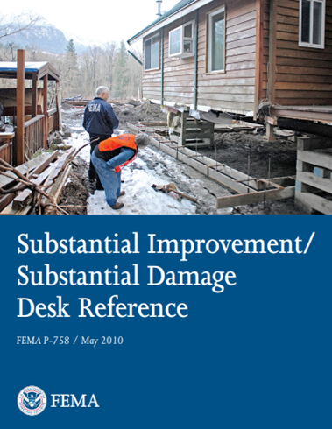If buildings have not been maintained and have deteriorated over time, then the market value is determined as of the date of the application for the permit to improve or repair the building. Additionally, whatever method is used to determine market value, it should be used uniformly and fairly for all residents. If an applicant disagrees with the method used, they can obtain and submit a professional appraisal at their own cost.

There may be challenges when determining building value. Owners may want to inflate building values in the belief that it will reduce the overall percent improvement. If the owners challenge a building value with an appraisal, the appraisal must be:

* prepared by a state-licensed appraiser;
* signed, sealed, and dated;
* include details specific to the building under review; and
* be reasonable for the structure type.

Section 4.5 of the FEMA P-758 [*Substantial Improvement/Substantial Damage Desk Reference*](https://www.fema.gov/sites/default/files/documents/fema_nfip_substantial-improvement-substantial-damage-desk-reference.pdf) provides extensive background information that can be used to determine market value.

***Substantial Damage Assessments***

While completing substantial damage assessments, the substantial damage team will report daily on the number of assessments completed. Blank SDE Damage Assessment Worksheets for residential and non-residential structures can be found in **Appendix I: Blank SDE Damage Assessment Worksheets**. Additionally, quality review of the completed assessments will be performed. For larger events, a report on the percent damage of structures assessed and those remaining will be maintained.

The [community official, ex. Code Enforcement Officer] will assign remaining assessments based on the available workforce.

Daily substantial damage team duties include:

* Report on the number of assessments completed and assessments remaining;
* [Best practice recommendation-tailor as appropriate to your community] Peer review QC performed on 20% of structures with less than 40% damage and 100% quality review of structures with over 40% damage;
* Report on structures with less than 40% and greater than 40% damage;
* Notify security representatives where teams will be working the next day.

After the damage estimate and market value have been determined and recorded, the [Community official, ex. FPA] will calculate if the cost of repairs is equivalent to or greater than 50% **[or threshold for your community]** of the market value. If that is the case, then the structure is substantially damaged.

Cost of Repairs ÷ Pre-Improvement Market Value of Structure ≥ 50% **[Adjust as necessary for your community]**

Once substantial damage assessments have been completed and preliminary determinations of substantial damage are completed, the [community official, ex. Code Enforcement Officer] will provide final substantial damage assessment results to the [community official, ex. Floodplain administrator].

Best Practice: Flood depths or high-water marks should be photographed on structures for substantial damage documentation. These photographs will also serve as a valuable record of the flood.

## Step 6: Review Damage Determinations

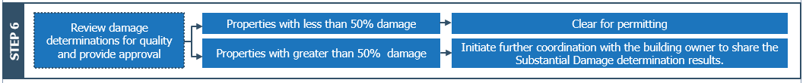

**Instructions**

Customize the section below as applicable to your community. Keep in mind, if you have adopted a lower threshold (less than 50%) or track Cumulative Substantial Improvements this paragraph will need to be customized.

After the substantial damage team delivers the substantial damage assessment results, the [community official, ex. Floodplain administrator] will review the results for quality. When the results are approved by the [community official, ex. Floodplain administrator], the list of substantially damaged structures will be used to clear properties with less than 50% damage for permitting and those with greater than 50% for further coordination with the building owner to share the Substantial Damage determination results.

## Step 7: Update Potential Substantial Damage Properties Inventory and Notify Property Owners

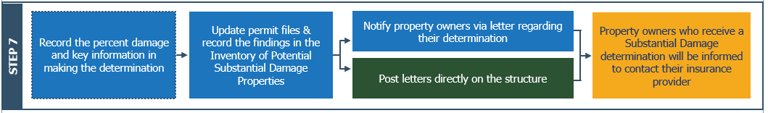

**Instructions**

Customize the section below as applicable to your community. Use the below text as an example of best practices for maintaining a substantial damage inventory or database.

Once the [community official, ex. FPA] has determined the percent damage, those findings need to be recorded along with the key information used in making the determination, including market value and the estimated costs of the damages. Careful record keeping is essential should the property owner appeal the determination. [Include the following sentence if your community has adopted Cumulative Substantial Improvement] This information is also critical to the [Community Name’s] tracking of Cumulative Substantial Improvements in accordance with its Flood Damage Prevention ordinance.

The [community official, ex. FPA] will also update the [Community Name] permit files and record the findings in the Inventory of Potential SD Properties (Appendix A: Potential Substantial Damage Properties List)**.**

**Appendix B: Letters to Property Owners** contains an example letter that will be sent to the property owners if their structure is determined to be substantially damaged. A sample letter for property owners whose structures have been determined to not be substantially damaged can also be found in **Appendix B: Letters to Property Owners**. Additionally, these letters will be posted directly on the structure by a member of the substantial damage team. If a structure has been determined substantially damaged, property owners will be advised to contact their insurance provider, where resources for NFIP insurance including Increased Cost of Compliance coverage can be found. Some homeowners may have private sector flood coverage where coverage options and resources can vary.

**[Best Practice - Include this paragraph as applicable]** The [community official, ex. GIS Manager] will update the Substantial Damage GIS layer to reflect new substantial damage determinations for the event. The Substantial Damage GIS layer will use the information for each parcel from [Community Name]'s Parcel GIS layer and will have additional fields for marking overall substantial damage, as well as determinations for each major event where substantial damage assessments are conducted. The event name will also be noted for tracking of when the substantial damage occurred. Marking the structure for substantial damage in the GIS layer will trigger a “flag/hold” on any permitting to substantial damage properties. This “hold” will alert the [community official, ex. Code Enforcement] when a property owner with substantial damage to their property applies for a permit.

## Step 8: Rebuilding After Substantial Damage

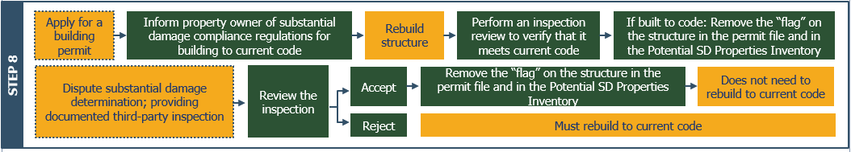

When rebuilding after a substantial damage determination, property owners must work with the [Community Name] to ensure properties are rebuilt to current code. Table 6shows property owner actions and [Community Name] responses when rebuilding properties after a substantial damage determination.

Table 6: Actions for Rebuilding After Substantial Damage

| **Property Owner Action** | **Community Response** |
| --- | --- |
| Apply for building permit | FPA/Code Enforcement informs property owner of substantial damage compliance regulations for building to current code |
| Rebuilds structure | FPA/Code Enforcement performs an inspection review to verify that it meets current code  If built to code: Remove the “flag” on the structure in the permit file and in the Potential SD Properties Inventory |
| Disputes substantial damage determination; provides documented third-party inspection that evaluates the damage level of the property | Review the inspection and accept or reject the third-party damage level determination*  Track property for cumulative substantial improvement/substantial damage |

\**If the structure is determined to not be substantially damaged by the third-party inspection and the City accepts this determination, the “flag” is removed from the structure in the permit file and in the Potential Substantial Damage Property Inventory and the property owner does not need to rebuild to current code but should be encouraged to integrate low-cost mitigation measures. If the structure is determined to be substantially damaged by the third-party inspection, the property owner must rebuild to current code.*

## Step 9: Substantial Damage Data Archiving & Mitigation Measures

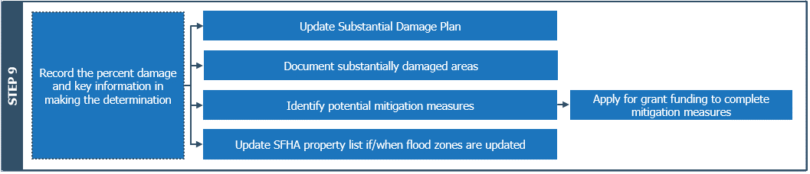

After all substantial damage assessments and determinations are complete, the [community official, ex. Floodplain administrator] will update the SDP. Additionally, the [community official, ex. Floodplain administrator] will identify mitigation measures to prevent substantial damage in the future and identify and apply for grant funding to complete mitigation measures. Finally, the floodplain administrator will update the SFHA property list if/when flood zones are updated.

Any new work done to a structure when rebuilding to code after substantial damage should not cause any aspect originally required for compliance to become non-compliant. Retrofitting methods to protect homes and businesses in the [Community Name] are shown in **Appendix J: Flood Protection for Homes and Businesses**. FEMA also published a guide of retrofitting options for homeowners to protect their homes from flooding that can be found [here](https://www.fema.gov/sites/default/files/2020-07/fema_nfip_homeowners-guide-retrofitting_2014.pdf).

Retrofitting

Any change made to an existing structure to reduce or eliminate the possibility of damage to that structure from flooding or other hazards

In general, residents are encouraged to implement flood and other damage-resilient building practices to prevent substantial damage in the future through the [Community Name]’s outreach. The [Community Name]’s website shows information about substantial damage and damage-resilient building practices to inform residents on methods to prevent flood damage in the future. Additionally, there are many additional resources available to assist homeowners and the community in disaster recovery and funding mitigation projects. More information on these resources can be found in **Appendix K: Additional Post-Flood Resources**.

## Step 10: Monitor and Enforce SD Compliance

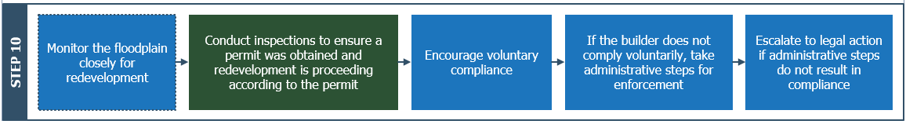

**Instructions**

Use this section to summarize your community's process for monitoring and enforcing SD compliance and adjust as needed for your community. Summarize the process for violation notification, explain how enforcement is accomplished and what penalties are enacted. You can find this information using your floodplain ordinance "Penalty" section.

As a condition of NFIP participation, the [Community Name] must comply with the permitting and building standards of our Flood Damage Prevention Ordinance. This includes ensuring compliance with Substantial Damage and Substantial Improvement provisions of the ordinance.

Rebuilding should be monitored closely to ensure permits are obtained and redevelopment is proceeding according to the approved permit. To ensure that development is meeting these requirements, the [community official, ex. Floodplain administrator] and their designee(s) must monitor the floodplain, and where necessary, conduct an inspection of a property.

If development activities without permits or contrary to the approved plans are discovered, action will be taken to enforce the [Community Name]’s ordinance. Several methods for enforcement exist. This section explores these methods.

***Voluntary Compliance***

The best approach is to convince the builder that complying with the ordinance is in their own best interest. This may take some explanation of the flood hazard and how the rules protect the property (or neighboring properties) from that hazard.

If the issue is protection of a building, sharing how expensive flood insurance could be if not built to code. Even if the builder or owner is not interested in flood insurance, future owners may want it and probably will be required to purchase it as a condition of a mortgage or loan.

Should voluntary efforts prove ineffective, the [Community Name] may employ the following compliance tools.

***Administrative Steps***

The first steps in enforcement involve what the **[Community Name]** can do as an ordinance administrator. When considering compliance tools, the **[Community Name]** will review the following potential course of action with legal counsel:

* Contact the property owner or building contractor in person or by telephone to explain the concerns.
* Notify the property owner (in writing) of the nature of the violations and what to do to correct them.
* Post a violation notice on the property. If a problem is found during construction of a permitted project, the [Community Name] has additional tools:
  + If the violation is a serious one, or if the problem still exists after a follow-up inspection, a stop-work order can be issued, or the permit can be revoked.
  + The certificate of occupancy can be withheld until the problem is corrected. Usually, utilities will not be turned on or a bank loan will not be closed until the certificate of occupancy is issued.

***Legal Recourses***

If administrative measures do not bring results, go back to the **[Community Name]** attorney, and discuss the next steps. This could mean taking the case to court and requesting additional enforcement measures be brought to bear.

Record keeping of all correspondence and meetings with the person accused of the violation are essential. Be prepared to identify what section of the ordinance was violated, when and how, and what was specifically allowed in the approved permit. Also be prepared to advise the attorney about what actions can be taken that will bring the project into compliance.

Depending on the violation, these actions could include removing the building (or other project), retrofitting the building to protect it, and/or applying for a variance. More detail is found in Section **[Insert applicable section of your Flood Damage Prevention Ordinance]** of the **[Community Name]**’s ordinances.

# Potential Substantial Damage Property Inventory

**Instructions**

This section of the plan corresponds to Step 4 of the required CRS planning process. It describes the process by which the potential SD property inventory was generated, lists the data fields stored for each property (required items plus others the community wishes to use), and discusses missing or desired data.

This section should also describe the method by which compliance with the federal Privacy Act is ensured when using data with personal identifiers.

**TIP**: For CRS communities, 50 points are available if FEMA’s Substantial Damage Estimator (SDE) is pre-populated for all properties with the potential to be substantially damaged.

The Potential SD Property Inventory included with this Plan is an [list database format, ex. Excel sheet, Access Database, etc.]. The Inventory has been pre-populated with the potential SD properties identified in the **Primary Flood Risk Areas** section of this plan. Because personally identifiable information is included in the SD Property Inventory, it is maintained in a secure file and accessible to **[Community Name]** representatives. The inventory can be obtained **[provide community department, contact, or link to where the password protected file is stored]**.

**Instructions**

List all the information items (attribute fields) included for each property in the Potential SD Property Inventory, including both the required items as well as any additional pieces of information your community maintains on each property. Describe how the data were obtained by listing sources. Use below examples and adjust as needed for your community.

**TIP**: The minimum fields to be included in your community’s Potential SD Property Inventory are as follows: Parcel Id/PIN, Address, Building Type, Foundation Type, and Square footage. Communities wishing to receive CRS credit for SDP2 must capture all 28 attributes listed below and load the data into the FEMA SDE.

The fields included for each property in the inventory are:

1 Parcel id/number

2 Address lines 1 & 2

3 Building Type (e.g. Residential or non-residential)

4 Foundation type (e.g. Slab on grade, crawlspace. Basement, etc.)

5 Square footage

The sources for the data in the Property Database include [Community Name] tax assessment and parcel data, FEMA’s Flood Map Service Center, and [list any other relevant data sources].

[Discuss the pieces of data that are missing and those that the community would like to add to the database in the future. Describe how your community plans to pursue those improvements.]

**Instructions**

50 points are available for CRS communities if FEMA’s Substantial Damage Estimator is pre-populated for all properties with the potential to be substantially damaged. To Obtain full CRS credit, the 28 fields reflected below are needed and must be entered into FEMA’s Substantial Damage Estimator.

Include this paragraph if your community has opted to pre-populate the SDE Tool. Remove if not applicable to your community.

**TIP:** Pre-populating the SDE Tool will save valuable time in a post event scenario. Even if your community is not in CRS, consideration should be given to taking this action.

The potential SD property inventory has been used to pre-populate FEMA’s SDE with all 28 building attributes listed below. Updates to the inventory will be completed in FEMA’s SDE on an as needed basis in accordance with the schedule provided in the **Primary Flood Risk Areas** section of this plan.

The attributes for each property pre-populated into FEMA’s SDE are:

1 Owner’s first & last name

2 Lot number

3 Parcel number

4 Address lines 1 & 2

5 Street suffix

6 Street cardinal (NW, SW, etc.)

7 Apartment, unit

8 City

9 State

10 County, parish

11 Zip code

12 Year of construction

13 Longitude

14 Latitude

15 Community name

16 Community NFIP ID

17 FIRM panel

18 FIRM zone

19 BFE

20 Suffix

21 Residential/non-residential

22 Inspector phone #

23 Date of FIRM panel

24 Regulatory floodway (Y/N)

25 Subdivision

26 Lowest floor elevation

27 Datum

28 Total square footage

# Pre-Event Action on Substantial Damage

**Instructions**

This section of the plan corresponds to Step 5 of the required CRS planning process, the ongoing (pre-event) actions to manage vulnerability to substantial damage. At least one action is required to help educate the community—residents and/or elected officials--about substantial damage (or substantial improvement) requirements. Training for the substantial damage management team is also considered a pre-event action, as is informing residents in potential substantial damage areas about mitigation options.

The following sections detail procedures and preparation that [Community Name] will do ahead of time to prepare for a disaster and streamline the substantial damage determination process.

## Annual Training of Substantial Damage Team Members

**Instructions**

Describe the annual activities, including schedule, how the activity was done and by whom. Include copies of any materials that were used (press releases, handouts, flyers, presentations, etc.). Adjust below sample paragraphs and sources as needed.

The substantial damage team will be trained using available substantial damage resources, including State NFIP Coordinators/state floodplain association training on substantial damage, the FEMA substantial damage training course and materials, and the FEMA SDE Tool training materials and exercises. Training will occur at least once a year for new members of the substantial damage team.

Online trainings are available here:

* Substantial Damage for Floodplain Administrators: [IS-0285: Substantial Damage for Floodplain Administrators - Lesson 1: Welcome to IS-0285 (fema.gov)](https://emilms.fema.gov/is_0285/curriculum/1.html)
* Using the Substantial Damage Estimator 3.0 Tool: [FEMA - Emergency Management Institute (EMI) Course | IS-284.A: Using the Substantial Damage Estimator 3.0 Tool](https://training.fema.gov/is/courseoverview.aspx?code=IS-284.a&lang=en)

FEMA also offers training workshops on SDE. FEMA may also deploy personnel to help local officials use the SDE tool after disasters. Additionally, there are disaster response certification programs available through International Code Council that enable local inspectors to become certified on damage assessments using state funding.

## Communication with Elected Officials on SD and SI Responsibilities

**Instructions**

Describe how community leaders in your community will be updated and informed of substantial damage requirements. Describe the process and include copies of minutes, presentations, letters, brochure, etc. as applicable. Use the example paragraph below as guidance and edit as needed for your community.

On [Insert date], the [community official ex. FPA] briefed the [board of Supervisors, council, other governing body] on [Community Name]’s management of substantial damage, its regulations, and the procedures included in this SDP to administer and enforce the regulations.

At the onset of any triggering event where SD assessments will be required, the [community official ex. FPA] will brief the [board of Supervisors, council, other governing body] on [Community Name]’s SD and SI regulations and the procedures included in this SDP. Prior to the meeting, the fact sheet found in **Appendix L: NFIP “Substantial Damage” Fact Sheet** is shared with elected officials. The fact sheet covers NFIP requirements including SI and SD.

# Plan Implementation

**Instructions**

This section should describe the SDP implementation process including any presentation made to public officials and public notices. A sample public notice document can be found in Appendix M: Public Notice Template**.**

This plan was submitted to the [insert name of the community’s governing body] on [give date] by [describe process, including cover letter, presentation, etc. as appropriate].

This plan is available for transmittal to the FEMA Regional Office, Region 2 and to the New York State Department of Environmental Conservation Floodplain Management Section, [floodplain@dec.ny.gov](mailto:floodplain@dec.ny.gov).

# Evaluation and Update of the Plan

Updates to this plan and/or evaluation reports are available for transmittal to the FEMA Regional Office, Region 2 and to the New York State Department of Environmental Conservation Floodplain Management Section, [floodplain@dec.ny.gov](mailto:floodplain@dec.ny.gov).

## Annual Evaluation Procedure

Instructions

Use this section to indicate when and how the substantial damage management plan will be updated. Indicate the timeframe of the regularly scheduled updates. Use the following paragraphs and points below as an example of best practices for regular plan updates and adjust as applicable to your community.

TIP: You must complete an annual evaluation of your SDP to continue to receive CRS credit. However, CRS does not require an annual update of the plan. The plan is only required to be updated as needed. For CRS purposes, all six planning steps below should be reviewed. Whether you participate in CRS or not, the framework will help your community assess the need for updates to the SD Management Plan or Potential SD Property Inventory.

[Community Name] will evaluate this SDP [indicate timeframe for regular updates ex. once per year or as needed]. The plan will be evaluated and reviewed by the [list community staff, ex. floodplain administrator, the Code Enforcement Officer, and GIS manager] annually. A template of the Annual Evaluation Report for the SDP can be found in **Appendix N: Annual Plan Evaluation Report Template**. All six planning steps must be reviewed. During this review, the team will go over the following:

* Review of pre-event action items
* Describe what was implemented (or not implemented)
* Recommend changes to the action items
* Highlight flood damage that has occurred in the past year and update the Substantial Damage Determinations Property List
* Update the plan to reflect new ordinance language that affect substantial damage or substantial improvement definitions
* Review the roles and responsibilities of Substantial Damage Management team. This includes confirming roles, assigning new roles, or redistributing roles.
* Review of post event actions. If a disaster has recently occurred, [Community Name]’s review team will answer the following questions:
* What steps were followed?
* What steps were not necessary?
* Were there additional steps necessary?
* Are there additional materials or research that could have been done to make the process easier?
* Should the order of steps be altered?
* Inspect documents that are prepared and printed out in case of a disaster.
* Are all documents up to date with current requirements and regulations?
* Are they in usable condition?
* Are there any additional resources to include?
* Ensure that links for references and guidance in the document are up to date and include any additional guidance that may have been released in the past year.

After this review is completed, the review team will complete the Annual Plan Evaluation Report stating that they have reviewed and approved the report and indicate any changes that have been made. The evaluation report and if deemed necessary, the updated Substantial Damage Management Plan will be shared with the [Community Name] elected officials by the [community official, ex. Floodplain administrator] at a [name of community meeting, ex. City Council meeting].

If there is any personally identifiable information in the data, a summary report will be prepared with aggregated data that will adhere to the Privacy Act. This summary report will then be shared with elected officials, committees, media, and the public.

**[Include this sentence if you are a CRS community]** The report summarizing the annual evaluation, as well as the updated Substantial Damage Management Plan, if applicable will also be available for each CRS cycle verification visit.

## Post-Event Evaluation Procedure

The Substantial Damage Management Plan will be updated after each major flood or other damaging event to re-evaluate the [Community Name] substantial damage management strategy and to update the substantial damage inventory **[and map]**. That update will occur within [weeks/months or other schedule] of the event.

# Considering Mitigation Options

**Instructions**

This section of the plan provides a summary of mitigation measures that can help reduce flood damage. The techniques are also applicable for rebuilding post-flood.

**TIP:** 50 points are provided for CRS communities that develop **structure-by-structure** pre-flood mitigation recommendations. Guidance on receiving credit for SDP3 can be found in the [2021 Addendum to the CRS Coordinator’s Manual, 2017 Edition](https://www.fema.gov/sites/default/files/documents/fema_community-rating-system_coordinator-manual_addendum-2021.pdf).

Please be aware that the content provided in this section does not include the level of detail required to obtain CRS SDP3 credit and is provided solely for informational purposes.

Identifying mitigation options and informing [Community Name] residents of potential mitigation projects will reduce future substantial damage to properties in the [Community Name].

## Mitigation Options

There are many mitigation measures that can be used to protect substantial damage structures and areas from future damage. Mitigation alternatives are shown in Table 7.

Table 7: Mitigation Measures for Flood Protection

| **Mitigation Measure** | **Description** | **Advantages** | **Disadvantages** | |
| --- | --- | --- | --- | --- |
| Acquisition | Transferring private property to property owned by the local government for open space purposes. | 100% flood protection  FEMA mitigation funds available for some properties | | High cost  Need source of non-FEMA cost share  Need interested public agency to take over the land |
| Elevation | Raising a structure above the base flood elevation. | More secure flood protection  Flood insurance rate reduction  FEMA mitigation funds available for some properties | | High cost  Need source of non-FEMA cost share |
| Reconstruction | Construction of an improved, elevated building on the same site where an existing building and/or foundation has been partially or completely demolished or destroyed. | More secure flood protection  Flood insurance rate reduction  FEMA mitigation funds available for some properties | | High cost  Need source of non-FEMA cost share |
| Development Regulations | Development and construction standards can be written such that flooding can be minimized by new construction and buildings are protected from floodwaters. | Provide property protection measures during construction at a lower cost  Provide a mechanism to avoid future flood losses | | Add initial cost to a development project |
| Purchase Flood Insurance | Flood insurance covers damage to a structure and its contents caused by surface flooding. | Always in effect  Works for all flood levels | | Does not prevent flood damage (does provide funds for repairs) |
| Drainage Maintenance | Includes maintenance efforts to ensure inlets and canals are free of clogging debris. | A cost-effective way for communities to avoid future flood losses from small storms  An effective way to avoid future repetitive flood losses | | Requires regular monitoring and maintenance |
| Improve Drainage Systems | Property specific improvements that will limit the risk of localized flooding, including grading around the foundation, use of gutters, or drainpipes. | Protects yards and streets as well as buildings | | Potentially High cost |
| Flood Vents | Flood vents are small permanent openings that allow floodwater to flow freely through an enclosure such as a crawlspace or garage. | Reduces structure damage | | Not for slab foundations |
| Elevate utilities and service equipment | Raise and anchor air conditioning condensers, heat pumps, water meters, and other service equipment onto pedestals or platforms that are at least 1 foot above the potential flood elevation. | Reduces equipment/utility loss | | Potentially high cost (if elevating electrical) |
| Sump pumps | Sump pumps, pump groundwater away from a structure. Excellent defense against basement seepage and flooding. | Provides mitigation during a flood | | Requires electricity (unless battery-powered) |
| Correct/prevent sewer backup problems | Install drain plugs for all basement floor drains to prevent sewer backups. Another option is to install sewer backflow valves for all pipes entering the building. | Prevents sewer from backing up | | Requires licensed plumber |
| Barriers | Berms or floodwalls can be effective and efficient ways to protect properties from flood damage but are not recommended for floodwaters deeper than three feet. The use of barriers needs to be evaluated on a property-by-property basis. | Effective for shallow flooding | | Subject to seepage  Not feasible for lots that are subject to deeper flooding |

## Outreach

**Instructions**

Describe activities you undertake to share flood protection with your residents pre-flood. Also describe how you intend to share flood protection and potential funding information with residents post-flood. Use the paragraphs that follow and resources in the appendices to support these efforts.

Mitigation outreach to substantial damage property owners is disseminated through multiple sources. Information on mitigation measures and potential funding is included on the [Community Name]'s website, as well as included in press releases and social media messages sent to residents following a disaster event. Appendix D: Sample Press Release includes language for residents on flood insurance and ICC coverage. Planned social media messages for residents following a disaster include language on how residents can protect their homes. Social media messages for [Community Name] residents are shown in Appendix E: Social Media Messages for Flood-Related Events.

## Potential Funding

FEMA and other Federal agencies have an array of financial assistance programs for States, communities, and individual property owners interested in mitigating the negative effects of flood hazards. Funding resource examples for mitigation measures can be found in Appendix K: Additional Post-Flood Resources. Many of the funding resources are effective for all properties regardless of a substantial damage declaration, except for Increased Cost of Compliance (ICC) coverage. ICC coverage provides funding toward the costs to mitigate a property that has been determined to be substantially damaged.

ICC funds as well as state grant funding may be used towards the non-federal match required for FEMA grant programs. The [Safeguarding Tomorrow Revolving Loan Fund Program](https://www.fema.gov/grants/mitigation/storm-rlf#:~:text=The%20Safeguarding%20Tomorrow%20Revolving%20Loan%20Fund%20%28RLF%29%20program,to%20reduce%20risks%20from%20natural%20hazards%20and%20disasters.), authorized under Section 205 of the [Robert T. Stafford Disaster Relief and Emergency Assistance Act](https://www.fema.gov/disaster/stafford-act), provides capitalization grants to states and other entities to establish revolving loan funds that provide hazard mitigation assistance for local governments to reduce risks from natural hazards and disasters. The program's state, low-interest loans may also be used to meet non-federal match requirements.

# Appendix A: Potential Substantial Damage Properties List

Personally identifiable information is not included in this Substantial Damage Plan.  This inventory is maintained in a secure file and accessible to **[Community Name]** representatives. The inventory is in a **[provide location, file path, and/or link to this data]**.

# Appendix B: Letters to Property Owners

## Sample Letter for Damage Assessments Notification

**[Insert Community Letterhead Here]**

**[Date]**

TO: **[Property Owners]**

**[Address]**

FROM: **[Local Official]**

[Address]

SUBJECT: **Upcoming Substantial Damage Assessments**

Dear Property Owner or Persons Residing at this Address,

The [insert community name] is requesting your cooperation to assist us with expediting recovery of our community from the impacts of [insert name of event]. As you should be aware, properties in flood zones designated on FEMA’s flood maps that were damaged by wind, water, fallen trees or other factors must be inspected before we can issue building permits for repair, reconstruction, or other improvements. In accordance with [insert community name]'s Floodplain Ordinance, we must determine whether the damage meets the definition of “substantially damaged.” Please see attached flyer for basic information.

The process we’ve developed to achieve efficient, orderly and responsive permit review, begins with damage assessments. Therefore, we ask that you allow our staff, or staff of other agencies such as State, FEMA, or private contractors working on our behalf, to access and inspect your damaged building. These authorized staff carry a “right of entry” document and their agency identification and must show them to you before you let them access your property. This assessment is different than initial preliminary damage assessments, and inspectors will inform you that they are at your property to perform substantial damage assessments.

The damage assessments are limited to evaluating the extent of damage to foundations, roofs, windows and doors, siding, installed appliances, electrical and plumbing, heating and air conditioning, and walls and floors. Assessments are required to assess the condition of the building and determine the work required to repair the building to its pre-damage condition. The period of assessments is limited to daylight hours only, and assessments are estimated to be completed between [insert anticipated period of assessments]. Once we have inspected your property and the results recorded in our database, we will send you a letter with the results and explain any requirements that may apply.

Construction to repair your structure cannot begin until after you have received a determination letter from the [insert community name] to inform you if your property has substantial damage. However, you can secure and protect your property before you receive this letter.

We greatly appreciate your willingness to allow our community inspectors to assess the condition of your property which will help you and the community move forward as quickly as possible with the permitting and repair of your building.

If you have any questions about this process or the inspectors, please contact us immediately by calling [phone number].

Thank you for your cooperation and support to help our community to recover from [insert name of event] and mitigate future flooding impacts.

Sincerely,

[Name, Title, Ex: City Manager/County Administrator]

## Sample Letter to Notify Property Owner SD Determinations Have Been Completed

**[Insert Community Letterhead Here]**

[Date]

TO: [Property Owners]

[Address]

FROM: [Local Official]

[Address]

SUBJECT: **End of Substantial Damage Assessment Period**

Dear Property Owner:

We have completed substantial damage assessments to buildings located in the FEMA Special Flood Hazard Area that were damaged during [disaster name]. You may now begin the permitting process if your structure requires immediate construction.

If the total cost of repairs is determined to be 50% or more of the market value before the disaster occurred, you will be notified by mail that your structure has substantial damage, and you will be required to construct your structure to comply with the [insert community name]'s building standards in the floodplain ordinance. If the total cost of repairs is determined to be less than 50% of the market value before the disaster occurred, you will also be notified by mail that your structure does not have substantial damage.

Sincerely,

[Name, Title, Ex: City Manager/County Administrator]

## Sample Letter to Notify Property Owners of Substantial Damage Determination

**[Insert** Community Letterhead **Here]**

[Date]

TO: [Property Owners]

[Address]

FROM: [Local Official]

[Address]

SUBJECT **Substantial Damage Assessment Determination**

Dear Property Owner:

We have reviewed your recent application for a permit to repair your home that was damaged by [insert cause of damage]. The building is located in a FEMA mapped Special Flood Hazard Area. As required by our floodplain management ordinance and/or building code, we have determined that the building has been substantially damaged. This determination is based on a comparison of the cost estimate of the work required to restore the building to its pre-damage condition to the market value of the building before the disaster (excluding land value). When the cost to repair equals or exceeds 50 percent of the market value of the building, the work to repair is considered substantial damage. The following information relates to the address referenced above:

|  |  |
| --- | --- |
| Community Number: | **[CID Number]** |
| Parcel Zone Information: | [Parcel Zone] |
| Fair Market Value: | [Dollar Amount] |
| Flood Damage: | [Dollar Amount from flood damage] |
| Percent Damaged: | [% of property damaged] |
| Ordinance Requirement: | [List ordinance requirements] |

The determination is that this structure is declared **Substantially Damaged** and must be brought into compliance with the [Community Name]’sFloodplain Ordinance prior to repair and reoccupation. For this structure to be in compliance with the ordinance, the structure must be elevated, moved outside the floodplain or demolished.

Building inspections, Building Permits, and an **Elevation Certificate** will be required prior to the issuance of a *Certificate of Occupancy*. This structure may **NOT** be occupied until these corrections are made.

We are available to meet with you and your designated representative (architect/builder) at a time convenient to you to discuss how to bring your home into compliance. There are several aspects that must be addressed to achieve compliance. The most significant requirement is that the lowest floor must be elevated to the Local Design Flood Elevation (LDFE) which is calculated using the methodology described in the Floodplain Development Regulations Ordinance. This is currently the FEMA Base Flood Elevation (BFE) plus two (2) feet of freeboard. You may wish to contact your insurance agent to understand how raising the lowest floor higher than the minimum required elevation can reduce NFIP flood insurance premiums.

If the damage was caused by flooding and if you have a flood insurance policy from the National Flood Insurance Program, you should contact your adjuster to discuss the Increased Cost of Compliance (ICC) coverage. This coverage may provide a claim payment to help pay for work required to bring your home into compliance. Your adjuster can explain that the ICC claim may also be used to pay certain costs associated with demolishing and rebuilding your home or moving your home to a site outside of the floodplain.

Please resubmit your permit application along with plans and specifications that incorporate compliance measures. Construction activities that are undertaken without a proper permit are violations and may result in stop work orders, fines, or other legal action.

Sincerely,

[Name, Title, Ex: City Manager/County Administrator]

## Sample Letter to Notify Property Owner Structure is Not Substantially Damaged

**[Insert** Community Letterhead **Here]**

[Date]

TO: [Property Owners]

[Address]

FROM: [Local Official]

[Address]

SUBJECT **Work Does Not Constitute Repair of Substantial Damage**

Dear Property Owner:

We have reviewed your recent application for a permit to repair your existing building that was damaged by [insert cause of damage]. The building is located in a FEMA mapped Special Flood Hazard Area. As required by our floodplain management regulations, we have determined that the work proposed to repair the damage does not constitute repair of substantial damage. This determination is based on a comparison of the cost estimate of the work required to restore the building to its pre-damage condition to the market value of the building.

Please be advised that we will make another determination if you elect to perform work other than what is necessary to repair the damage, such as additional renovations or upgrades or building an addition. Construction activities that are undertaken without a proper permit are violations and may result in stop work orders, fines, or other legal action.

Sincerely,

[Name, Title, Ex: City Manager/County Administrator]

# Appendix C: Substantial Damage Fact Sheet

**What is Substantial Damage?**

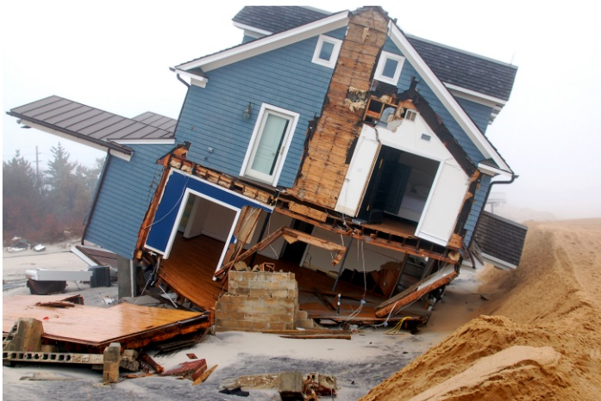After a disaster, such as a major flood or hurricane, community officials inspect homes damaged by flood waters to determine whether a structure was damaged to the extent that it will have to meet current building codes and floodplain management regulations when it is repaired.

**Substantial Damage (SD)** means damage of any origin sustained by a structure whereby the cost of restoring the structure would equal or exceed 50% of the market value of the structure before the damage occurred.

**What is a Substantial Damage Determination?**

A determination of “substantial damage” applies to a severely damaged home or other structure in a Special Flood Hazard Area, regardless of the cause of damage, where the community participates in the National Flood Insurance Program (NFIP).

*Photo Credit: FEMA*

To make the substantial damage determination, the cost of the proposed improvement or repairs is compared to the market value of the building (excluding land, accessory structures, and landscaping). If the resulting ratio equals or exceeds 50%, the existing building must be brought into compliance with the Community’s floodplain management requirements for new buildings.



Costs included in the total cost to repair include, but are not limited to:

|  |  |  |
| --- | --- | --- |
| * **Materials & labor** | * **Demolition & debris disposal** | * **Construction management & supervision** |
| * **Structural elements and exterior finishes** | * **Interior finishes** | * **Utility & service equipment** |

Property owners in the Special Flood Hazard Area will be notified of a substantial damage determination by letter if their proposed construction work constitutes repair of substantial damage or if it does not constitute repair of substantial damage.

**What Should Homeowners Do if Their Home Has Substantial Damage?**

Homeowners will need to repair the structure to meet floodplain regulation requirements. The most significant requirement is that the lowest floor must be elevated to the Local Design Flood Elevation (LDFE) which is calculated using the methodology described in the Floodplain Development Regulations Ordinance. This is currently the FEMA Base Flood Elevation (BFE) plus two (2) feet of freeboard.

If the damage was caused by flooding and if you have a flood insurance policy from the NFIP, you should contact your adjuster to discuss the Increased Cost of Compliance (ICC) coverage. This coverage may provide a claim payment to help pay for work required to bring your home into compliance. Your adjuster will also explain that the ICC claim may also be used to pay certain costs associated with demolishing and rebuilding your home or moving your home to a site outside of the floodplain.

If a homeowner disagrees with the market value used in the substantial damage determination, they may appeal the decision with the community’s permitting office by obtaining and submitting a professional appraisal at their own cost. Every structure owner has the option to submit an appraisal at their own cost. If the owners challenge a building value with an appraisal, the appraisal must be: prepared by a state-licensed appraiser; signed, sealed, and dated; include details specific to the building under review; and reasonable for the structure type.

**For More Information**

For answers to questions on substantial damage/improvement: Answers to [Questions About Substantially Improved/Substantially Damaged Buildings FEMA 213 - 2018](https://www.fema.gov/sites/default/files/2020-07/fema_p213_08232018.pdf)

For answers to questions about ICC Coverage: [NFIP Increased Cost of Compliance Coverage Fact Sheet-2020](https://dewberryportal.sharepoint.com/sites/NYSDECSISDResources/Shared%20Documents/General/FOR%20DEC_REVIEW/Comment%20Resolution/Instructions)

FEMA Substantial Damage Quick Guide: [Substantial Damage Quick Guide | FEMA.gov](https://www.fema.gov/fact-sheet/substantial-damage-quick-guide)

# Appendix D: Sample Press Release

[Insert Community Letterhead Here]

**RESIDENTS IN** [COMMUNITY NAME] **WITH DISASTER DAMAGE REMINDED OF PERMIT REQUIREMENTS**

Residents of [Community Name], hopefully this message finds you and your family safely out of harm. This press release is intended to provide information useful to all community members.

Firstly, community members should be aware of the following safety hazards [fill in safety hazards here (ex: fallen trees on roadways, downed utility lines, debris on sidewalks, etc.)].

The following are updates for utilities. Electricity is still out in [areas of town], and the [power company] is doing all they can to restore power. It can be expected to be restored [anticipated time if available, if not indicate it is still unknown]. The drinking water is currently [safe/unsafe] for consumption [if unsafe indicate when will be restored if known].

As property owners in [Community Name] contemplate clean up and repairs following recent [disaster], the [Community office, ex. Floodplain Administrator’s Office] is reminding residents to obtain local permits before repairing or rebuilding flood-damaged structures. The [Community Name] will waive permit fees for repairs due to _________.

The permits are required as part of local government participation in the National Flood Insurance Program and current Building Code, providing eligibility for flood insurance, flood disaster assistance, state and federal grants and loans, and buyout funds for flood-prone property.

Local floodplain management ordinances require that permits be obtained for any construction or development activity in a floodplain area, including the repair or reconstruction of structures damaged by a disaster.

Special conditions apply to substantially damaged buildings - those in which the total cost of repairs is 50 percent or more of the structure’s pre-disaster market value. If a building is found to be substantially damaged, regulations require that repairs not begin until compliance with the local floodplain ordinance is demonstrated and will have the same building requirements as new construction. In some cases, that may require repairs that include elevating or commercial flood-proofing the structure to reduce the potential for future flood damage. If damage is less than 50 percent, you may want to consider bringing the structure into compliance anyway to protect the structure against future damage, lower flood insurance rates, and eliminate the possibility of needing to do it later if additional future improvements cumulatively result in greater than 50 percent.

The cost to repair must be calculated for full repair to "pre-damaged" condition, even if the owner elects to do fewer repairs. The total cost to repair includes structural and finish materials as well as labor. If labor and materials have been donated or being performed by yourself, they must still be assigned a value. If local building codes require the structure to be repaired according to certain standards, these additional costs must be included in the full repair cost for the structure.

If you are filing a flood insurance claim, you need to report your losses to your insurance agent or company. An adjuster will be assigned to estimate your damages and advise you how to prepare “Proof of Loss” documentation. Adjusters may authorize advance partial payments to help owners start making repairs. After the adjuster and owner agree on the damage estimate, the adjuster sends documentation to the owner’s insurance company and the claim is settled (paid), unless the claim is denied by FEMA. Often times NFIP claims can be paid quickly and ahead of a community’s effort to determine building permit requirements. Make sure you acquire the necessary permits for any work performed to avoid violating the building code and Flood Damage Prevention Ordinance. The National Flood Insurance Program Claims Handbook can be found here: <https://www.fema.gov/sites/default/files/2020-05/FINAL_ClaimsHandbook_10252017.pdf>

Information on how to start your claim can be found here: <https://www.fema.gov/flood-insurance/resources-practitioners/file-your-claim>

If you disagree with your insurance claim, you can file an appeal with your insurance company. The policyholder must submit the appeal within 60 days after the date of the insurance company’s written denial letter. Information on this process can be found here: <https://www.fema.gov/sites/default/files/2020-09/fema_appealing-flood-insurance-claim-en_fact-sheet_jun2020.pdf>

State and federal assistance may be available to property owners to reduce the chances of future flood damage. Mitigation assistance may cover costs of relocation, or for elevating or purchasing flood-damaged structures. If damage is caused by a flood, flood insurance may also provide up to $30,000 to protect a structure from future flooding through a claims process known as ICC (Increased Cost of Compliance). The property owner must have had NFIP flood insurance prior to the flood event and received a Substantial Damage determination from [Community Name] for ICC to become available.

Property owners and residents with [disaster name]-damaged buildings should contact [local building and zoning administrator] for more information on repair and reconstruction permits. Contact your insurance agent for information about filing claims and future mitigation through ICC.

Any other questions or concerns can be directed to [contact information].

# Appendix E: Social Media Messages for Flood-Related Events

**Instructions**

Use the table below as a guidance/ example of best practices for social media messaging for your community pre-and post-flood or disaster event. Customize the table below as applicable to your community's social media and web resources available to your residents.

| **Topic Covered** | **Message** |
| --- | --- |
| Before the flood: Know your flood hazard | Storms in the [Community Name] with rainfall in excess of less than 2 inches within a couple of hours can generally be expected to cause flooding in low lying areas. Sign-up for [Community Name] weather alerts to stay informed about approaching storms. |
| Before the flood: Protect people from the hazard | Do you know your evacuation route? Make a plan for evacuation for your family by visiting the [insert link to community evacuation routes]. |
| After the flood: Protect people from the hazard | Don’t enter a flooded building until it’s been cleared and declared safe by an inspector. |
| After the flood: Protect your property from the hazard | If your water heater or furnace needs to be replaced, have the new one installed above the flood level, so you won’t have to replace it after the next flood. Efforts such as this will not only protect the equipment in a flood, they may also provide a discount on flood insurance. |
| After the flood: Protect your property from the hazard | Do you need to repair damaged property from the recent flood? Get a building permit before you start your post-flood repairs. |
| After the flood: Protect people from the hazard | A car can be swept away in as little as one foot of water. If the street is under water, turn around, don’t drown! |
| After the flood: Protect people from the hazard | If your house recently flooded, do not go back until you receive official notification from [Community Name] that it is safe to do so. |
| After the flood: Protect your property from the hazard | The [Community Name] will be conducting substantial damage assessments on structures located within the FEMA Special Flood Hazard Area. For more information on substantial damage, visit [Substantial Damage Quick Guide | FEMA.gov](https://www.fema.gov/fact-sheet/substantial-damage-quick-guide#:~:text=What%20is%20Substantial%20Damage%3F,considered%20to%20be%20Substantially%20Damaged.). |
| After the flood: Protect your property from the hazard | The [Community Name] has concluded substantial damage assessments. You will receive a letter in the mail regarding the damage assessment of your home. Failure to obtain reconstruction approval may result in a Stop Work Order. |

# Appendix F: Notice of Damage and Permits Required

**NOTICE!**

Your structure is located in a FEMA mapped floodplain and was damaged by [event name/type].

A damage assessment must be conducted by [Community Name].

Before occupying this building or beginning any repairs you must call the [contact, FPA, permitting office] to schedule an inspection.

They can be reached at the following contact information [contact].

Failure to obtain reconstruction approval may result in a Stop Work Order.

# Appendix G: Notice of Occupancy

**UNSAFE STRUCTURE NOTICE!**

This structure has been deemed unsafe for human occupancy.

No individual is to occupy this building until the structure is rendered safe and secure.

Before occupying this building or beginning any repairs you must call the [contact, FPA, permitting office].

They can be reached at the following contact information [contact].

Failure to obtain reconstruction approval may result in a Stop Work Order.

# Appendix H: Included/Excluded Costs for Substantial Improvements and Repair of Substantial Damage

**Included Costs**

Items that must be included in the costs of improvement or costs to repair are those that are directly associated with the building. The following list of costs that must be included is not intended to be exhaustive, but characterizes the types of costs that must be included:

* Materials and labor, including the estimated value of donated or discounted materials and owner or volunteered labor
* Site preparation related to the improvement or repair (foundation excavation, filling in basements)
* Demolition and construction debris disposal
* Labor and other costs associated with demolishing, moving, or altering building components to accommodate improvements, additions, and making repairs
* Costs associated with complying with any other regulation or code requirement that is triggered by the work, including costs to comply with the requirements of the Americans with Disabilities Act (ADA)
* Costs associated with elevating a structure to the Design Flood Elevation
* Construction management and supervision
* Contractor’s overhead and profit
* Sales taxes on materials
* Structural elements and exterior finishes, including:
  + Foundations (e.g., spread or continuous foundation footings, perimeter walls, chainwalls, pilings, columns, posts, etc.)
  + Monolithic or other types of concrete slabs
  + Bearing walls, tie beams, trusses
  + Joists, beams, subflooring, framing, ceilings
  + Interior non-bearing walls
  + Exterior finishes (e.g., brick, stucco, siding, painting, and trim)
  + Windows and exterior doors
  + Roofing, gutters, and downspouts
  + Hardware
  + Attached decks and porches
* Interior finish elements, including:
  + Floor finishes (e.g., hardwood, ceramic, vinyl, linoleum, stone, and wall-to-wall carpet over subflooring)
  + Bathroom tiling and fixtures
  + Wall finishes (e.g., drywall, paint, stucco, plaster, paneling, and marble)
  + Built-in cabinets (e.g., kitchen, utility, entertainment, storage, and bathroom)
  + Interior doors
  + Interior finish carpentry
  + Built-in bookcases and furniture
  + Hardware
  + Insulation
* Utility and service equipment, including:
  + HVAC equipment
  + Plumbing fixtures and piping
  + Electrical wiring, outlets, and switches
  + Light fixtures and ceiling fans
  + Security systems
  + Built-in appliances
  + Central vacuum systems
  + Water filtration, conditioning, and recirculation systems

**Excluded Costs**

Items that can be excluded are those that are not directly associated with the building. The following list characterizes the types of costs that may be excluded:

* Clean-up and trash removal
* Costs to temporarily stabilize a building so that it is safe to enter to evaluate required repairs
* Costs to obtain or prepare plans and specifications
* Land survey costs
* Permit fees and inspection fees
* Carpeting and recarpeting installed over finished flooring such as wood or tiling
* Outside improvements, including landscaping, irrigation, sidewalks, driveways, fences, yard lights, swimming pools, pool enclosures, and detached accessory structures (e.g., garages, sheds, and gazebos)
* Costs required for the minimum necessary work to correct existing violations of health, safety, and sanitary codes
* Plug-in appliances such as washing machines, dryers, and stoves

# Appendix I: Blank SDE Damage Assessment Worksheets

**Instructions**

The forms on the following pages are for reference only. These forms have been provided in full-scale, PDF format for your community's convenience. The editable form is available in the Fillable Forms Folder associated with these DEC SD Resources.

## Residential Structure Assessment Worksheet

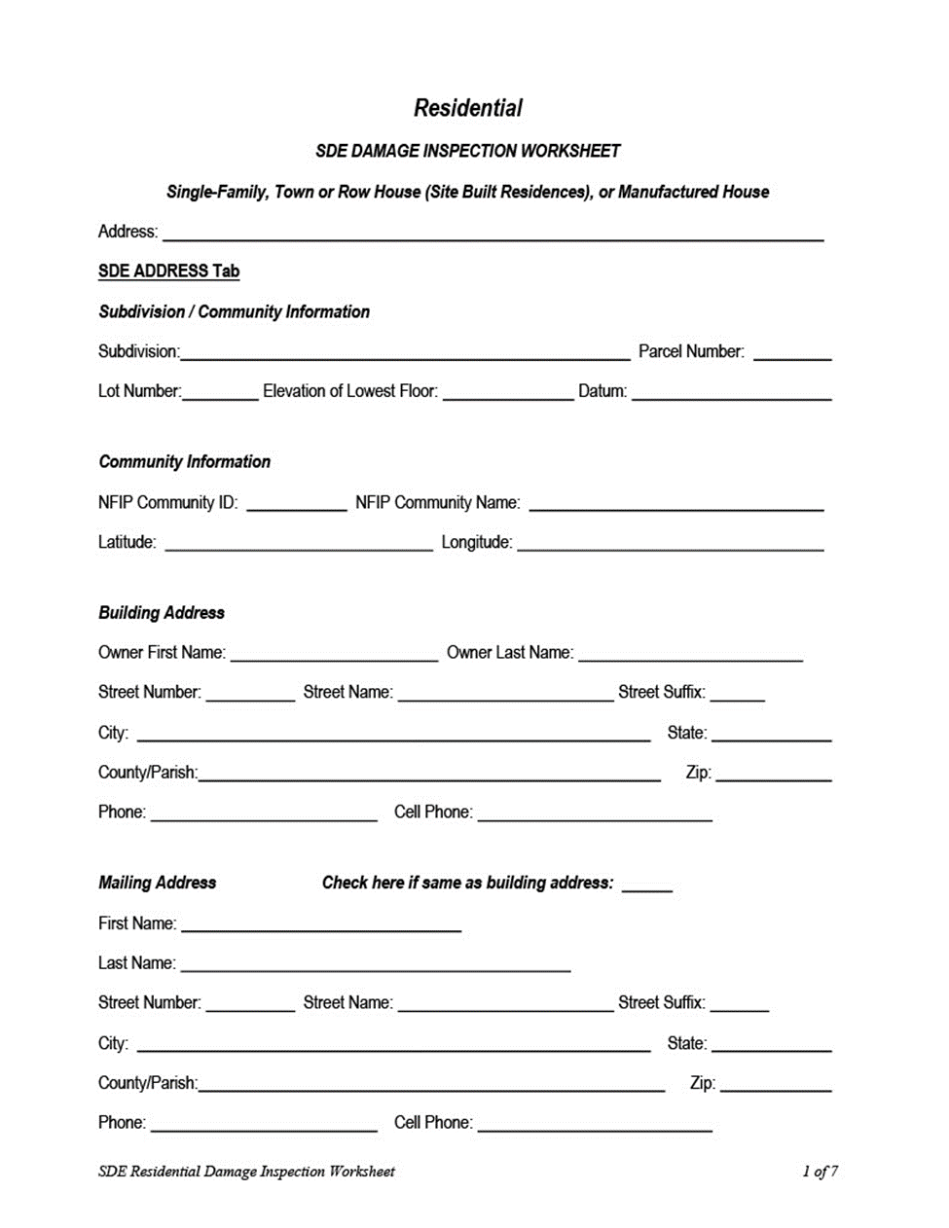

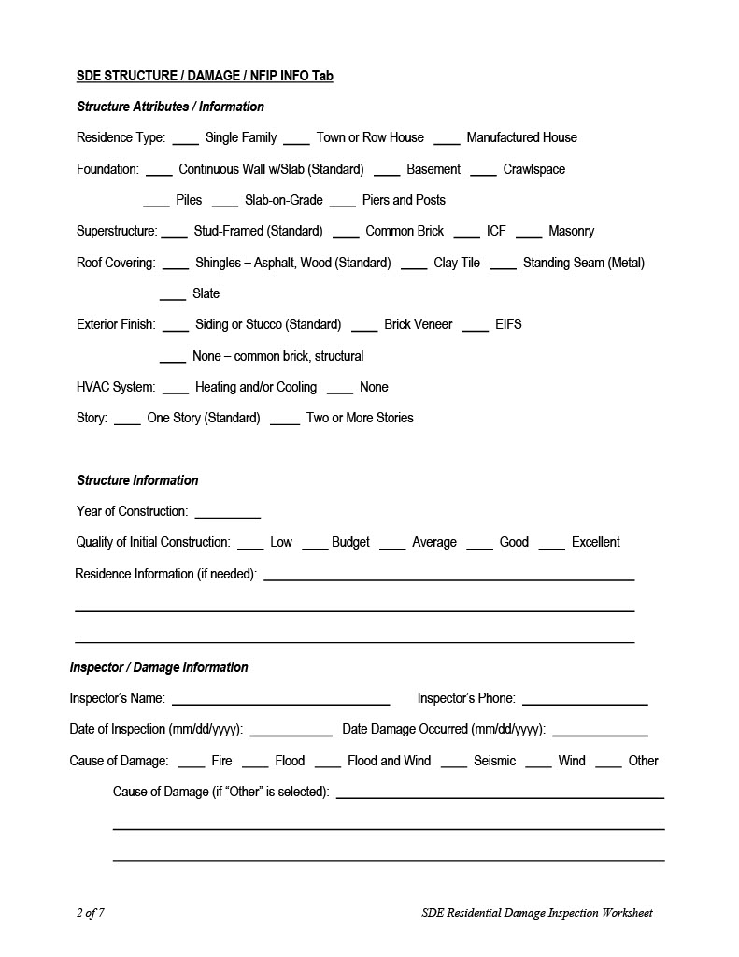

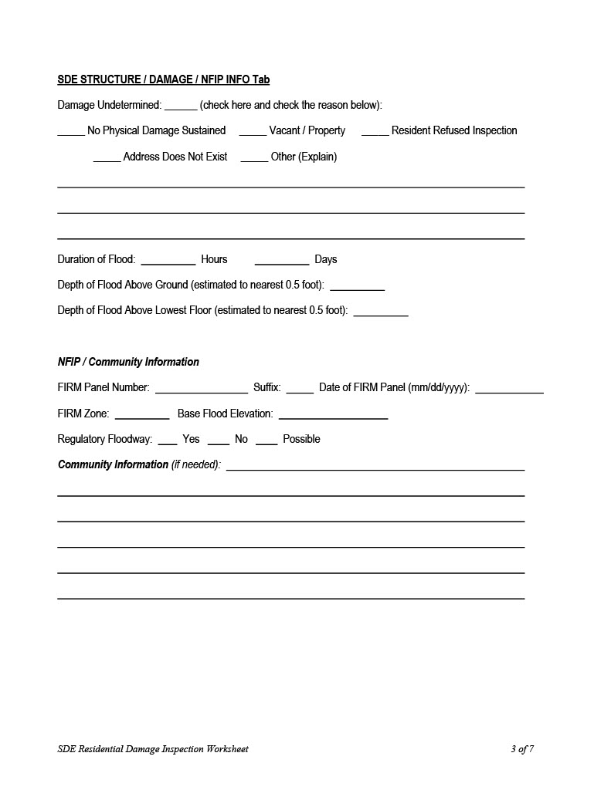

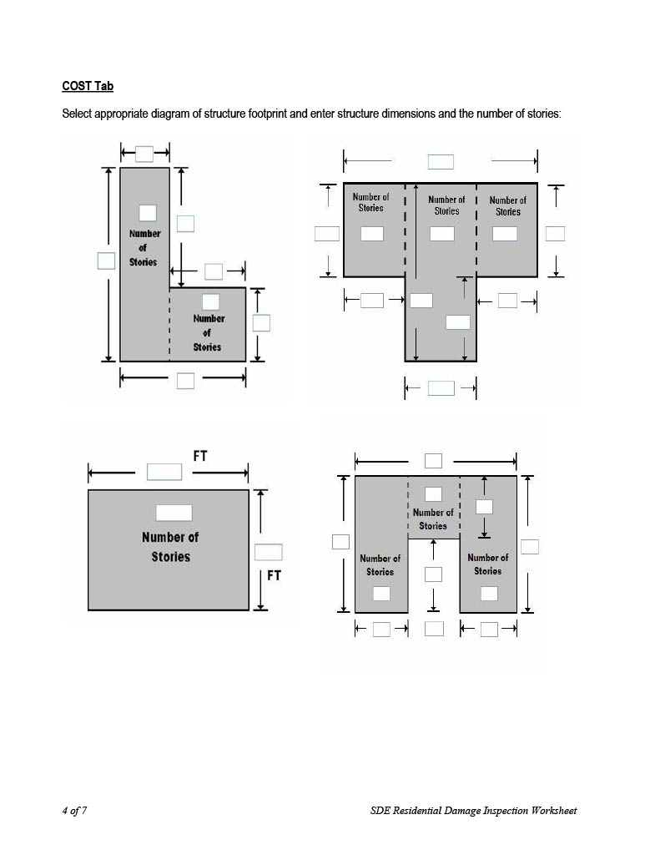

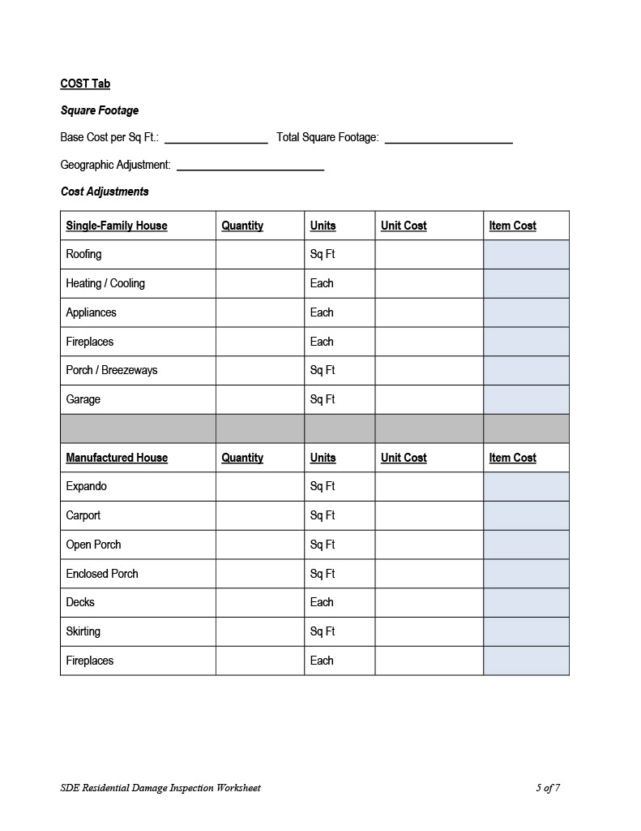

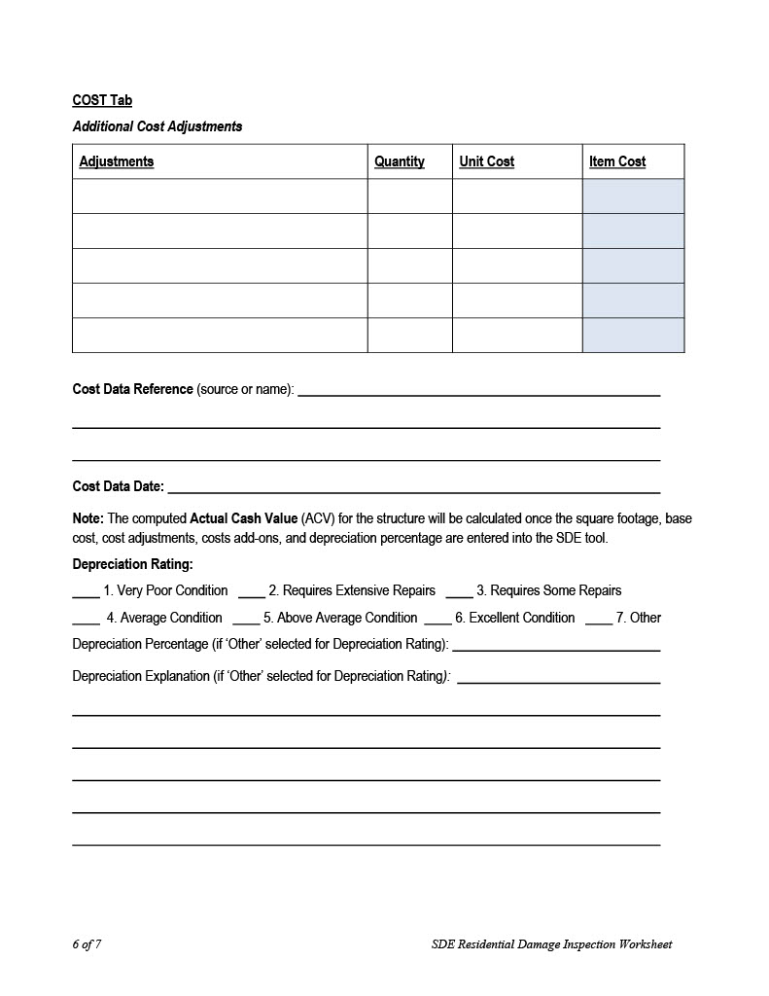

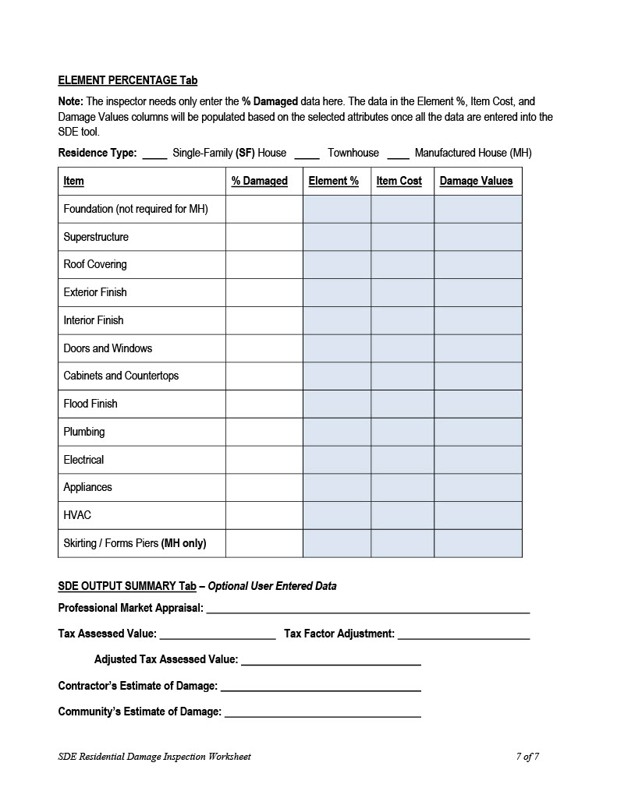

## Non-Residential Structure Assessment Worksheet

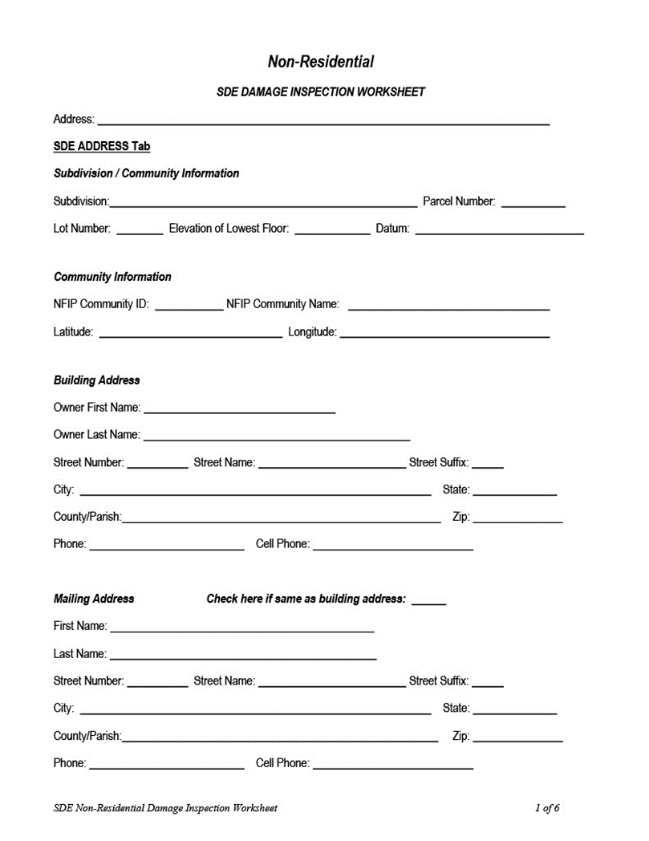

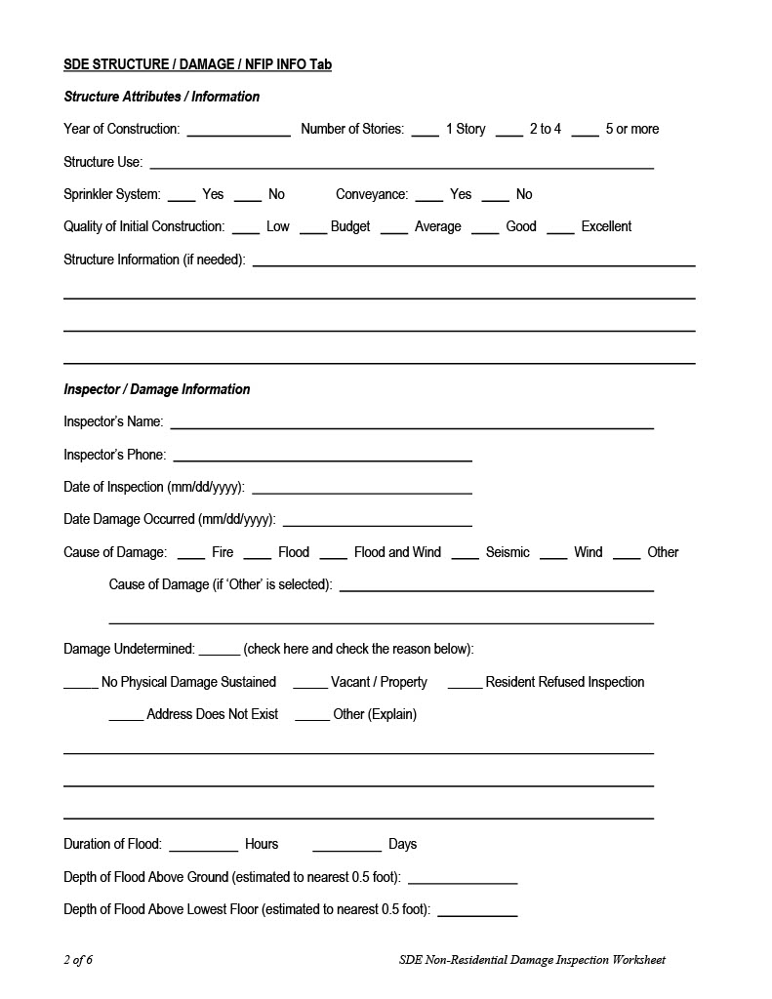

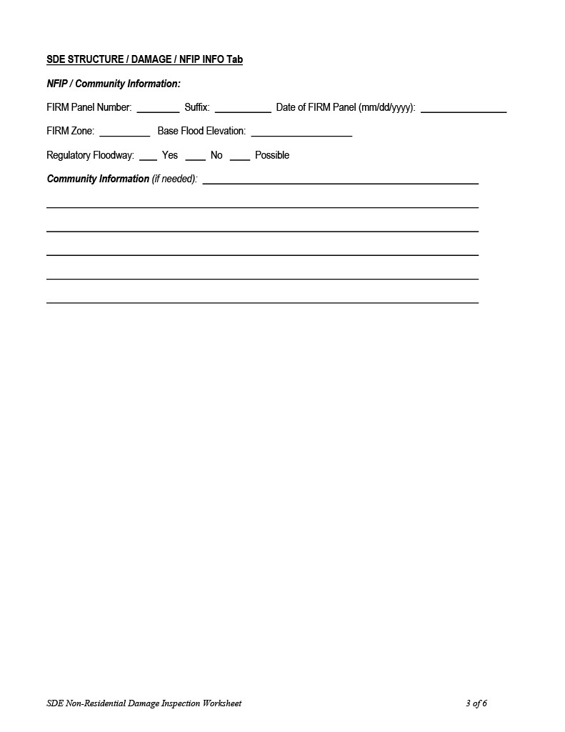

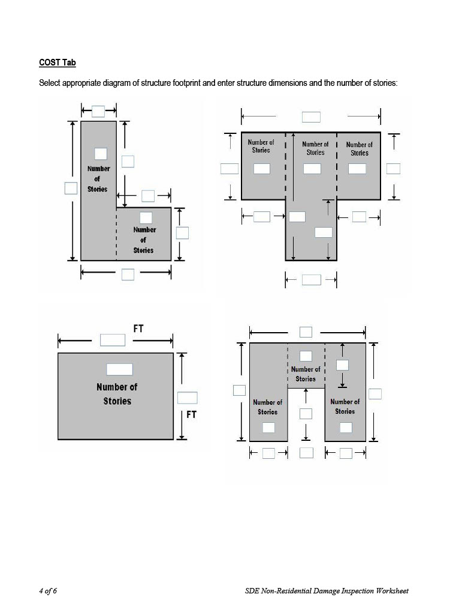

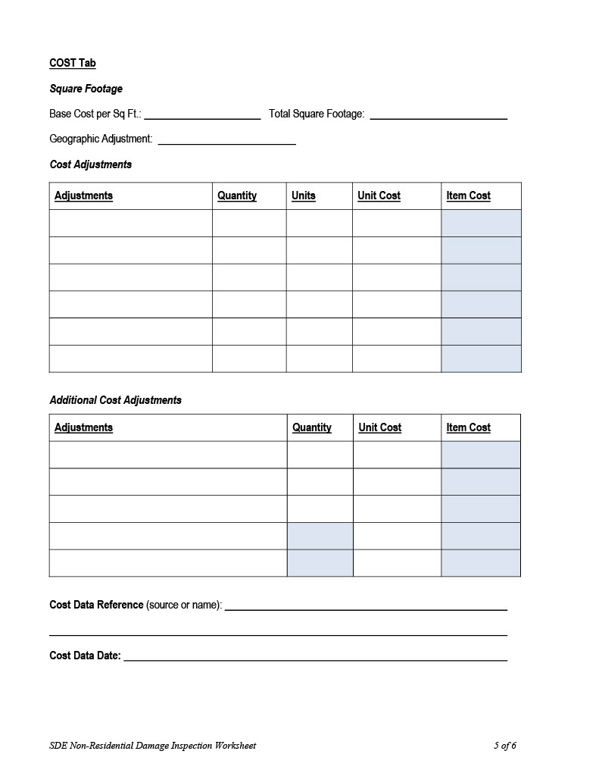

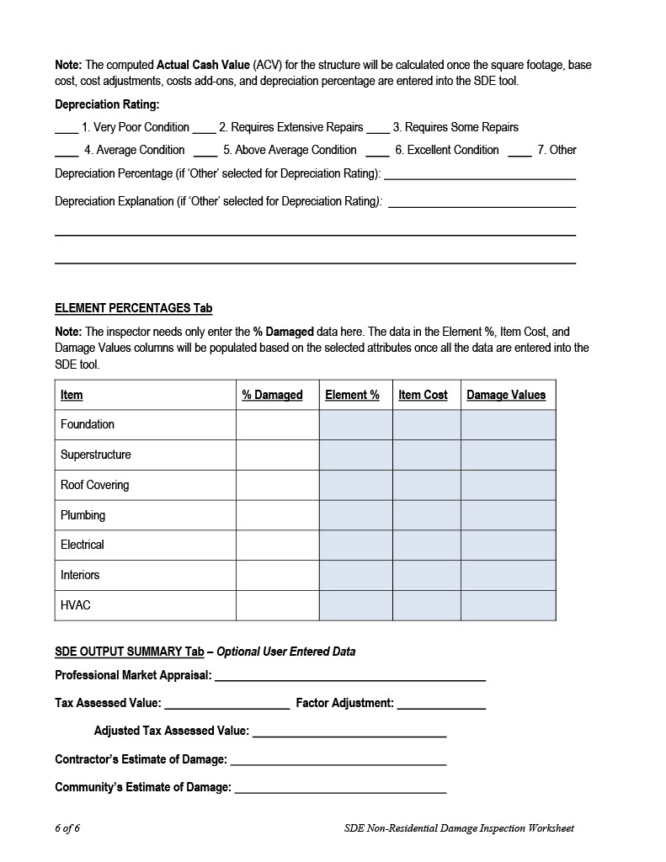

# Appendix J: Flood Protection for Homes and Businesses

When it comes to protecting your property from a flood event, there are many measures you can take before a flood occurs in order to be prepared. These include purchasing flood insurance; planning ahead about where and how you will move furniture out of harm’s way; keeping materials like sandbags, plywood, plastic sheeting and lumber handy for emergency waterproofing; and clearing brush and debris away from storm drains and ditches so water can drain away from the structure.

Special Flood Hazard Area

Properties located in a Special Flood Hazard Area (SFHA) have more than a 25% chance of flooding over the life of a 30-year mortgage. To minimize flood losses, properties in a SFHA are subject to specific development requirements.

There are also more permanent projects for protecting your property. Although such projects do not remove the flood insurance requirement for properties with federally regulated or insured mortgages that are located in the Special Flood Hazard Area (SFHA), (*the 1% annual chance or “100-year” floodplain as shown on the FEMA Flood Insurance Rate Map*), these projects can provide a level of protection for your property and bring you peace of mind. The technical limitations of the methods and the cost will help you determine the best project for your home or business.

|  |  |
| --- | --- |
| **Elevate the Structure**   * Ensure the lowest floor is above the Design Flood Elevation (In New York State this is BFE plus 2 feet). * Elevate the entire structure, including the floor, or leave the structure in its existing position and construct a new raised floor within the structure. * Elevation techniques include: posts, raised crawl space foundation, extending foundation walls. | 61-Substantial Improvement.jpg  House elevated to above the DFE *(Source- FEMA)* |

|  |  |
| --- | --- |
| **Protection of Utilities**   * One of the easiest, most cost-effective retrofitting methods. * Raise and anchor air conditioning condensers, heat pumps, water meters, and other service equipment onto pedestals or platforms that are at least 1 foot above the potential flood elevation. Another option is to create a shield to divert water away from utilities and appliances. * Basements are particularly floodprone. Residents should limit the furnishings in the basement and relocate equipment to a higher floor if possible. | Relocating utilities to above DFE *(Source- FEMA)* |
| **Drainage Improvements**   * Determine how water flows or accumulates around your home or business to identify potential trouble spots. * Stormwater should always drain away from the building; if necessary, change your landscaping to improve runoff. This may include building up any sunken areas around the foundation, digging small depressions to properly channel water, and otherwise improving the yard so that it slopes away from your home. * Please note that any drainage improvements must be limited to only your property. Drainage improvements cannot redirect stormwater or floodwater onto neighboring properties. | Grading a yard to direct surface water away from the foundation |

# Appendix K: Additional Post-Flood Resources

## Flood Insurance Claims and Increased Cost of Compliance

### National Flood Insurance Program Flood Insurance Claims

Property owners who have NFIP flood insurance policies will receive information from FEMA on the claims process, including the NFIP Insurance Claims Handbook. The following steps must be taken to file a claim:

* Owners report losses to their insurance agents or companies.
* Adjusters are assigned to estimate damage (“a detailed room-by-room unit-cost estimate of damage”) and advise owners about preparing the “Proof of Loss” documentation. Adjusters may authorize advance partial payments to help owners start making repairs.
* After the adjuster and owner agree on the damage estimate, the adjuster sends documentation to the owner’s insurance company and the claim is settled (paid), unless the claim is denied by FEMA.

Often, NFIP claims can be paid quickly and ahead of a community’s effort to determine building permit requirements. Therefore, it is important that the substantial damage team makes sure property owners understand the need for permits, and that working without them may violate the building code. If owners ask about filing a claim, they will be directed to the resources below. If they do not have NFIP insurance, they will be informed that they need to work with their Homeowner’s insurance provider.

Additional resources for policy holders:

* National Flood Insurance Program Claims Handbook:  
  <https://www.fema.gov/sites/default/files/2020-05/FINAL_ClaimsHandbook_10252017.pdf>
* FEMA Web Page, How do I start my flood claim?  
  <https://www.fema.gov/flood-insurance/resources-practitioners/file-your-claim>

#### Increased Cost of Compliance (ICC)

Use the ICC claim to:
Elevate the house on your lot
Demolish and rebuild the house
Move the house to high ground
Floodproof a non-residential structureSubstantially damaged properties that are in the SFHA and insured through the NFIP may be eligible for Increased Cost of Compliance (ICC) coverage. Private insurance may or may not have a rider that provides these funds. As of 2021, ICC coverage provides up to $30,000 toward the costs to mitigate a property that has been determined to be substantially damaged. A substantial damage determination triggers the requirement that owners bring structures into compliance with NFIP requirements for new buildings and the community’s ordinance in effect at the time of the flood event, which may mean elevating or relocating the structure, adding flood vents, or making other changes based on the flood zone. Below are the steps property owners must take to file an ICC claim.

* Contact the insurance company and document the loss, including photos.
* If the home is determined to be substantially damaged, discuss with the community what mitigation activity is required to bring the building into compliance and if any mitigation grants are available
* Submit to the adjuster the community’s substantial damage or RL loss letter, a signed repair contract, and the building permit that documents the rebuilding requirements in the floodplain.
* Insurance providers will also verify that a building’s flood damages equate to 50% or greater of the before damage market value. Note that this is for information purposes and does not change the official substantial damage determination made by the community.

In some cases, individual policyholders can take advantage of Federal grant money to supplement the cost of mitigation activities. Policyholders can assign their ICC benefits to their community and enable the community to file a single claim on behalf of a community mitigation project. FEMA will count the ICC claim monies as non-Federal matching funds when applying for mitigation grants, because ICC coverage is a direct contract between the policyholder and the insurer. The community can then use FEMA mitigation grant funds to help pay for any additional portion of the cost of elevation, floodproofing, relocation, or demolition that is more than the ICC claim payment.

Additional resources on ICC of Compliance can be found as noted below. If the substantial damage team is asked about ICC, they should point residents to these resources.

* FEMA ICC Website:   
  <https://www.fema.gov/floodplain-management/financial-help/increased-cost-compliance>
* Increased Cost of Compliance Factsheet:  
  <https://www.fema.gov/sites/default/files/2020-08/fema_increased-cost-of-compliance_fact-sheet.pdf>
* FEMA P-1080 – Answers to Frequently Asked Questions About Increased Cost of Compliance:  
  <https://www.fema.gov/sites/default/files/2020-11/fema_p1080_icc_faq_20170817.pdf>

### FEMA Grant Programs

The following are examples of FEMA post-disaster funding assistance options. This information changes annually. Check with your County Emergency Management Office for the latest Notice of Funding Opportunity for the current fiscal year.

#### FEMA Hazard Mitigation Grant Program

The Hazard Mitigation Grant Program (HMGP) provides grants to state and local governments, Indian tribes or other tribal organizations, and certain private non-profit to implement long-term hazard mitigation measures after a major disaster declaration. The purpose of the program is to reduce the loss of life and property due to natural disasters and to enable mitigation measures to be implemented during the immediate recovery from a disaster. Hazard Mitigation Grant Program funding is only available in states following a Presidential disaster declaration.

Individual homeowners and businesses may not apply directly to the program; however, a community or other qualified sub-grantee may apply on their behalf. Projects must provide a long-term solution to a problem, for example, elevation of a home to reduce the risk of flood damages as opposed to buying sandbags and pumps to fight the flood. In addition, a project's potential savings must be more than the cost of implementing the project. Funds may be used to protect either public or private property or to purchase property that has been subjected to, or is in danger of, repetitive damage.

Additional information on HMGP can be found here:

* Hazard Mitigation Grant Program:  
  <https://www.fema.gov/grants/mitigation/hazard-mitigation>
* Hazard Mitigation Assistance Guidance:  
  <https://www.fema.gov/sites/default/files/2020-07/fy15_HMA_Guidance.pdf>

#### Flood Mitigation Assistance

The Flood Mitigation Assistance (FMA) Program is a competitive grant program that is offered on an annual basis and provides funding to states, local communities, federally recognized tribes and territories to be used for projects that reduce or eliminate the risk of flood damage to buildings insured by the NFIP. Grants are designed to help communities apply a sustained flood reduction program that focuses on reducing or eliminating claims under the NFIP. The goal is to reduce overall risk to population and structures from future flood hazard events while reducing reliance on federal disaster funding.

FEMA requires local governments to develop and adopt hazard mitigation plans as a condition for receiving funding for FMA projects. FEMA chooses recipients based on the applicant’s ranking of the project and the eligibility and cost-effectiveness of the project. FEMA establishes ranking criteria with each grant cycle. Project eligibility requirements include a positive benefit cost analysis, good standing in the NFIP and the project must be identified in the Hazard Mitigation Plan. Consult the Hazard Mitigation Assistance guidance below for more information.

Local governments may apply for FMA grants through the New York Department of Homeland Security and Emergency Services (DHSES). Individuals must seek assistance and apply through their local governing authority.

FMA Project Grants are available to help States and NFIP participating communities implement measures to reduce flood losses. Communities receiving FMA Project Grants must be participating in the NFIP. Examples of eligible FMA projects include: flood reduction projects, elevation, acquisition, or relocation of NFIP-insured structures.

Additional information on FMA grants can be found here:

* Flood Mitigation Assistance (FMA) Grant:  
  <https://www.fema.gov/grants/mitigation/floods>
* Hazard Mitigation Assistance Guidance:  
  <https://www.fema.gov/sites/default/files/2020-07/fy15_HMA_Guidance.pdf>
* Link to DCA Division of Disaster Recovery and Mitigation:  
  <https://www.nj.gov/dca/ddrm/pdf_docs/2.10.102%20MAP_Policy_Final.pdf>

#### Building Resilient Infrastructure and Communities (BRIC)

FEMA’s Building Resilient Infrastructure and Communities (BRIC) program is also a competitive grant program that is offered on an annual basis for infrastructure projects. It supports communities that undertake hazard mitigation projects to reduce the risks they face from disasters and natural hazards. BRIC is a new pre-disaster hazard mitigation program that replaces FEMA’s Pre-Disaster Mitigation (PDM) program.

The BRIC program's guiding principles are supporting communities through capability- and capacity-building; encouraging and enabling innovation; promoting partnerships; enabling large projects; maintaining flexibility; and providing consistency.

The BRIC program aims to categorically shift the federal focus away from reactive disaster spending and toward research-supported, proactive investment in community resilience. BRIC projects demonstrate innovative approaches to partnerships, such as shared funding mechanisms, and/or project design. Through BRIC, FEMA will continue to invest in a variety of mitigation activities, with an added focus on infrastructure projects and Community Lifelines.

More information on the BRIC program can be found here:

* FEMA Building Resilient Infrastructure and Communities:  
  https://www.fema.gov/grants/mitigation/building-resilient-infrastructure-communities
* Hazard Mitigation Assistance Guidance:  
  <https://www.fema.gov/sites/default/files/2020-07/fy15_HMA_Guidance.pdf>

# Appendix L: NFIP “Substantial Damage” Fact Sheet

[Fact Sheet- NFIP “Substantial Damage” – What Does It Mean?](https://www.fema.gov/press-release/20210318/fact-sheet-nfip-substantial-damage-what-does-it-mean-0)

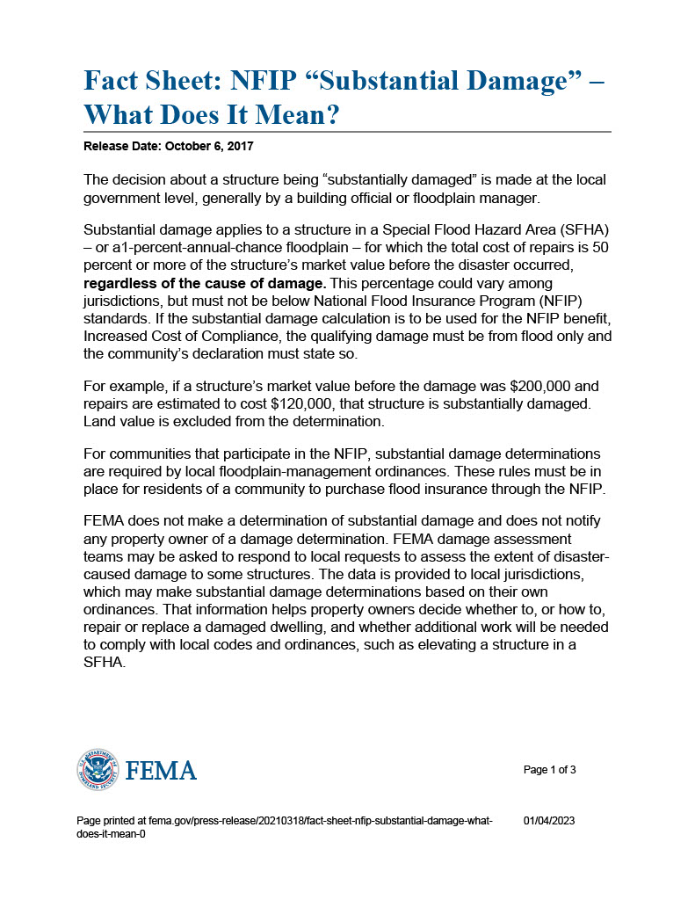

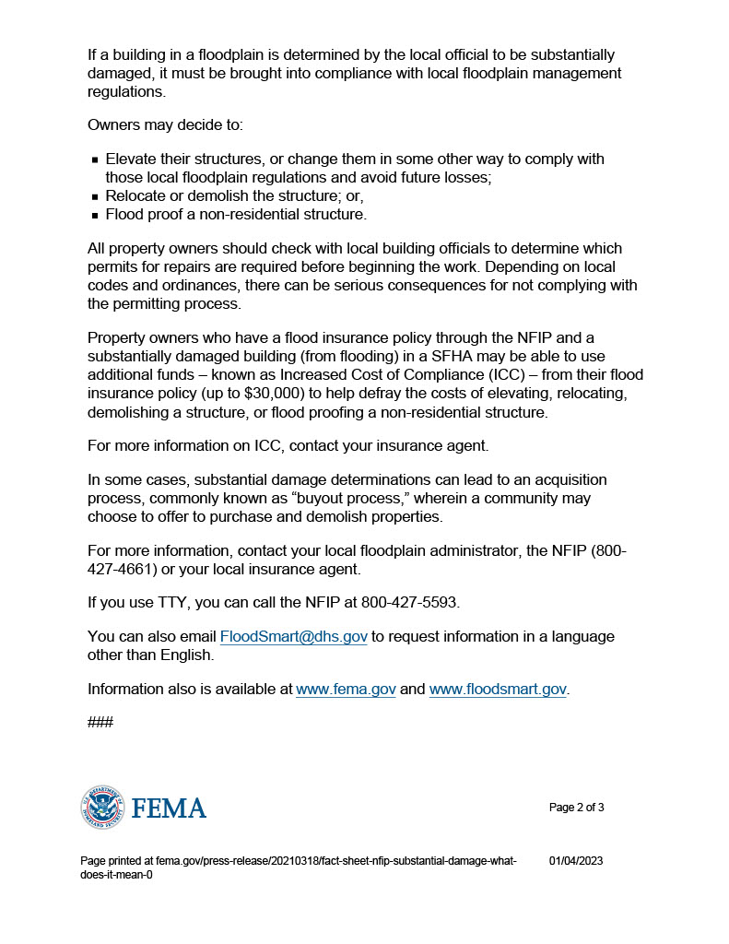

# Appendix M: Public Notice

**Instructions**

At your discretion, your community may wish to publicize and share the Substantial Damage Management Plan. Use of this template is optional for both CRS and non-CRS communities.

## Public Notice Template

**PUBLIC NOTICE**

[COMMUNITY NAME] SUBSTANTIAL DAMAGE PLAN ADOPTION

[Community Name], NY – The Substantial Damage Plan is being presented in accordance with FEMA’s Community Rating System Recertification guidelines and serves to earn credit under Activity 510. This point system is used to award flood insurance discounts to policyholders in the community who carry flood insurance through the National Flood Insurance Program (NFIP).

The [Community Name] has experienced multiple natural disasters in the past and is expected to continue to be impacted by hazards such as flooding, strong winds, and hurricanes. When structures inside the Special Flood Hazard Area (SFHA) are damaged, NFIP participating communities have a responsibility to assess impacts before repairs can be made, no matter the cause of damage. If the cost to repair is 50% or more of the market value, the structure is considered Substantially Damaged and must be brought into compliance with current local floodplain management standards. Rebuilding to current standards decreases risk to life and property and prevents future disaster suffering. The Substantial Damage Plan will be used by the [Community Name] as a guide to conduct substantial damage assessments following major disasters.

The plan was presented to [governing body, ex. City Council] by the [Community official] on [date].

For more information on substantial damage and to view the Substantial Damage Plan, visit the [Community Name website url].

# Appendix N: Annual Plan Evaluation Report Template

**Instructions**

The Annual Plan Evaluation is *required* for CRS participating communities seeking continued CRS credit.

This form is *optional* for non-CRS communities; however, it is recommended to ensure the SDP is up-to-date and still meeting the needs of your community. The editable form is available in the Fillable Forms Folder associated with these DEC SD Resources.

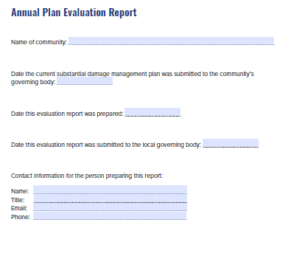

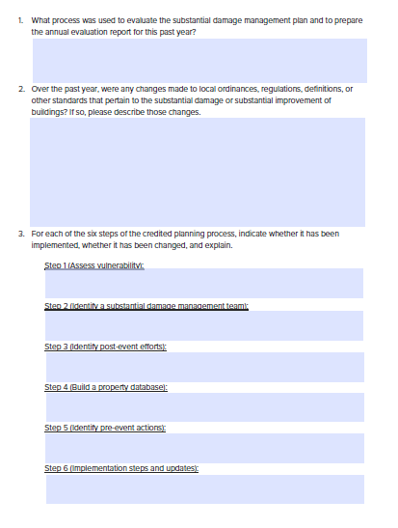

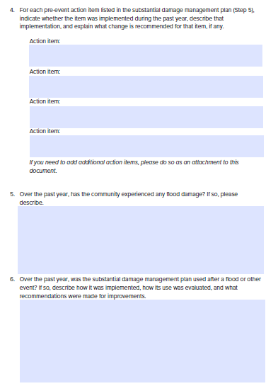

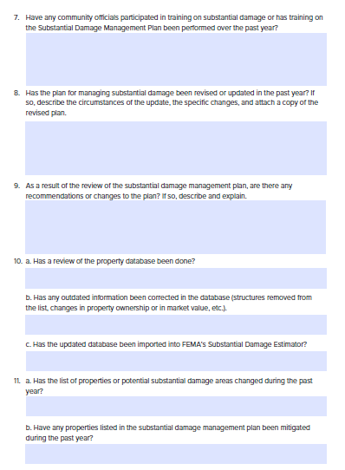

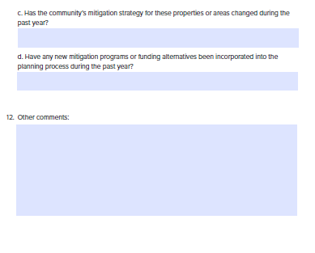

1. Weather.com. What is a Nor’easter? https://weather.com/science/weather-explainers/news/noreaster-snow-rain-wind-northeast-explainer